**Use Azurerm resource provider**

# Configure the Microsoft Azure Provider

provider "azurerm" {

  tenant_id       = "415a8c7e-86007-4b46-b291-00000000"

  subscription_id = "c355ece9-9b00a-46ce-9c84-000000000"

  client_id       = "09a66f62-4a78-4008-b60d-0000000000"

  client_secret   = "xlG7Q~9BM-yu1000QAd_00000000000"

  features {}

}

# Specify the version of the AzureRM Provider to use

terraform {

  required_providers {

    azurerm = {

      source  = "hashicorp/azurerm"

      version = "=3.0.0"

    }

  }

}

# Create a resource group

resource "azurerm_resource_group" "example" {

  name     = "example-resources"

  location = "West Europe"

}

---------------------------------------------------------------------------------------------------------------------------------------------------

**Terraform init :-**

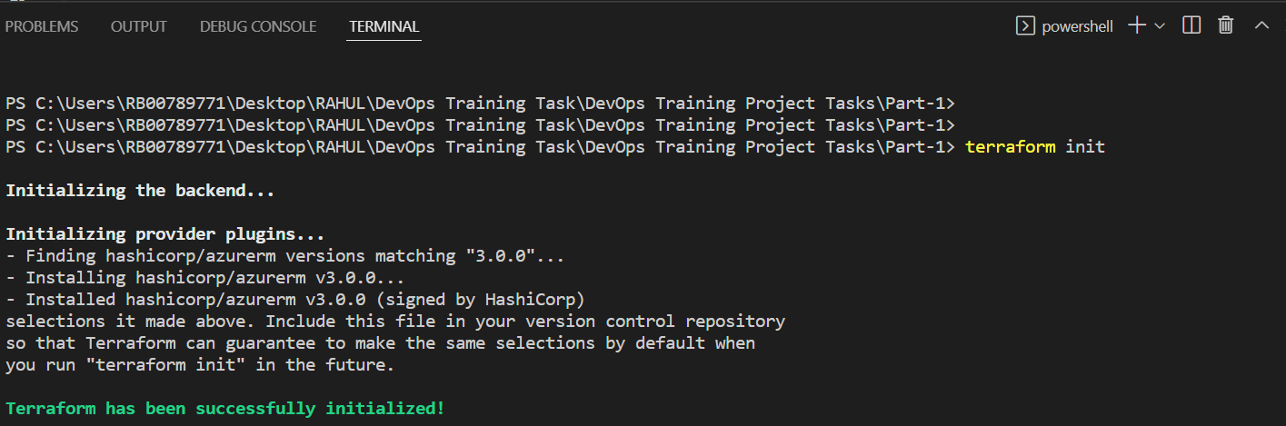

**Terraform plan :-**

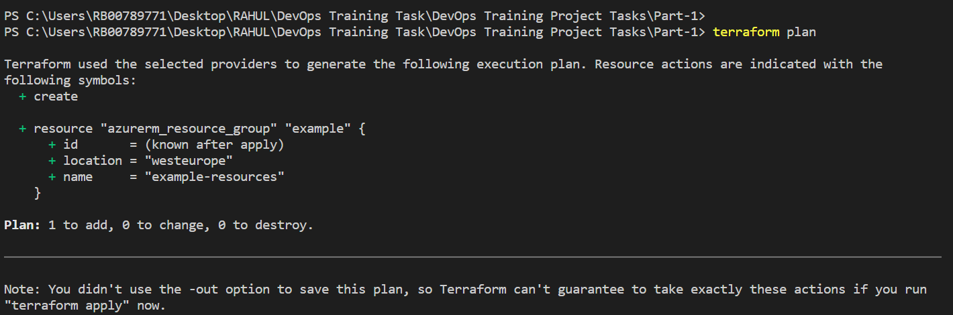

**Terraform apply :-**

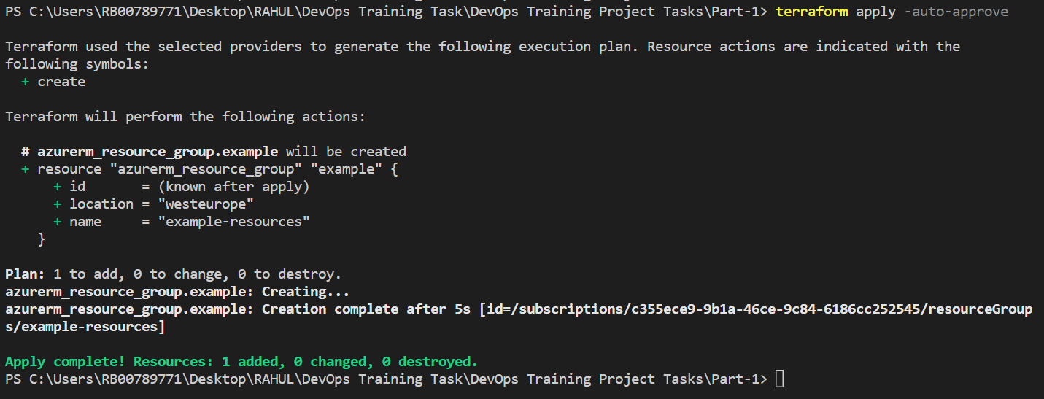

**Azure Portal Output :-**

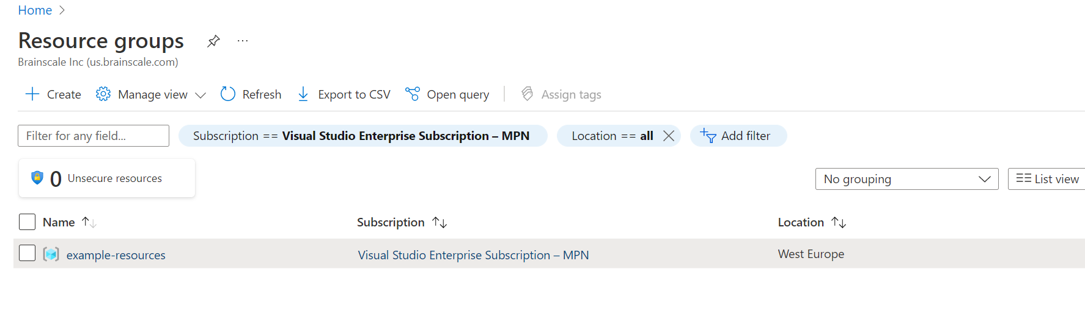

**Create required Vars.tf to create two VMs in Azure**

# Configure the Azure Provider

# Configure the Microsoft Azure Provider

provider "azurerm" {

tenant_id = "415a8c7e-8647-4b46-b291-000000000000"

subscription_id = "c355ece9-9b1a-46ce-9c84-000000000000"

client_id = "09a66f62-4a78-4dd8-b60d-0000000000"

client_secret = "xlG7Q~9BM-yu1xPtrQAd_0000000000000"

features {}

}

# Create a resource group

resource "azurerm_resource_group" "example_rg" {

name = "${var.resource_prefix}-RG"

location = var.node_location

}

# Create a virtual network within the resource group

resource "azurerm_virtual_network" "example_vnet" {

name = "${var.resource_prefix}-vnet"

resource_group_name = azurerm_resource_group.example_rg.name

location = var.node_location

address_space = ["10.2.0.0/16"]

}

# Create a subnets within the virtual network

resource "azurerm_subnet" "example_subnet" {

name = "${var.resource_prefix}-subnet"

resource_group_name = azurerm_resource_group.example_rg.name

virtual_network_name = azurerm_virtual_network.example_vnet.name

address_prefixes = ["10.2.1.0/24"]

}

# Create Linux Public IP

resource "azurerm_public_ip" "example_public_ip" {

count = var.node_count

name = "${var.resource_prefix}-${format("%02d", count.index)}-PublicIP"

#name = "${var.resource_prefix}-PublicIP"

location = azurerm_resource_group.example_rg.location

resource_group_name = azurerm_resource_group.example_rg.name

allocation_method = var.Environment == "Test" ? "Static" : "Dynamic"

tags = {

environment = "Test"

}

}

# Create Network Interface

resource "azurerm_network_interface" "example_nic" {

count = var.node_count

#name = "${var.resource_prefix}-NIC"

name = "${var.resource_prefix}-${format("%02d", count.index)}-NIC"

location = azurerm_resource_group.example_rg.location

resource_group_name = azurerm_resource_group.example_rg.name

ip_configuration {

name = "internal"

subnet_id = azurerm_subnet.example_subnet.id

private_ip_address_allocation = "Dynamic"

public_ip_address_id = element(azurerm_public_ip.example_public_ip.*.id, count.index)

}

}

# Virtual Machine Creation — Linux

resource "azurerm_virtual_machine" "example_linux_vm" {

count = var.node_count

name = "${var.resource_prefix}-${format("%02d", count.index)}"

location = azurerm_resource_group.example_rg.location

resource_group_name = azurerm_resource_group.example_rg.name

network_interface_ids = [element(azurerm_network_interface.example_nic.*.id, count.index)]

vm_size = "Standard_A1_v2"

delete_os_disk_on_termination = true

storage_image_reference {

publisher = "OpenLogic"

offer = "CentOS"

sku = "7.5"

version = "latest"

}

storage_os_disk {

name = "myosdisk-${count.index}"

caching = "ReadWrite"

create_option = "FromImage"

managed_disk_type = "Standard_LRS"

}

os_profile {

computer_name = "linuxhost"

admin_username = "rahul"

admin_password = "Password@1234"

}

os_profile_linux_config {

disable_password_authentication = false

}

tags = {

environment = "Prod"

}

}

**Variable.tf :-**

variable "node_location" {

type = string

default = "EastUS2"

}

variable "resource_prefix" {

type = string

default = "linuxnode"

}

variable "Environment" {

type = string

default = "Prod"

}

variable "node_count" {

type = number

default = "2"

}

--------------------------------------------------------------------------------------------------------------------------------------------------

**Terraform init :-**

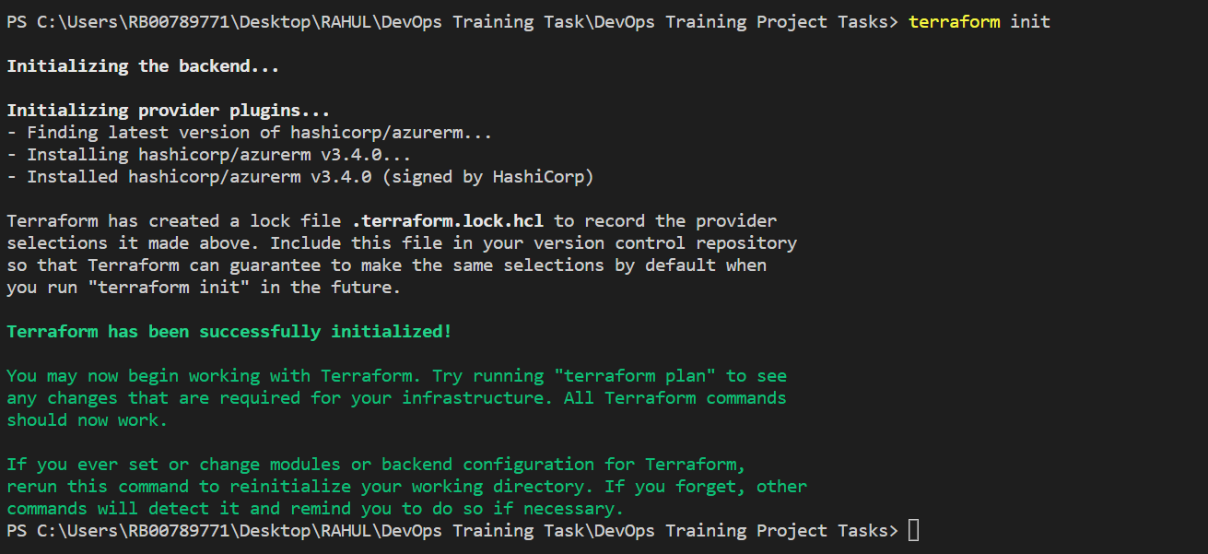

**Terraform Plan :-**

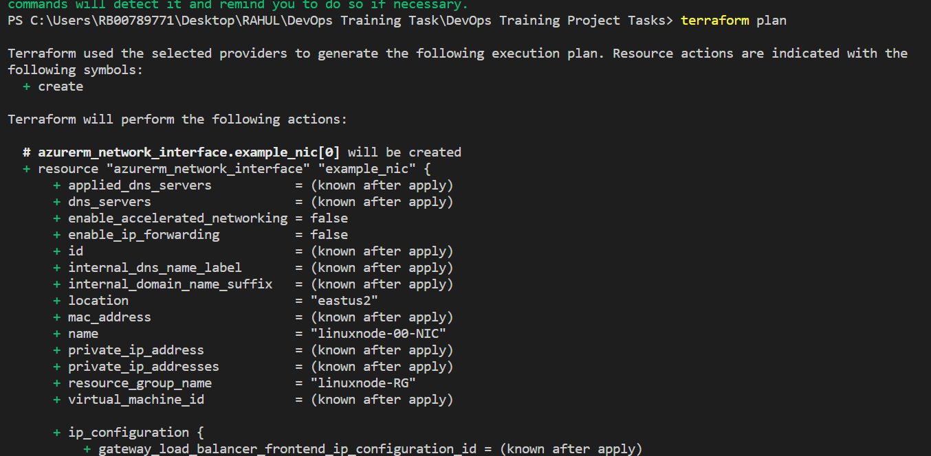

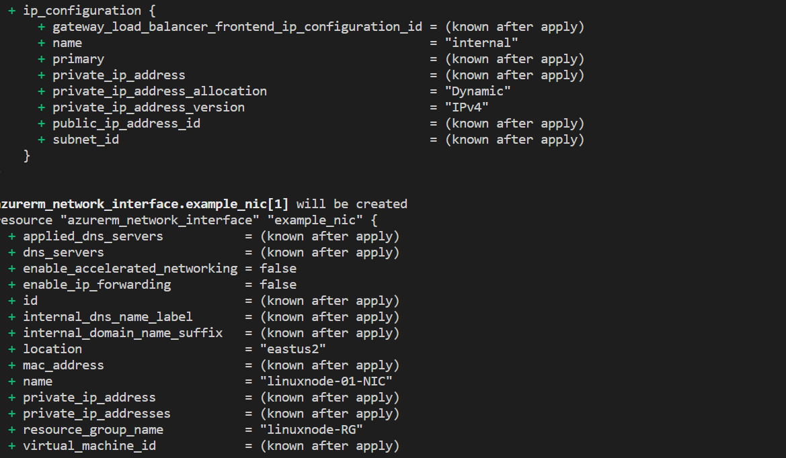

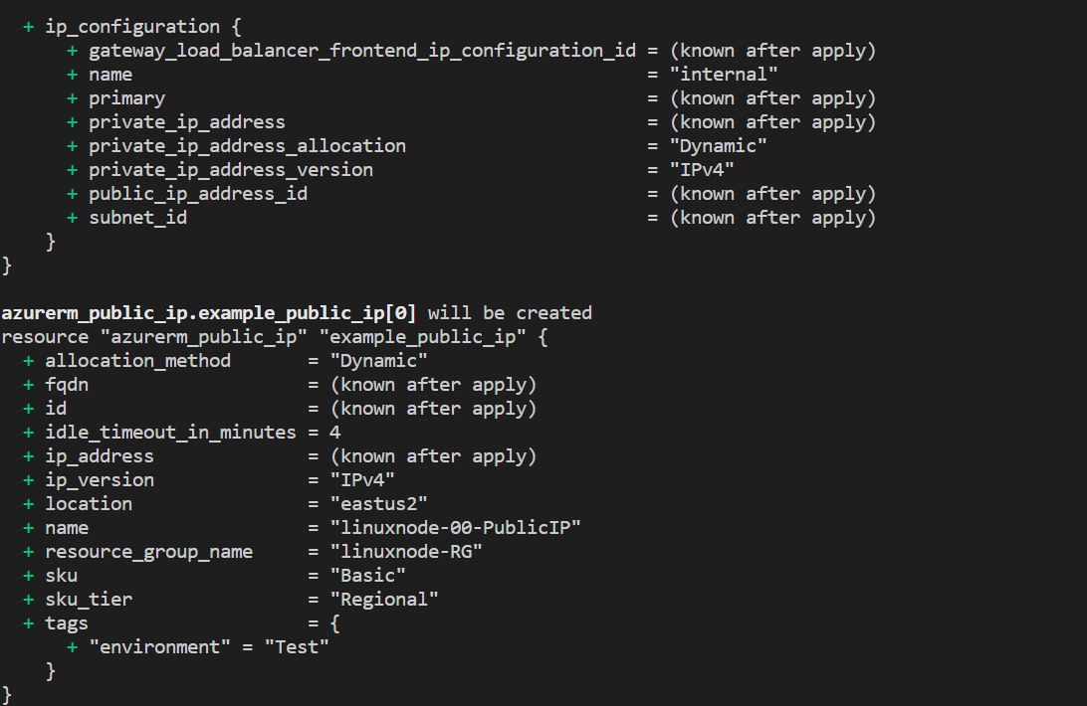

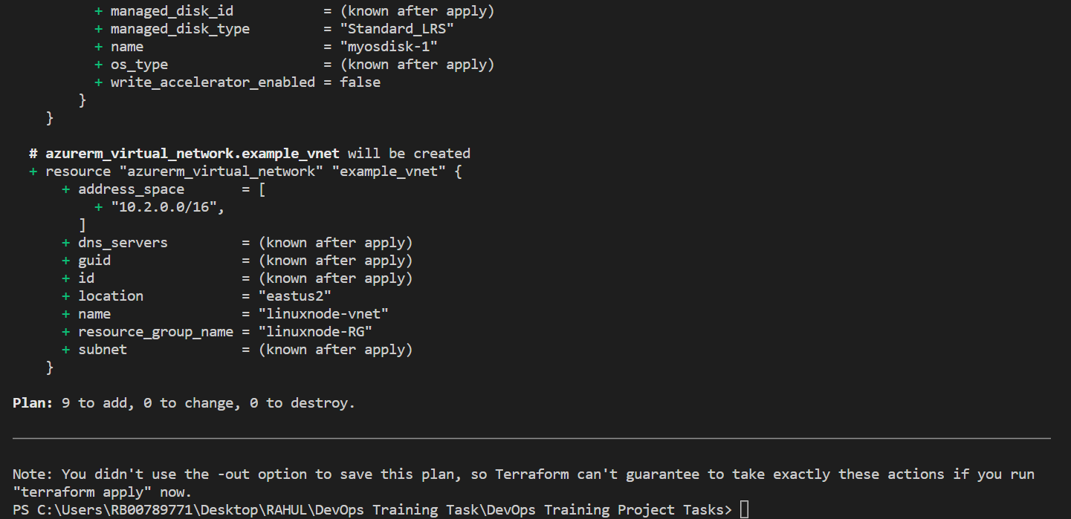

**Terraform Apply :-**

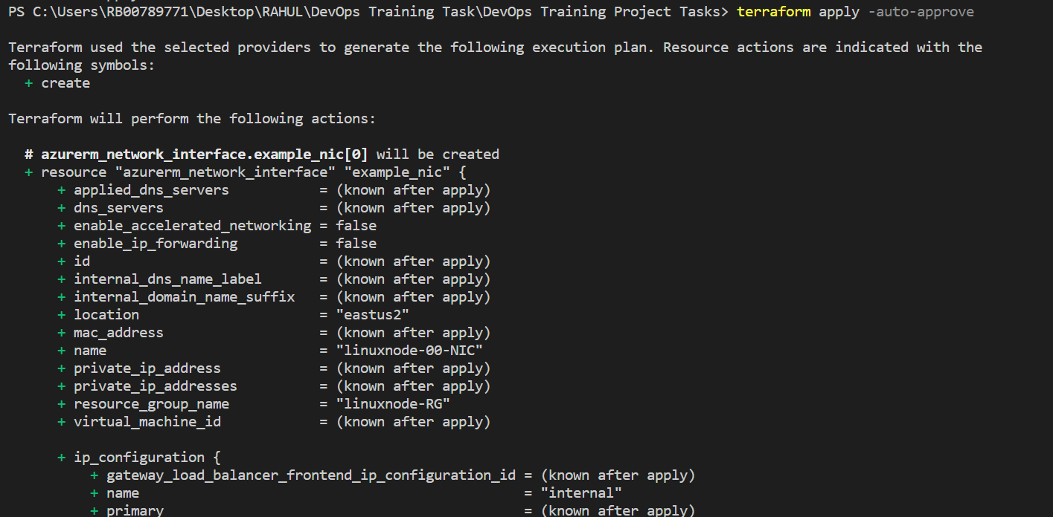

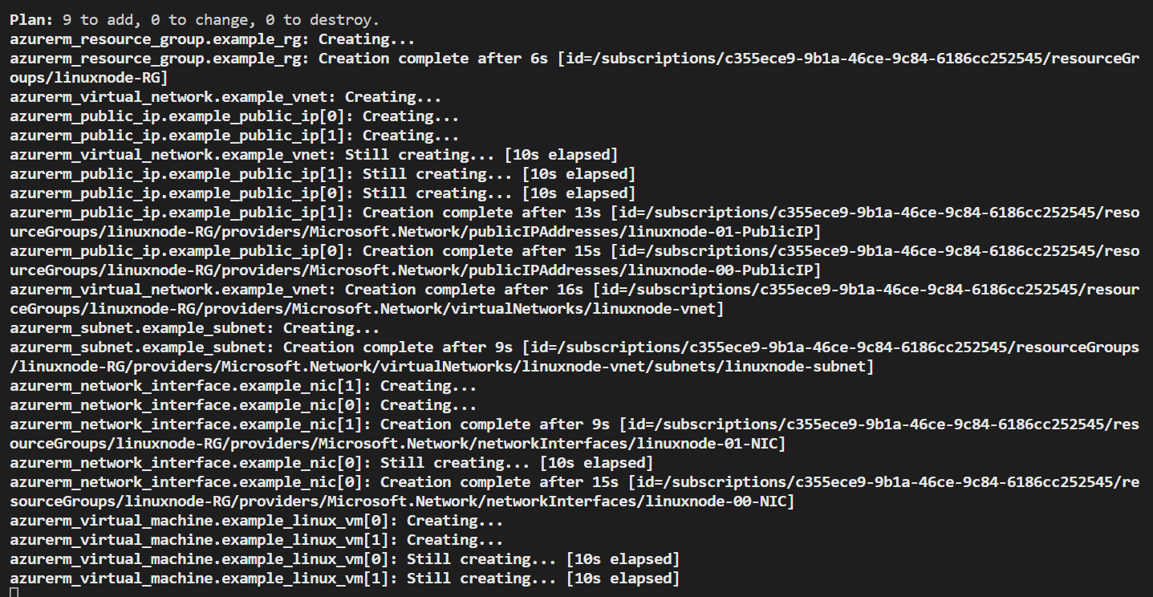

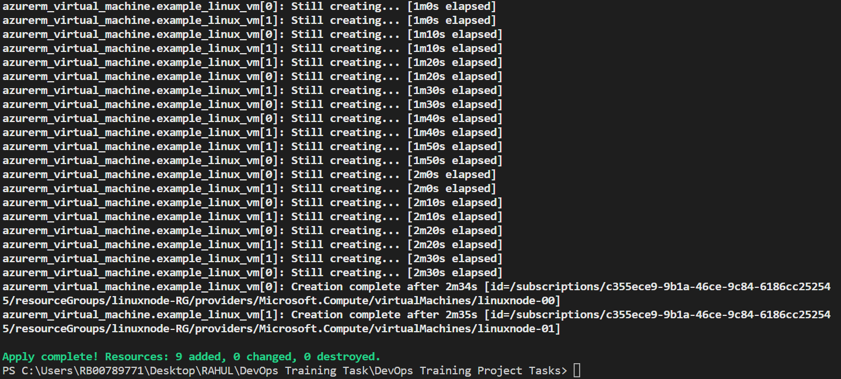

**Azure Portal :-**

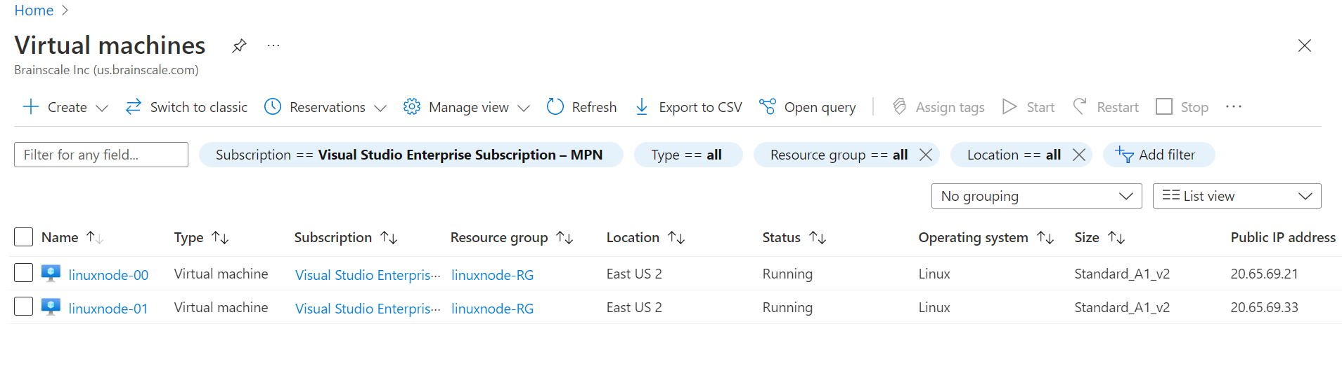

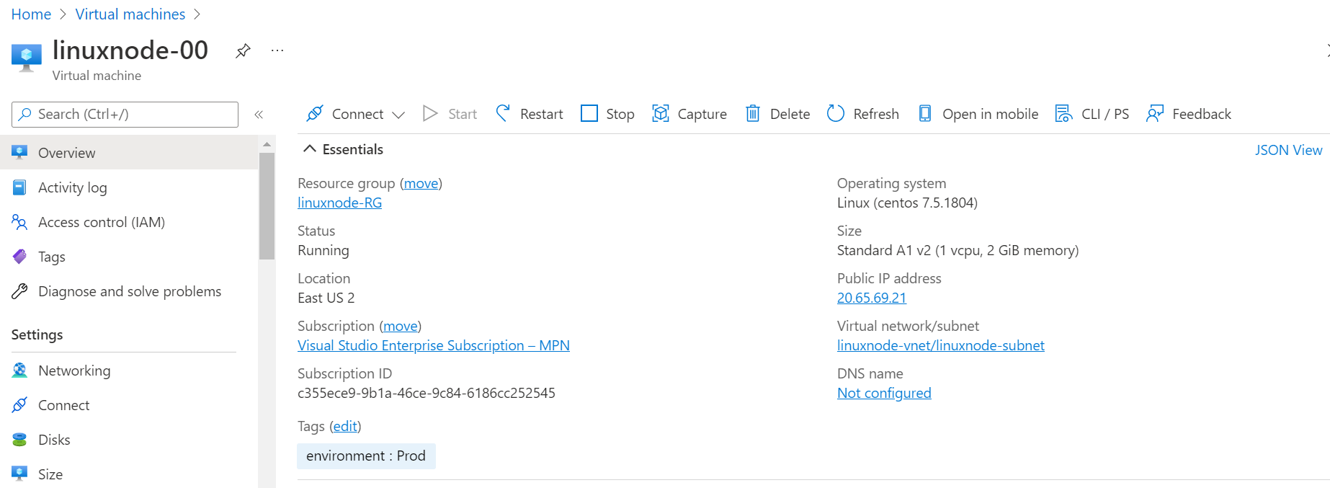

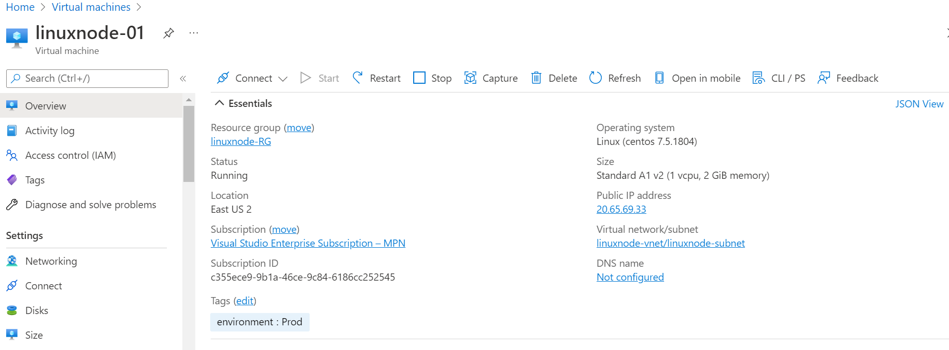

1. **Create main.tf to create two Linux VMs**

# Configure the Microsoft Azure Provider

provider "azurerm" {

  tenant_id       = "415a8c7e-8647-4b46-b291-00000000000"

  subscription_id = "c355ece9-9b1a-46ce-9c84-00000000000"

  client_id       = "09a66f62-4a78-4dd8-b60d-00000000000"

  client_secret   = "xlG7Q~9BM-yu1xPtrQAd_00000000000"

  features {}

}

# Specify the version of the AzureRM Provider to use

terraform {

  required_providers {

    azurerm = {

      source  = "hashicorp/azurerm"

      version = "=3.0.0"

    }

  }

}

# Create a resource group

resource "azurerm_resource_group" "test" {

   name     = "acctestrg"

   location = "EastUS2"

 }

resource "azurerm_virtual_network" "test" {

   name                = "acctvn"

   address_space       = ["10.0.0.0/16"]

   location            = azurerm_resource_group.test.location

   resource_group_name = azurerm_resource_group.test.name

 }

 resource "azurerm_subnet" "test" {

   name                 = "acctsub"

   resource_group_name  = azurerm_resource_group.test.name

   virtual_network_name = azurerm_virtual_network.test.name

   address_prefixes     = ["10.0.2.0/24"]

 }

 resource "azurerm_public_ip" "test" {

   name                         = "publicIPForLB"

   location                     = azurerm_resource_group.test.location

   resource_group_name          = azurerm_resource_group.test.name

   allocation_method            = "Static"

 }

 resource "azurerm_lb" "test" {

   name                = "loadBalancer"

   location            = azurerm_resource_group.test.location

   resource_group_name = azurerm_resource_group.test.name

   frontend_ip_configuration {

     name                 = "publicIPAddress"

     public_ip_address_id = azurerm_public_ip.test.id

   }

 }

 resource "azurerm_lb_backend_address_pool" "test" {

   loadbalancer_id     = azurerm_lb.test.id

   name                = "BackEndAddressPool"

 }

 resource "azurerm_network_interface" "test" {

   count               = 2

   name                = "acctni${count.index}"

   location            = azurerm_resource_group.test.location

   resource_group_name = azurerm_resource_group.test.name

   ip_configuration {

     name                          = "testConfiguration"

     subnet_id                     = azurerm_subnet.test.id

     private_ip_address_allocation = "Dynamic"

   }

 }

 resource "azurerm_managed_disk" "test" {

   count                = 2

   name                 = "datadisk_existing_${count.index}"

   location             = azurerm_resource_group.test.location

   resource_group_name  = azurerm_resource_group.test.name

   storage_account_type = "Standard_LRS"

   create_option        = "Empty"

   disk_size_gb         = "1023"

 }

 resource "azurerm_availability_set" "avset" {

   name                         = "avset"

   location                     = azurerm_resource_group.test.location

   resource_group_name          = azurerm_resource_group.test.name

   platform_fault_domain_count  = 2

   platform_update_domain_count = 2

   managed                      = true

 }

 resource "azurerm_virtual_machine" "test" {

   count                 = 2

   name                  = "acctvm${count.index}"

   location              = azurerm_resource_group.test.location

   availability_set_id   = azurerm_availability_set.avset.id

   resource_group_name   = azurerm_resource_group.test.name

   network_interface_ids = [element(azurerm_network_interface.test.*.id, count.index)]

   vm_size               = "Standard_DS1_v2"

   # Uncomment this line to delete the OS disk automatically when deleting the VM

   # delete_os_disk_on_termination = true

   # Uncomment this line to delete the data disks automatically when deleting the VM

   # delete_data_disks_on_termination = true

   storage_image_reference {

     publisher = "Canonical"

     offer     = "UbuntuServer"

     sku       = "16.04-LTS"

     version   = "latest"

   }

   storage_os_disk {

     name              = "myosdisk${count.index}"

     caching           = "ReadWrite"

     create_option     = "FromImage"

     managed_disk_type = "Standard_LRS"

   }

   # Optional data disks

   storage_data_disk {

     name              = "datadisk_new_${count.index}"

     managed_disk_type = "Standard_LRS"

     create_option     = "Empty"

     lun               = 0

     disk_size_gb      = "1023"

   }

   storage_data_disk {

     name            = element(azurerm_managed_disk.test.*.name, count.index)

     managed_disk_id = element(azurerm_managed_disk.test.*.id, count.index)

     create_option   = "Attach"

     lun             = 1

     disk_size_gb    = element(azurerm_managed_disk.test.*.disk_size_gb, count.index)

   }

   os_profile {

     computer_name  = "hostname"

     admin_username = "testadmin"

     admin_password = "Password1234!"

   }

   os_profile_linux_config {

     disable_password_authentication = false

   }

   tags = {

     environment = "staging"

   }

 }

---------------------------------------------------------------------------------------------------------------------------------------------------

**Terraform Init :-**

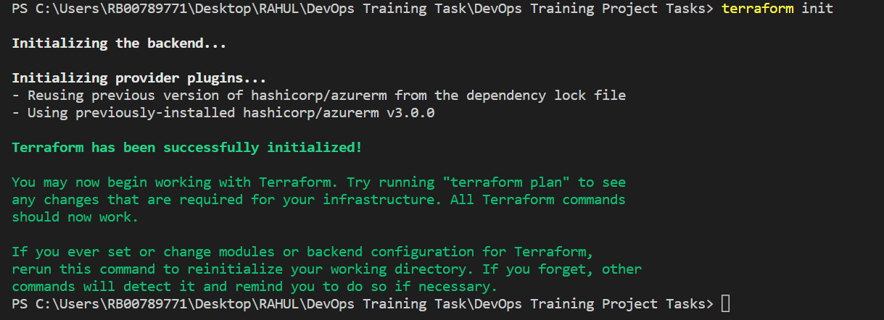

**Terraform plan :-**

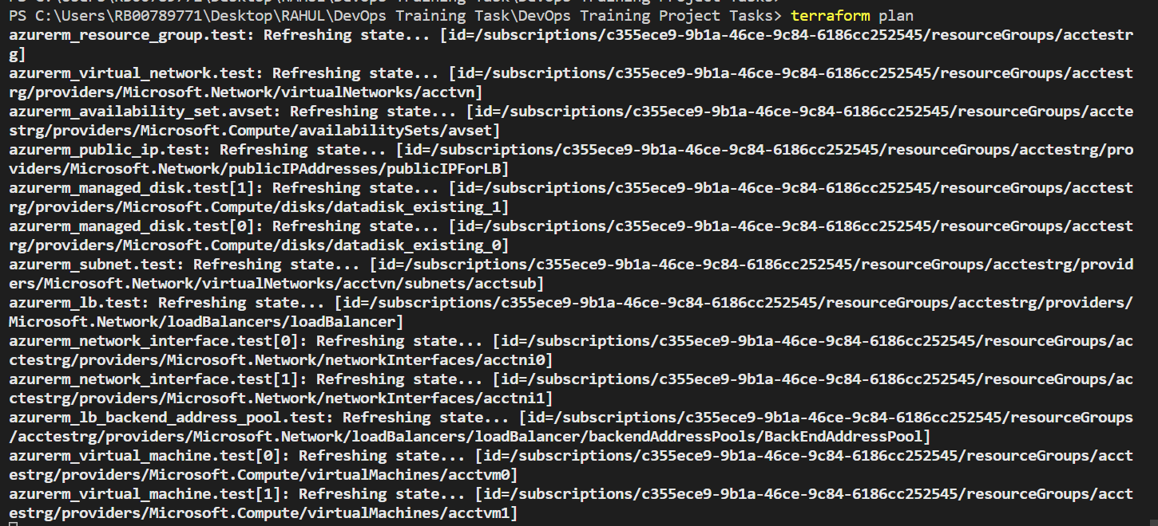

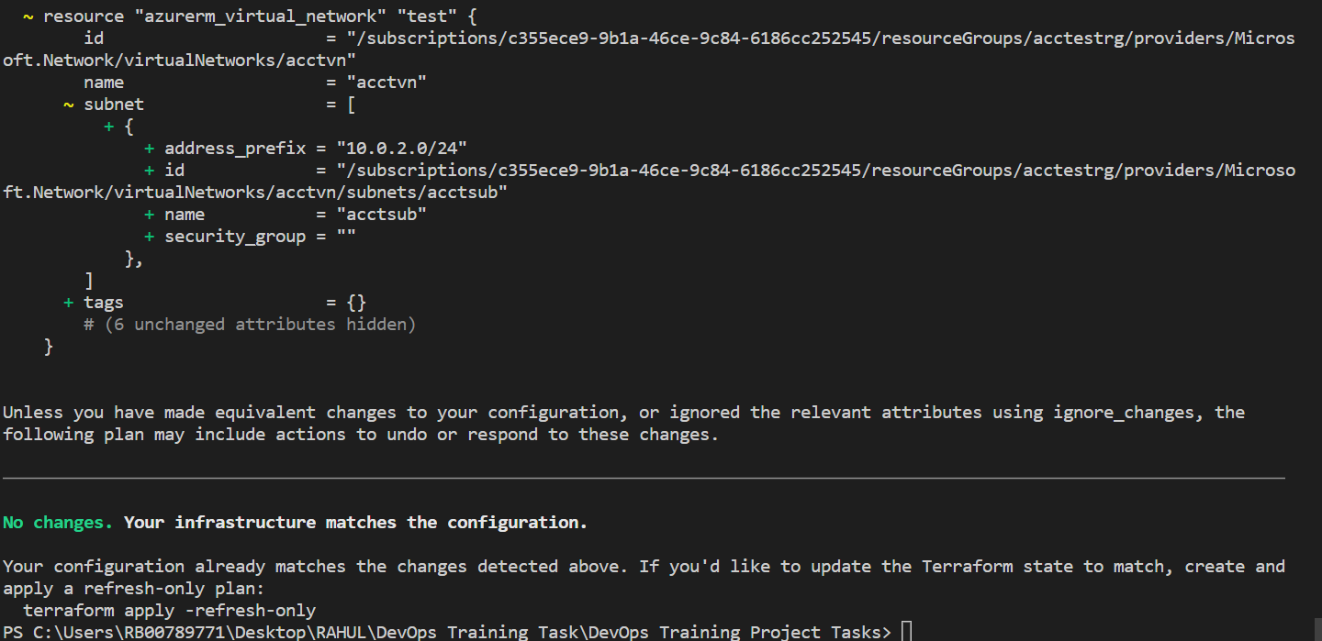

**Terraform apply :-**

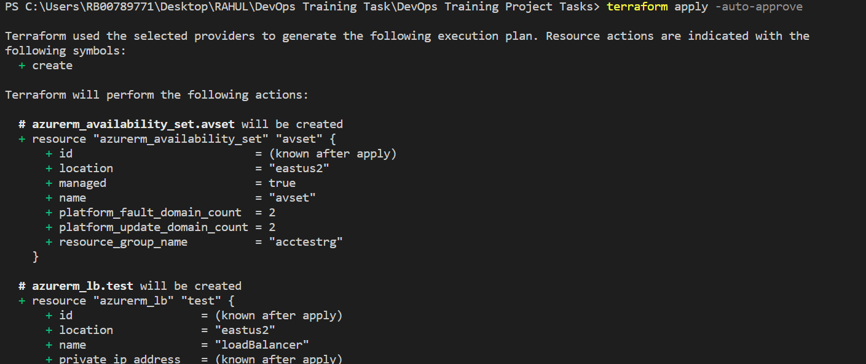

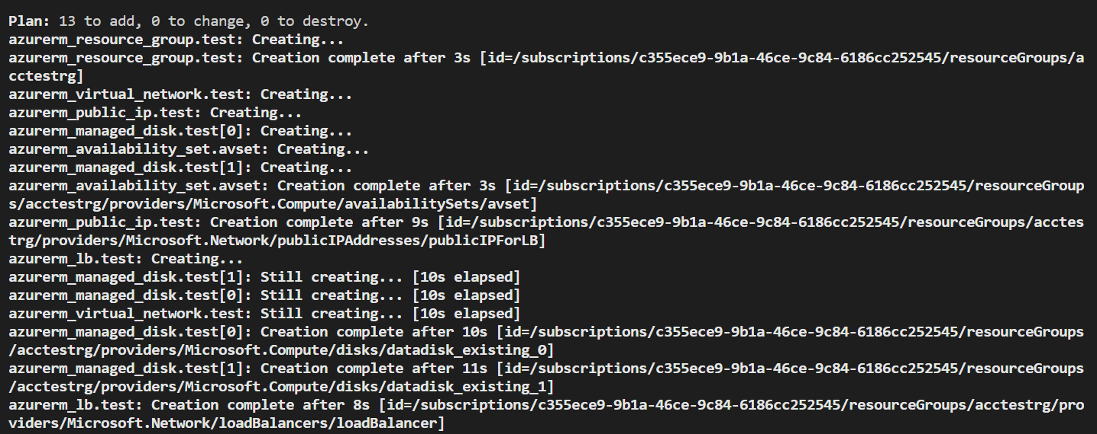

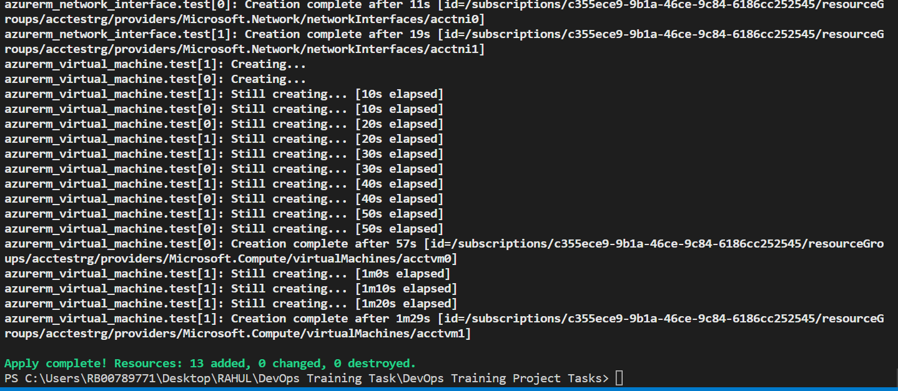

**Azure Portal :-**

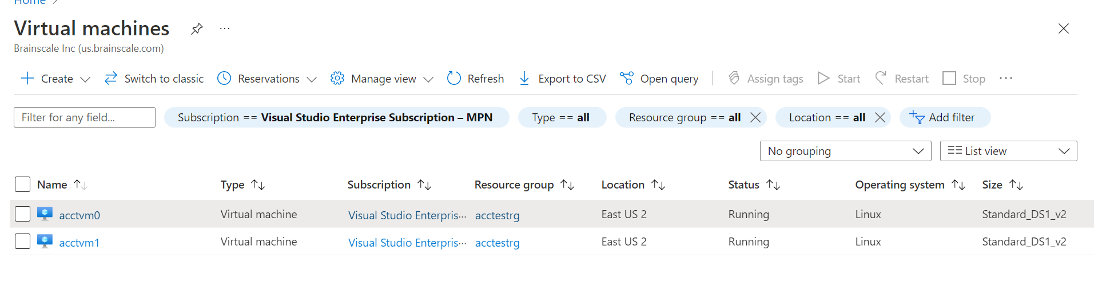

1. **Init,Plan and Apply Terraform Script**

Terraform init :-

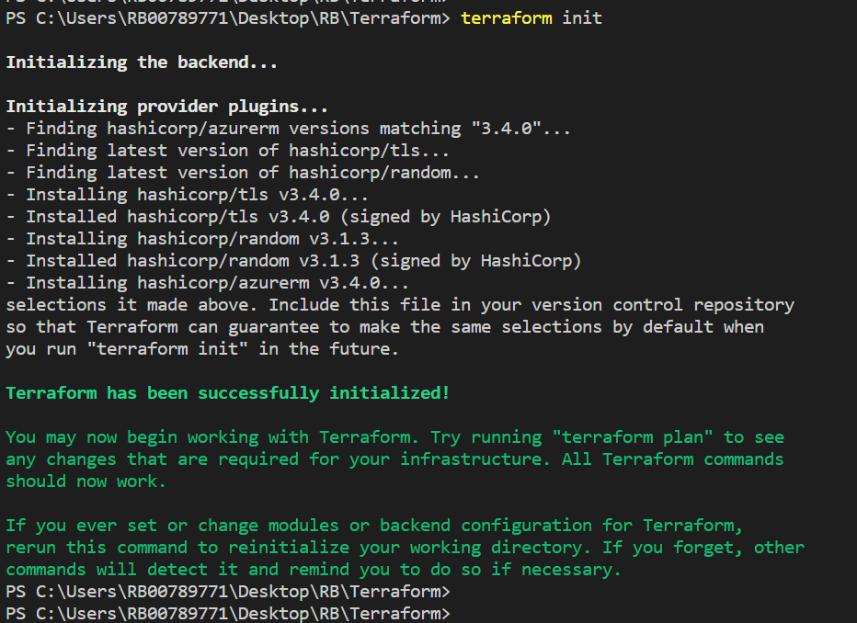

Terraform plan :-

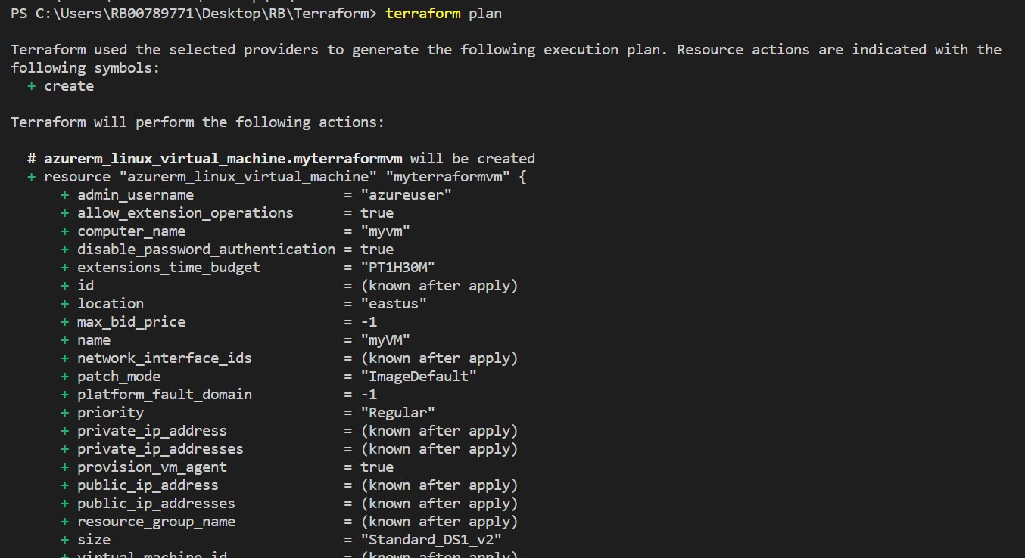

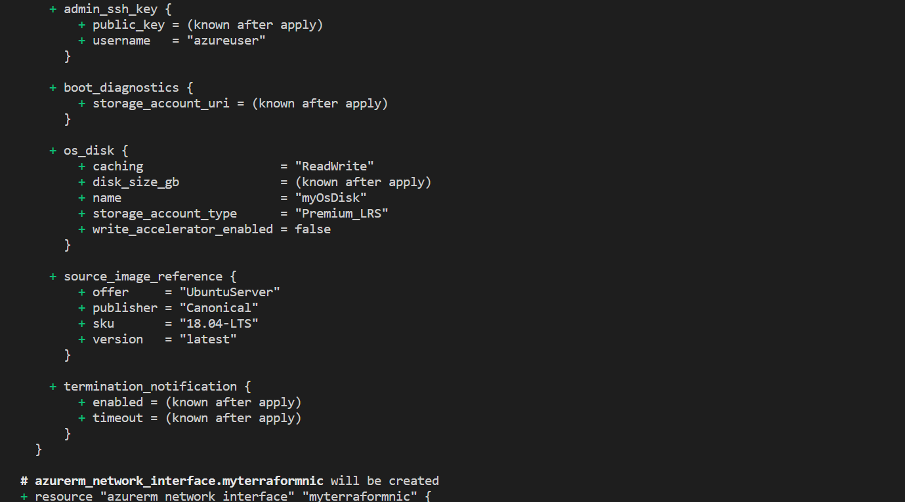

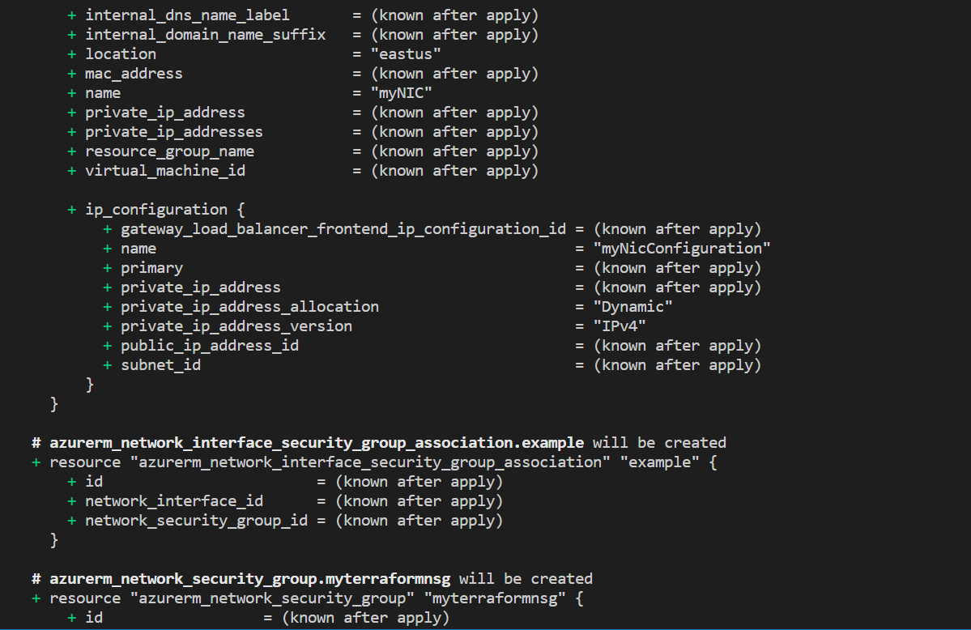

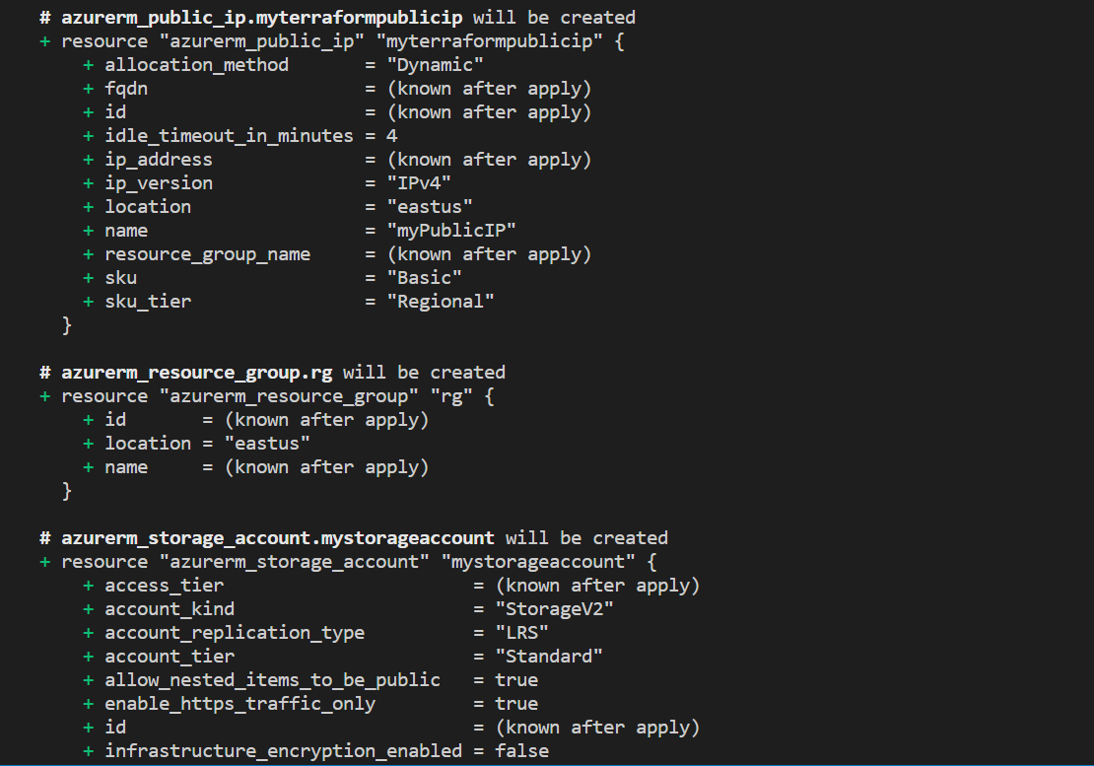

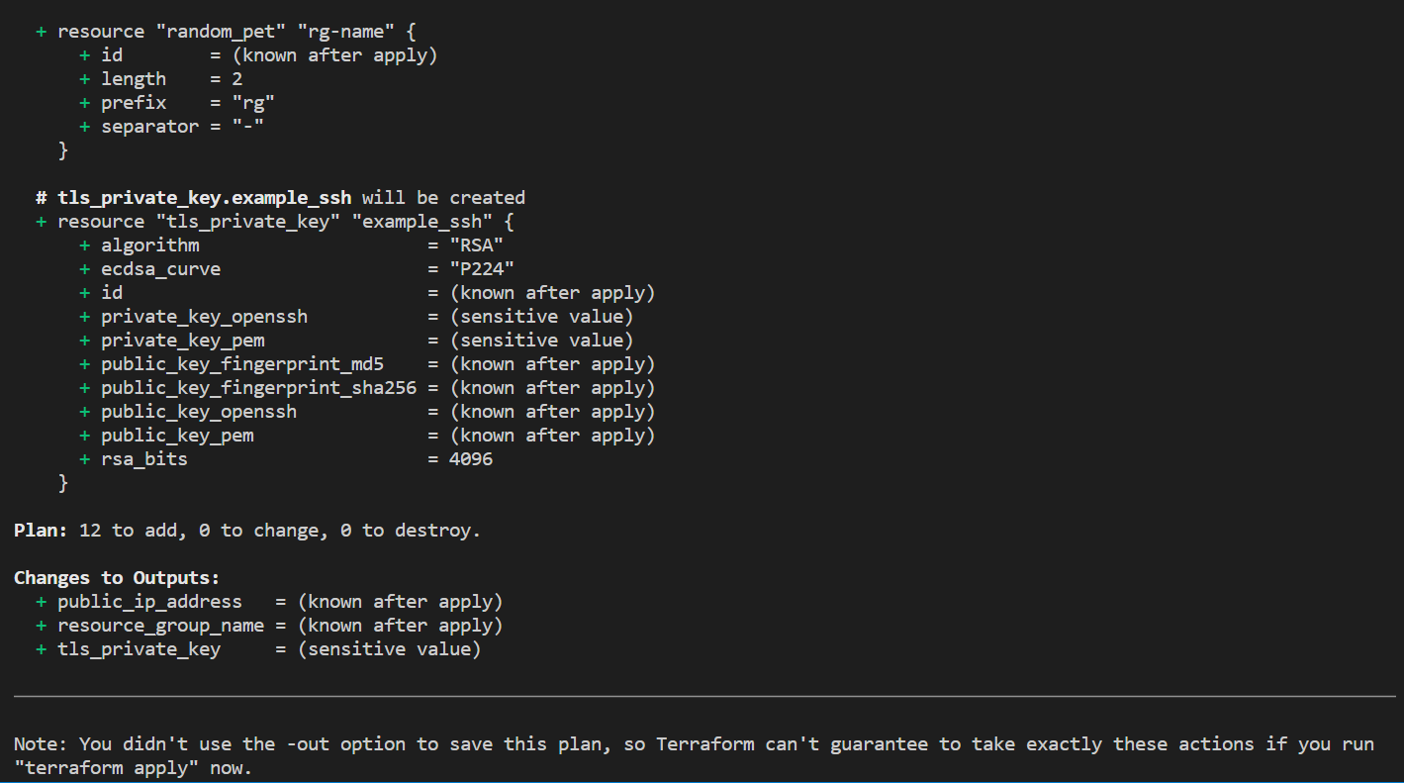

Terraform apply :-

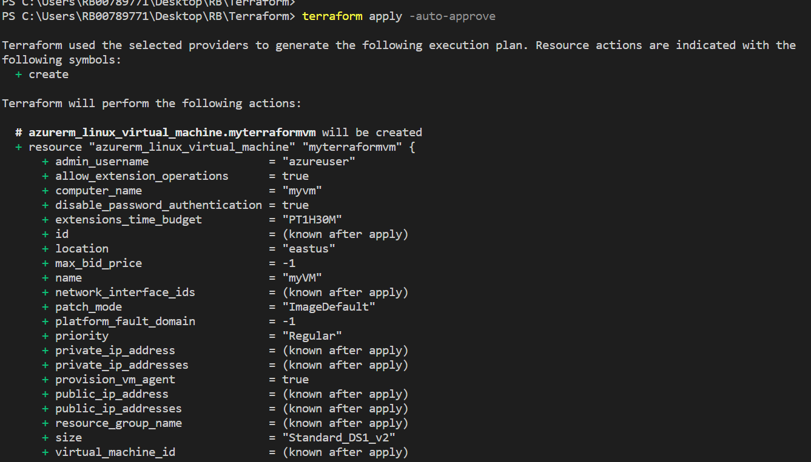

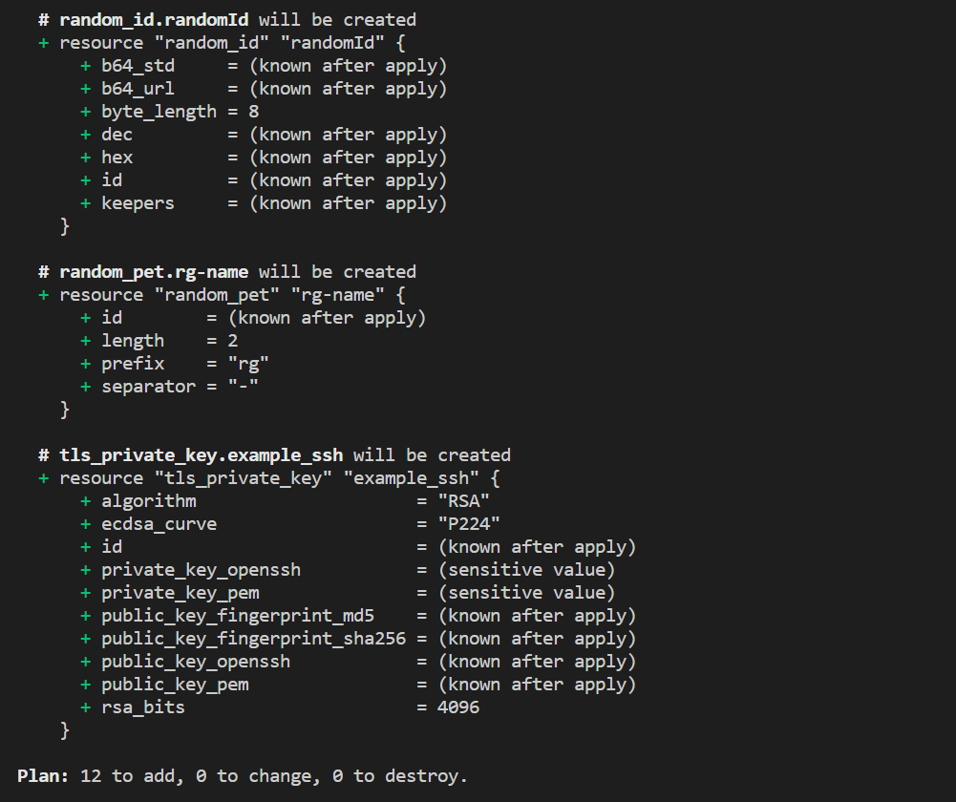

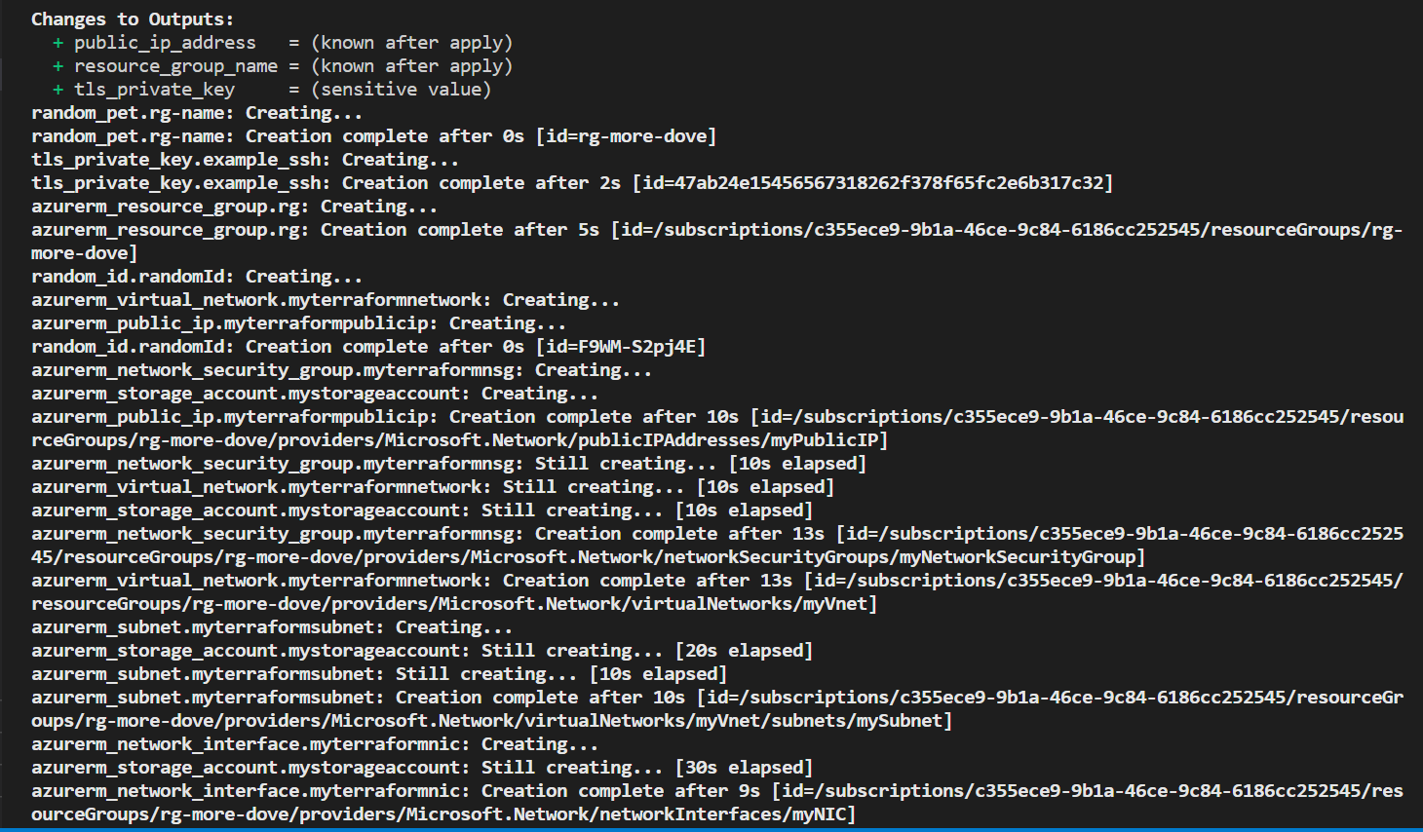

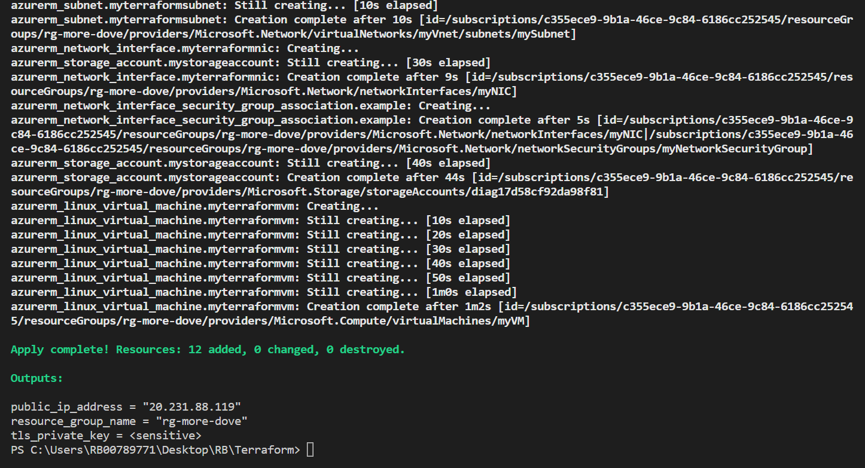

1. **Manually Start Jenkins and configure required Plug-ins and Master Slave Configuration**

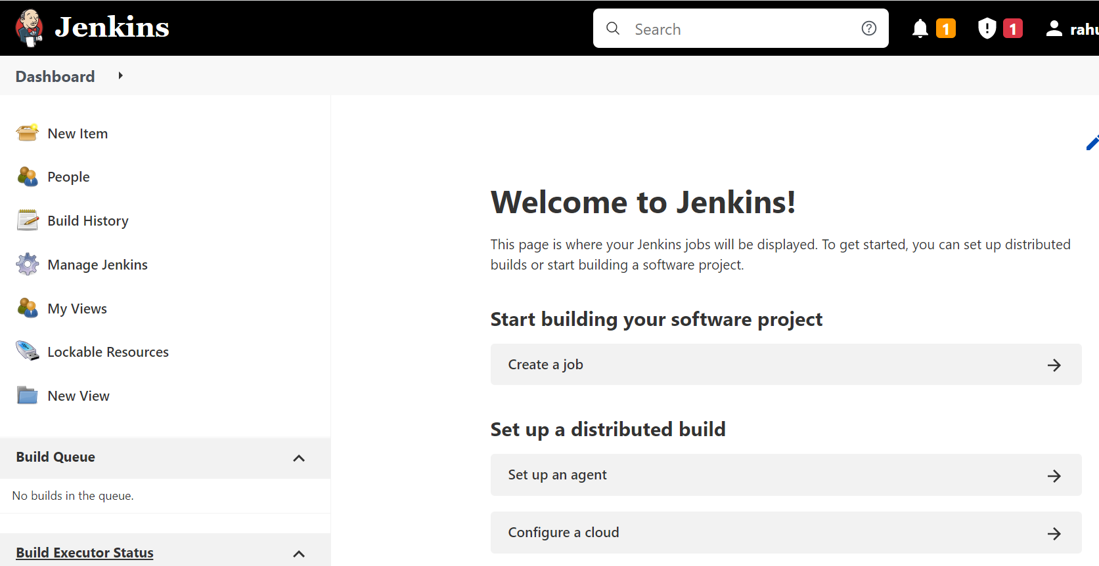

configure required Plug-ins :-

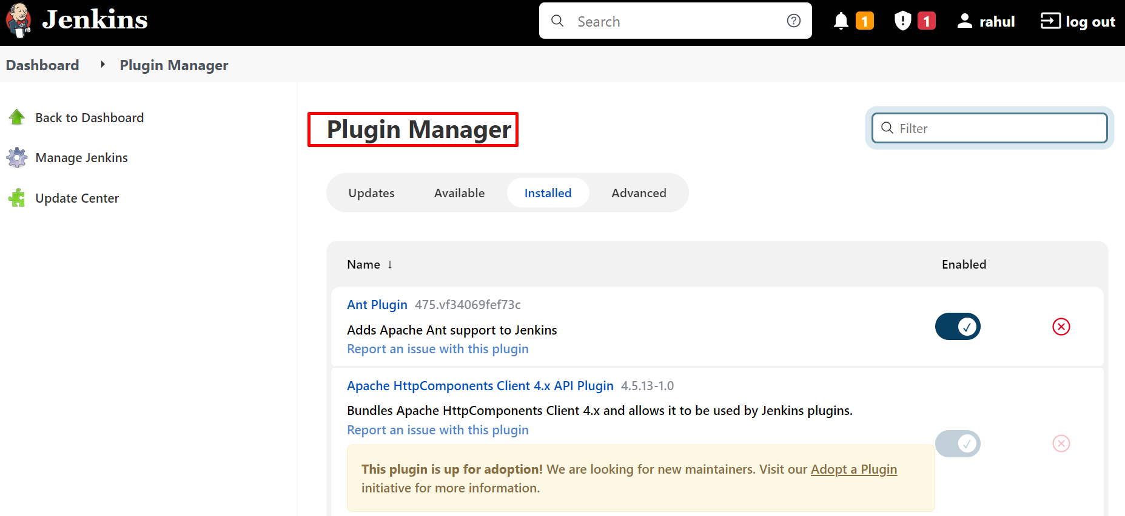

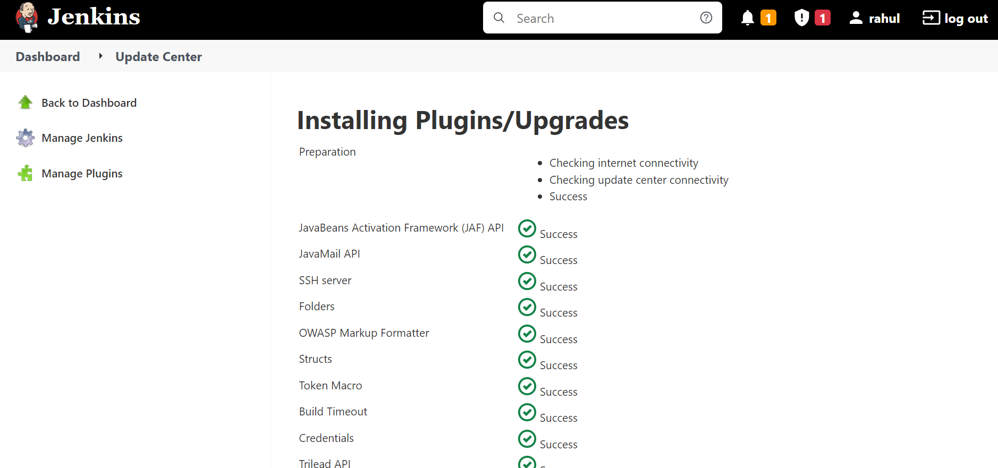

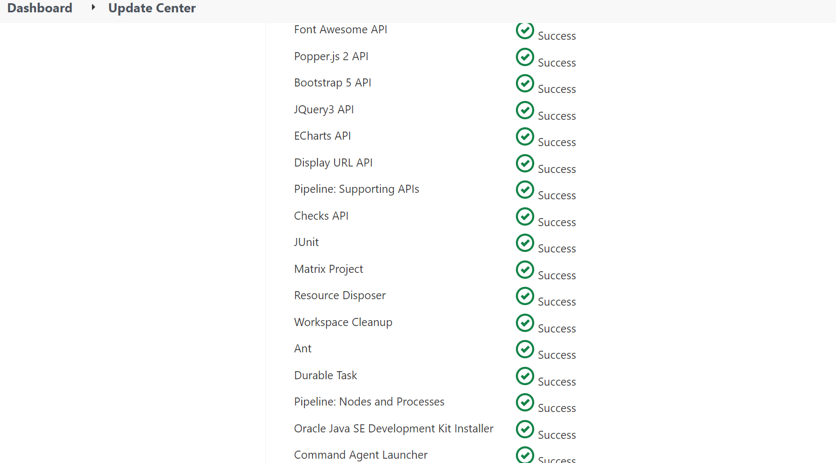

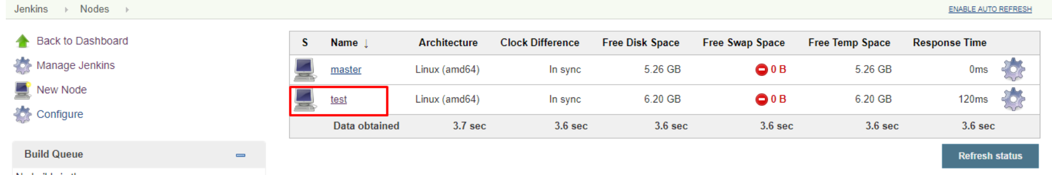

1. **Create Maven Project with Archtype as web application in eclipse**

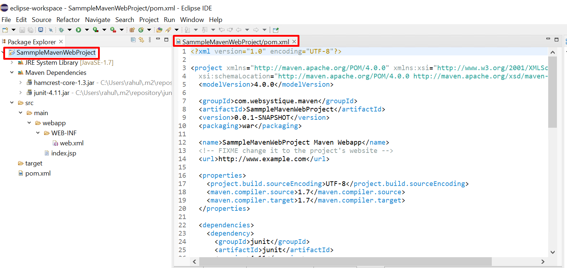

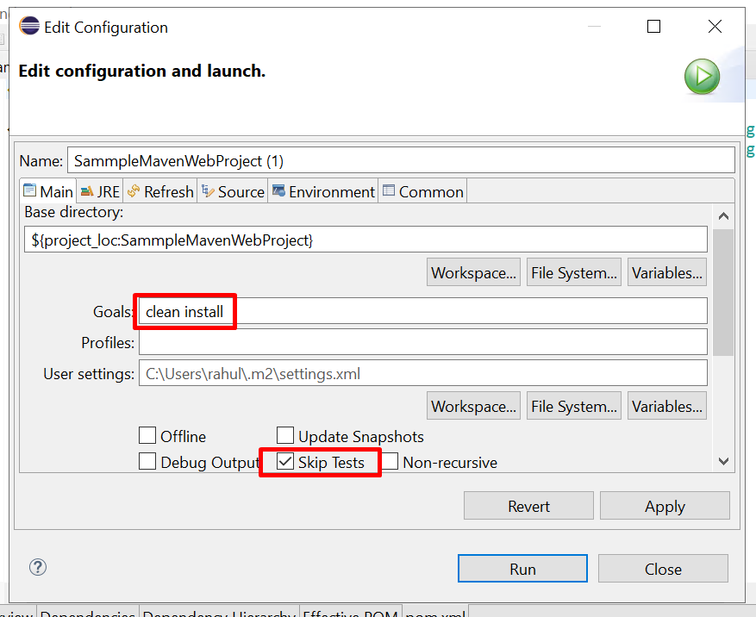

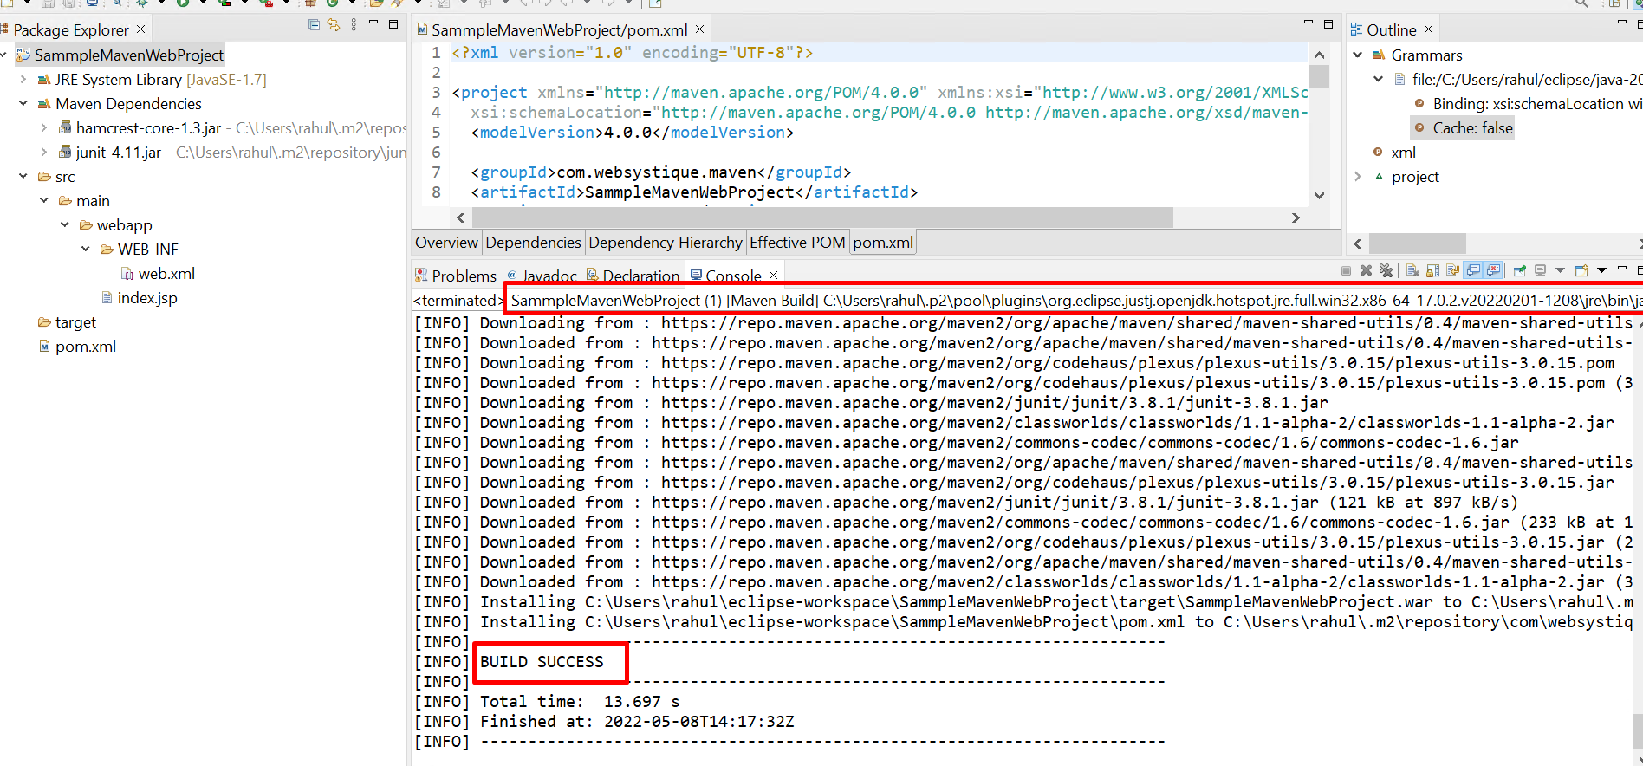

1. **Modify Index.jsp under src/main/webcontent to display a custom message**

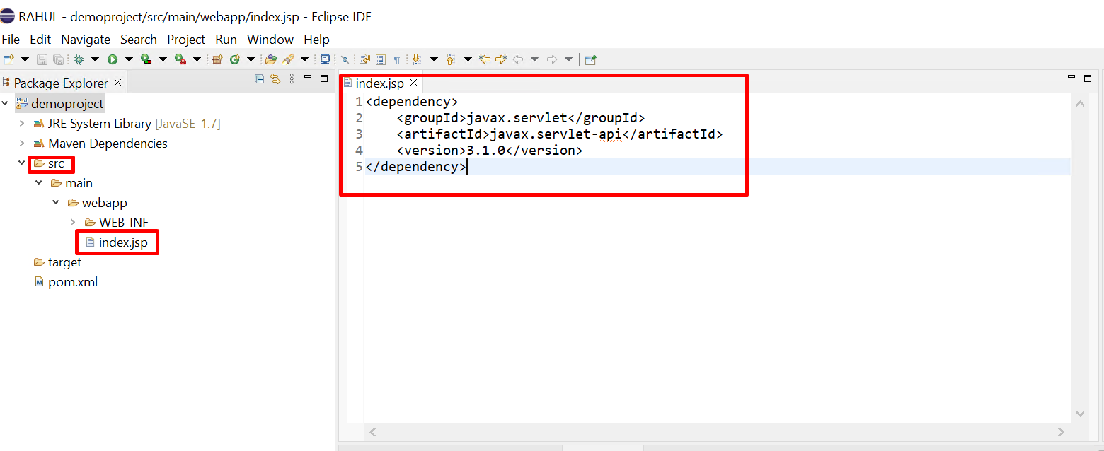

Build Project :-

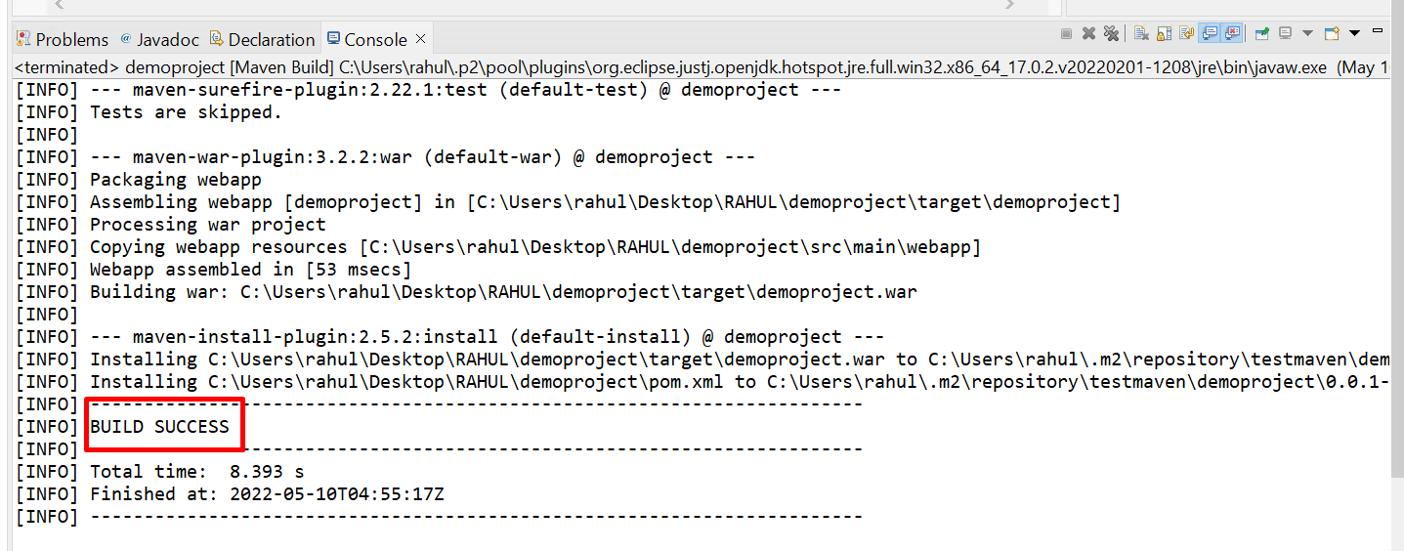

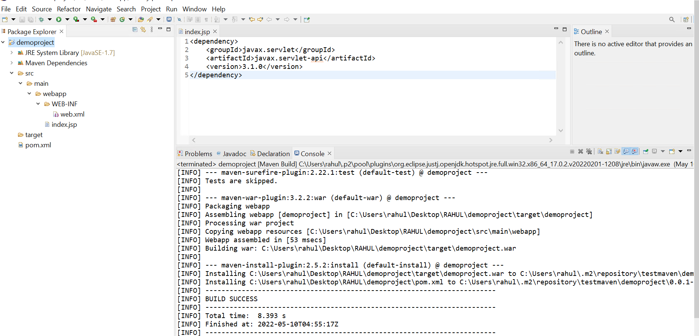

1. **Access the application from container and check it**

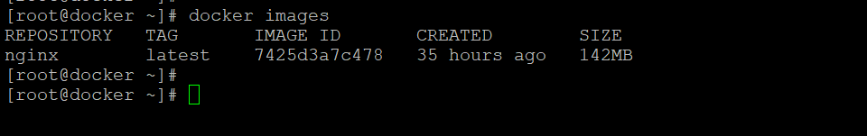



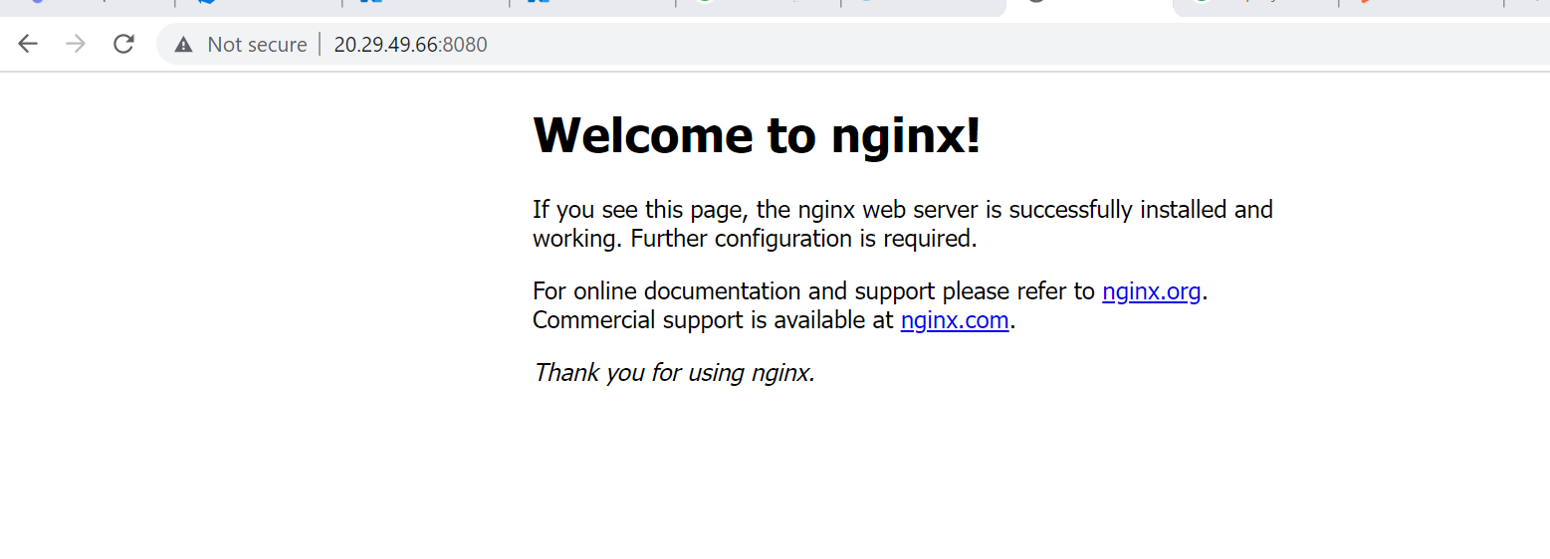

1. **Test the Dockerfile by running Docker build and create a container**

Create Dockerfile:-

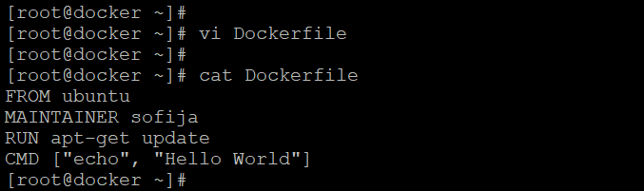

Docker Build :-

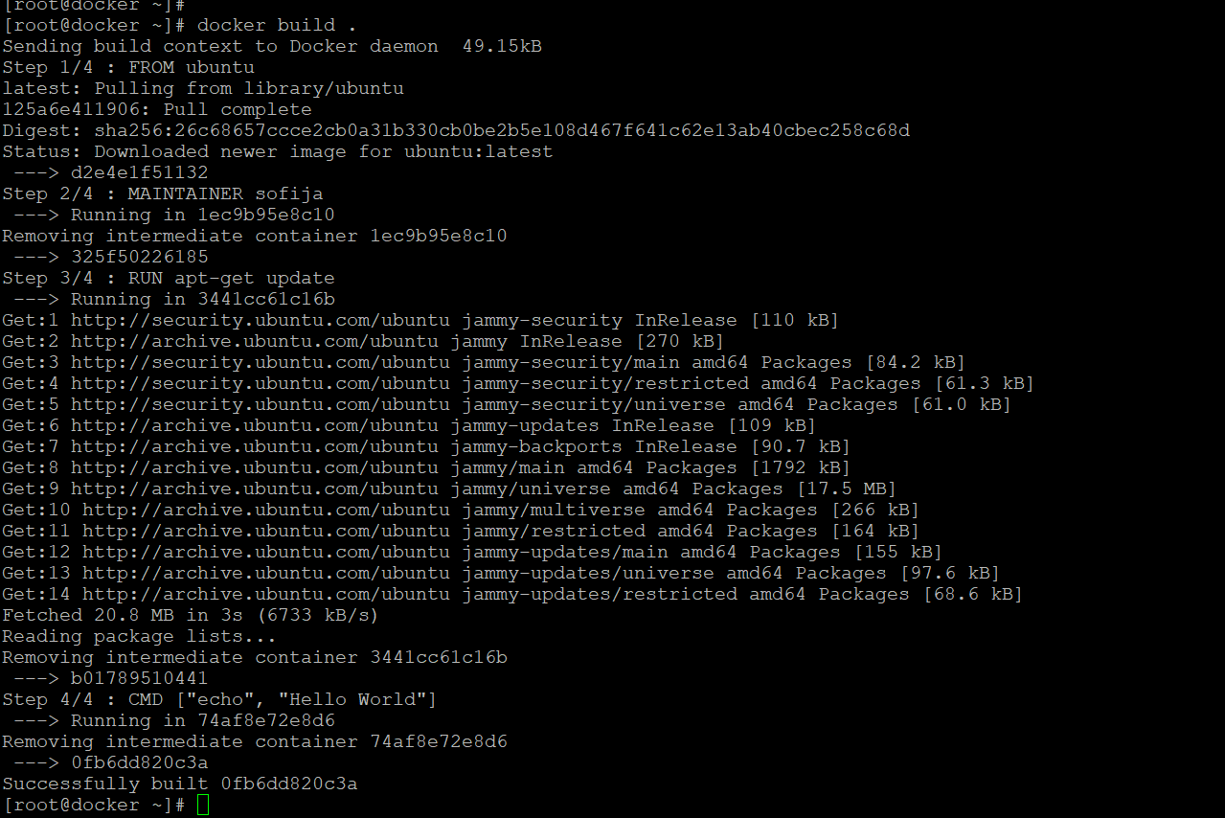

Docker images:-

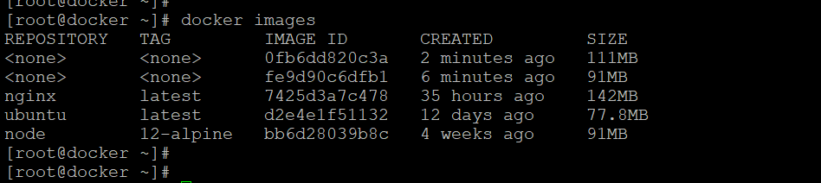

Docker Container:-



1. **Create a github repository and copy repo URL**

Create a github repository and copy repo URL

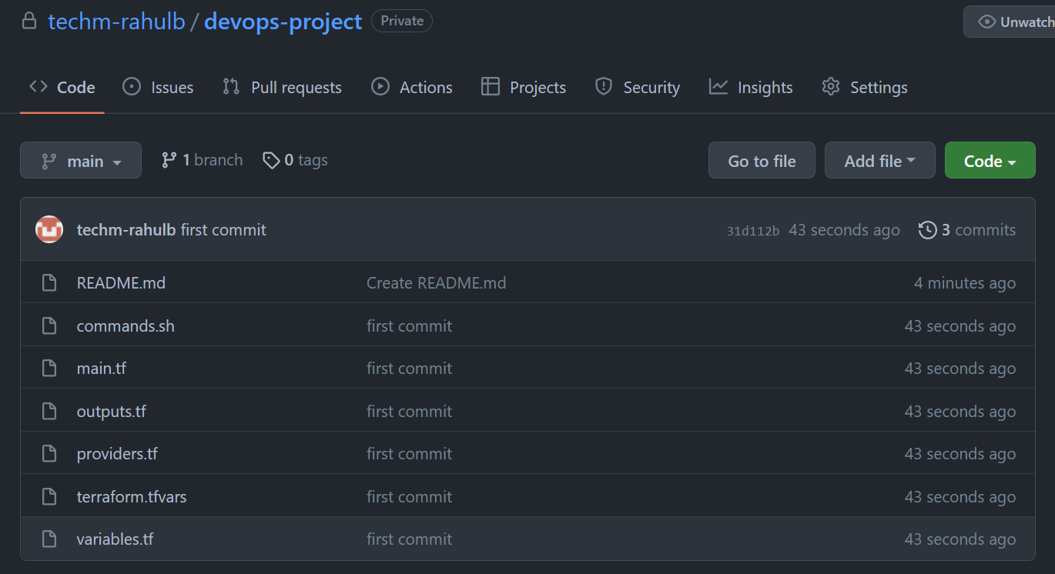

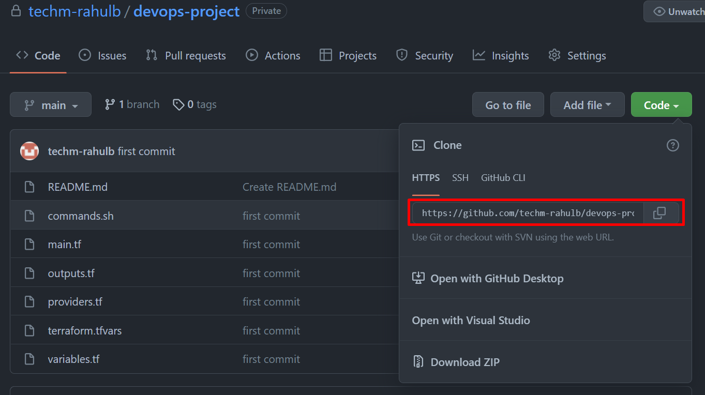

Repo URL :- <https://github.com/techm-rahulb/devops-project.git> ( this is Private repository )

1. **Commit and Push the code to remote repo**

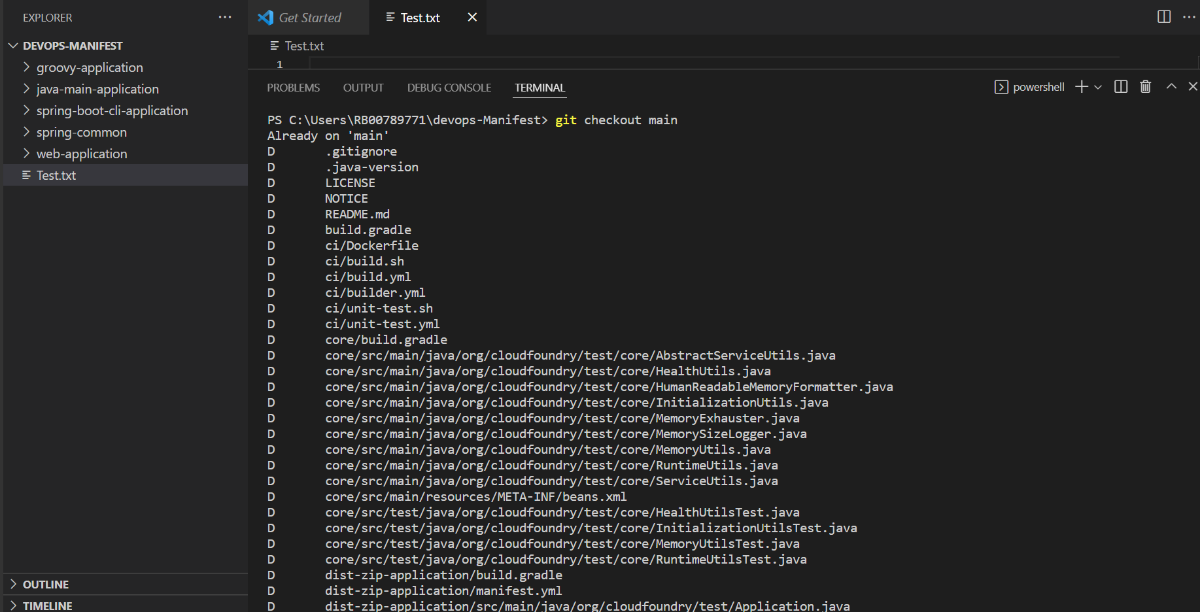

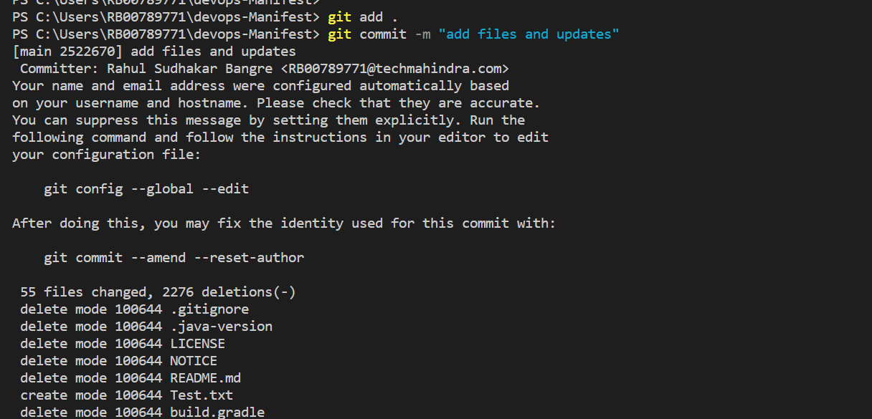

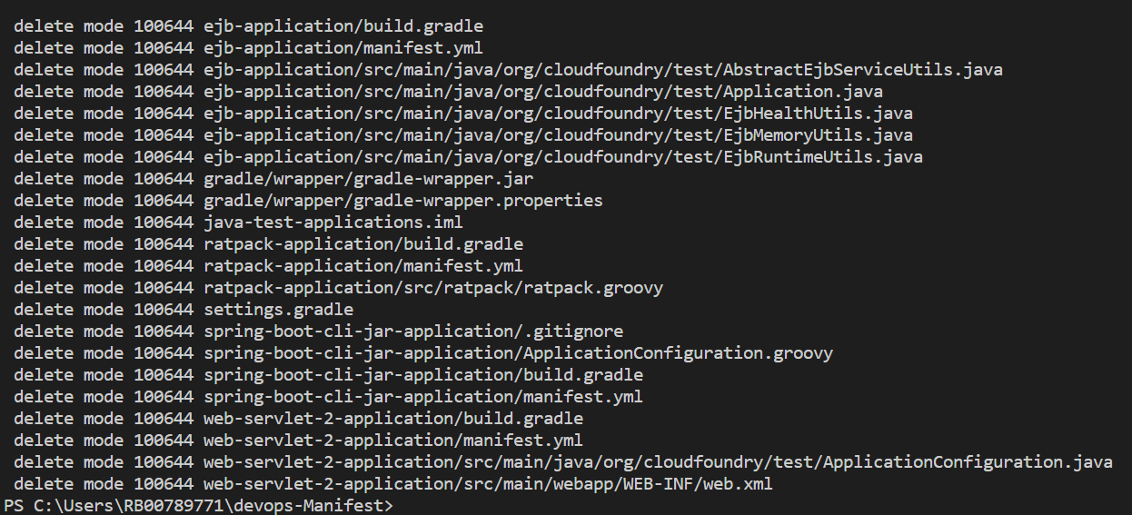

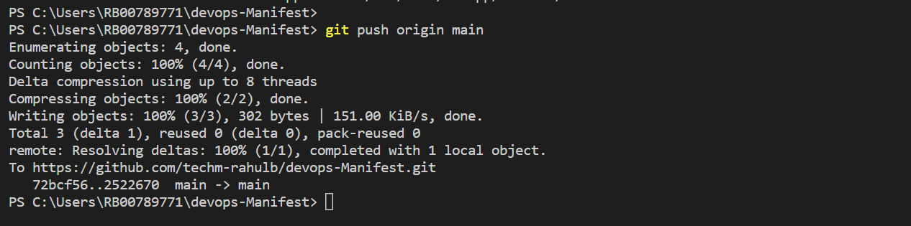

1. **Check for the change in remote Repo**

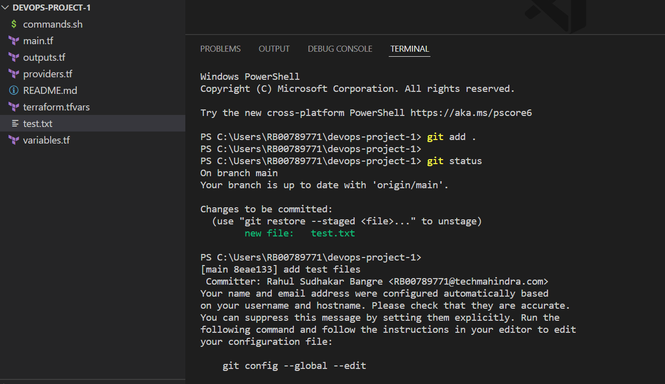

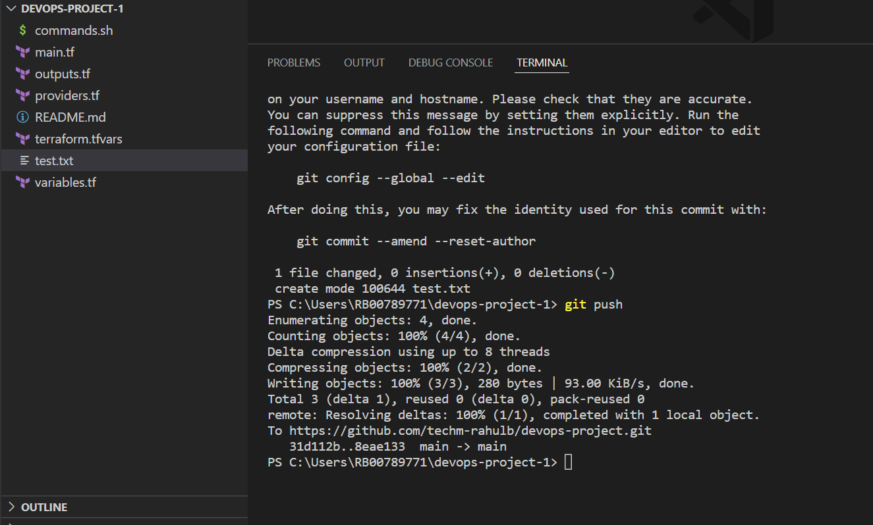

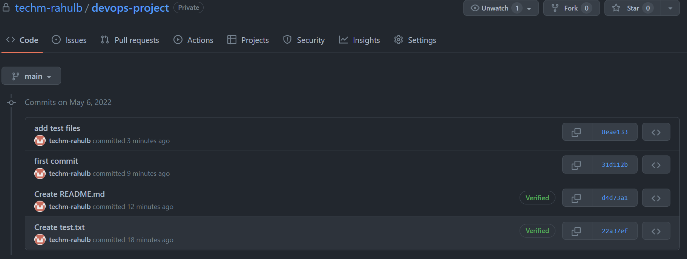

1. **In build server configure Ansible manually**

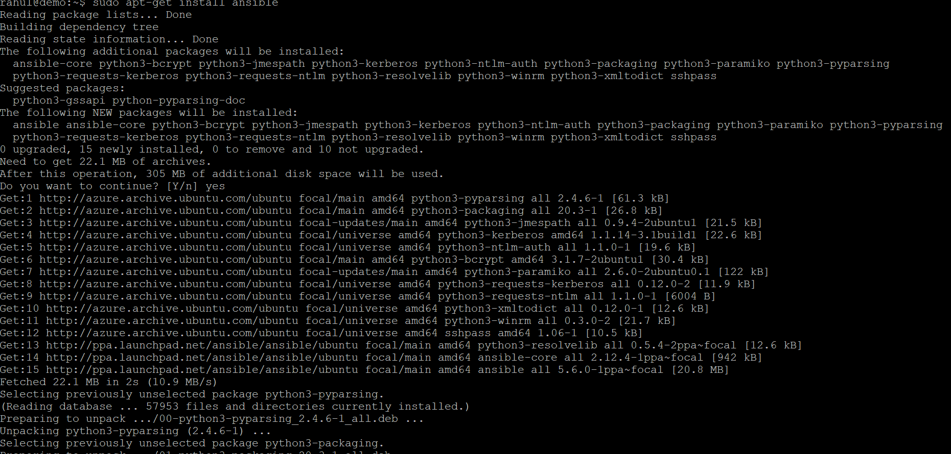

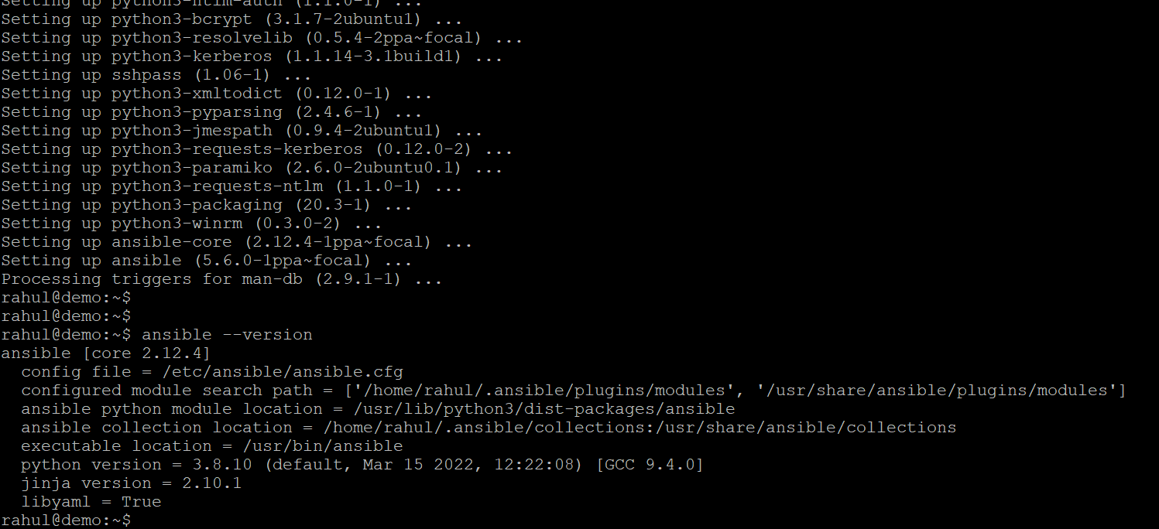

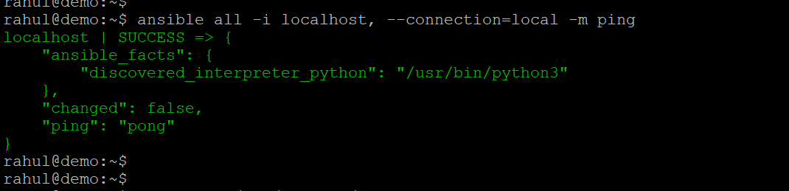

Configuring Ansible for the remote server



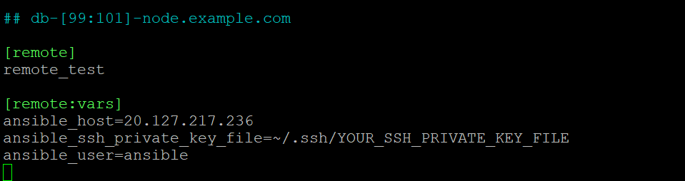

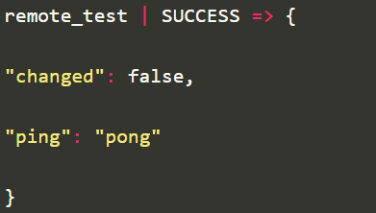

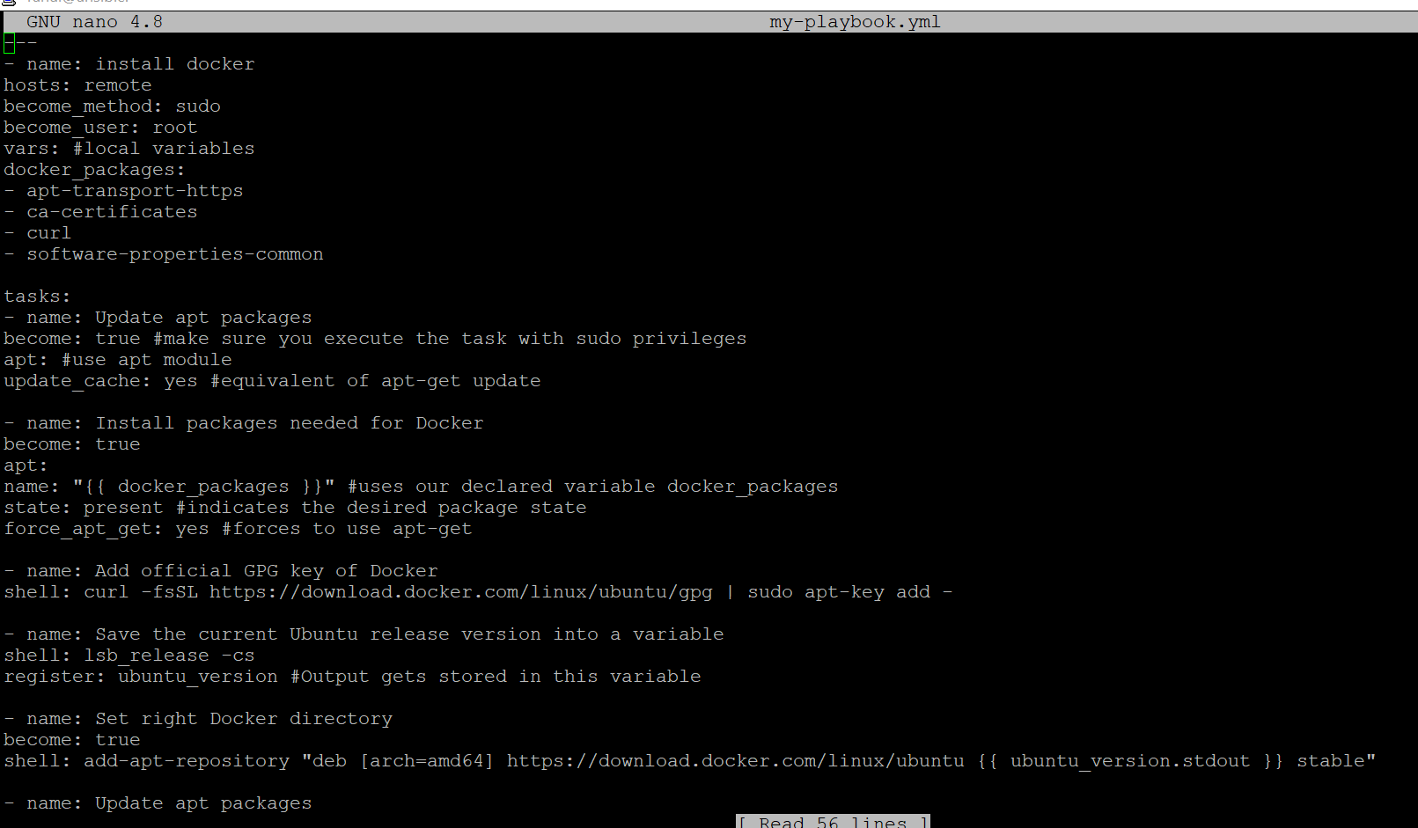

1. **Modify ansible.cfg to use hosts file as inventory**









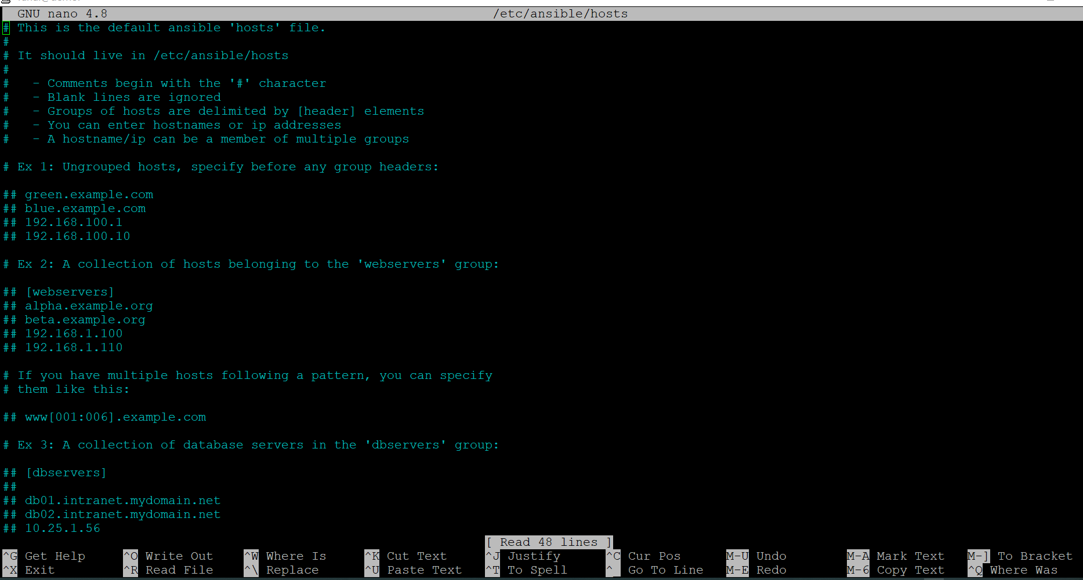

1. **install python-pip in ansible server**

root@Jenkins:~# apt-get install python3 python3-pip

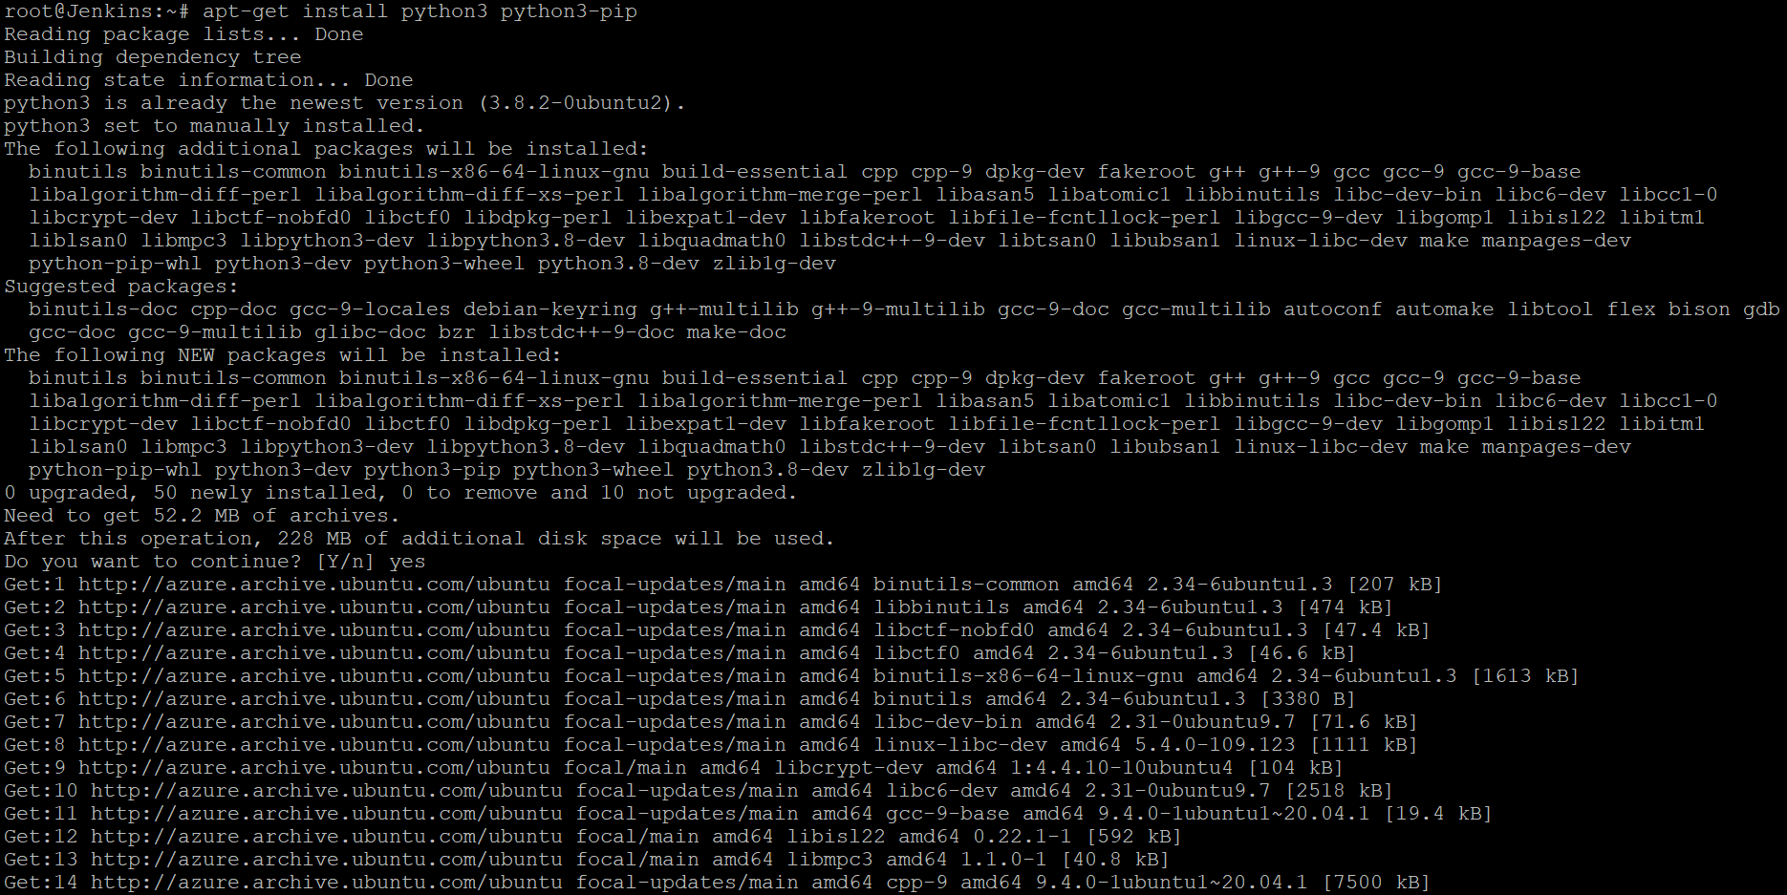

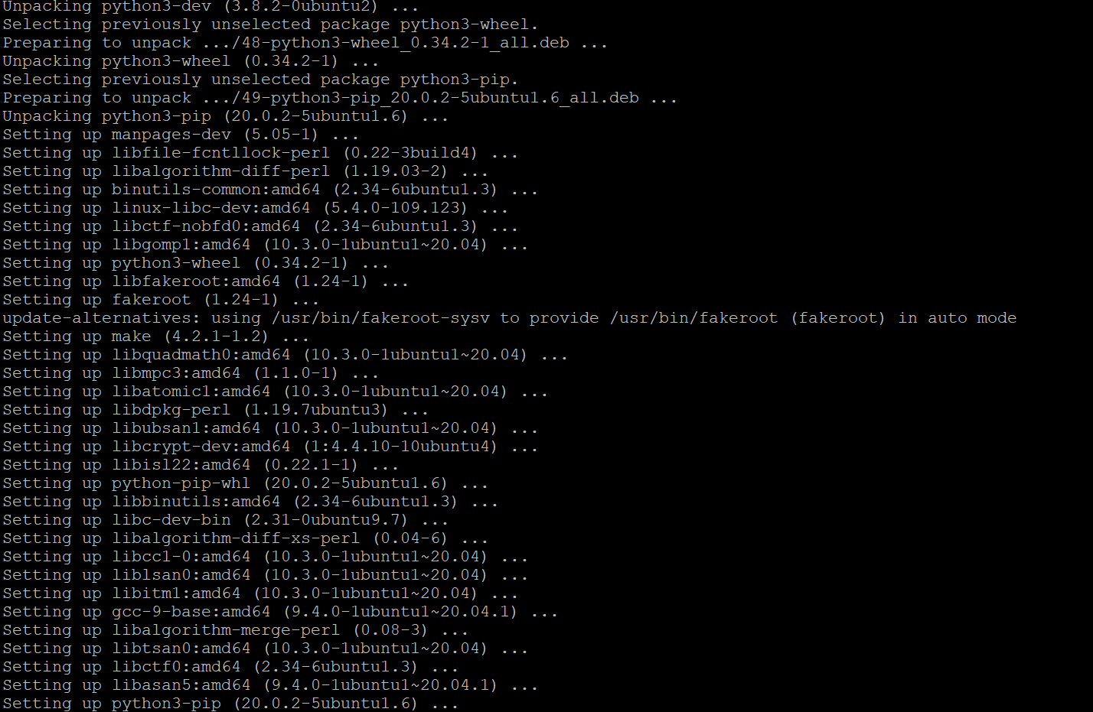

root@Jenkins:~# sudo pip3 install ansible

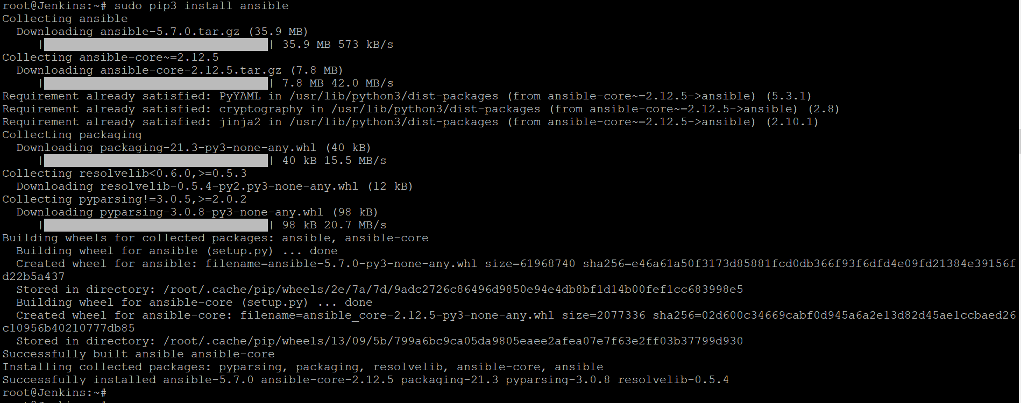

root@Jenkins:~# ansible --version

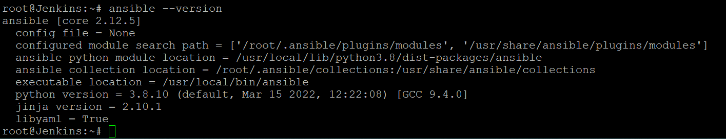

1. **Using PIP install azure modules in Ansible server**

sudo apt install python3-pip

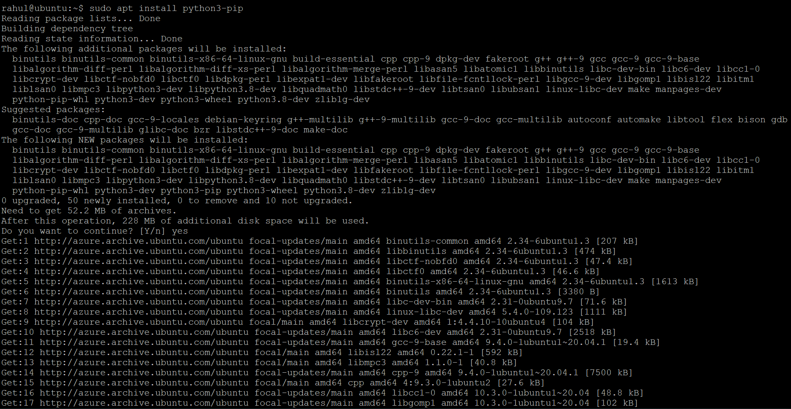

Install the pip library for Ansible-Azure

rahul@ubuntu:~$ pip install ansible[azure]

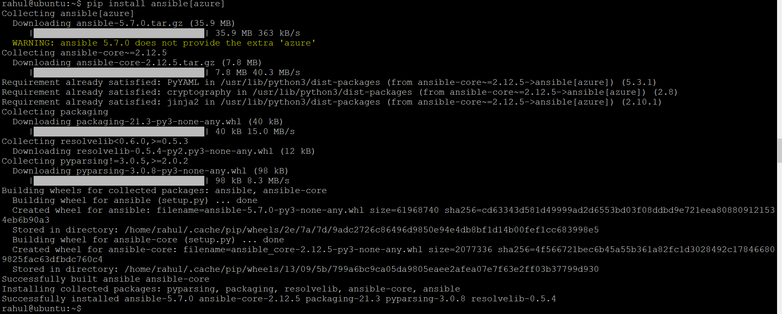

rahul@ubuntu:~$ sudo apt install ansible

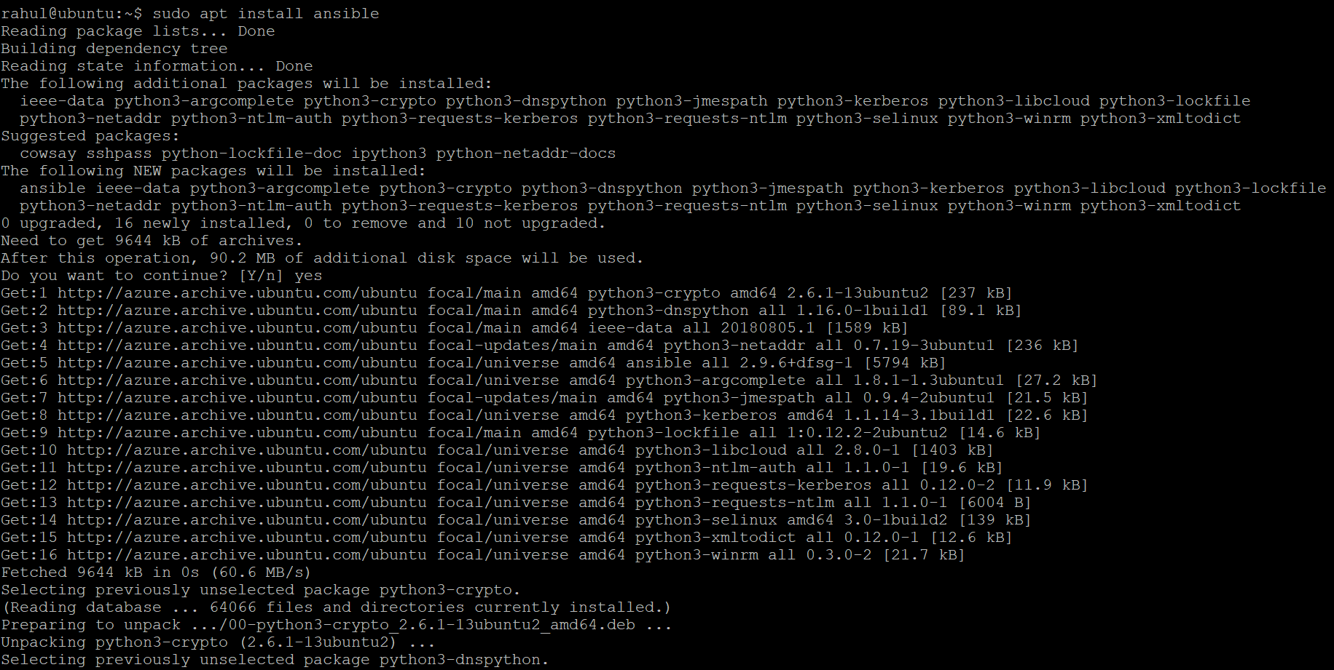

rahul@ubuntu:~$ ansible-galaxy install azure.azure_preview_modules

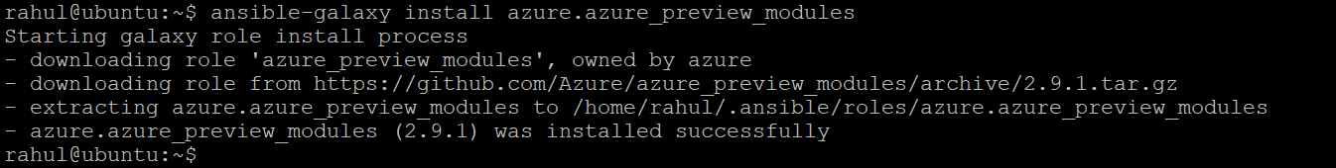

rahul@ubuntu:~$ pip install -r ~/.ansible/roles/azure.azure_preview_modules/files/requirements-azure.txt

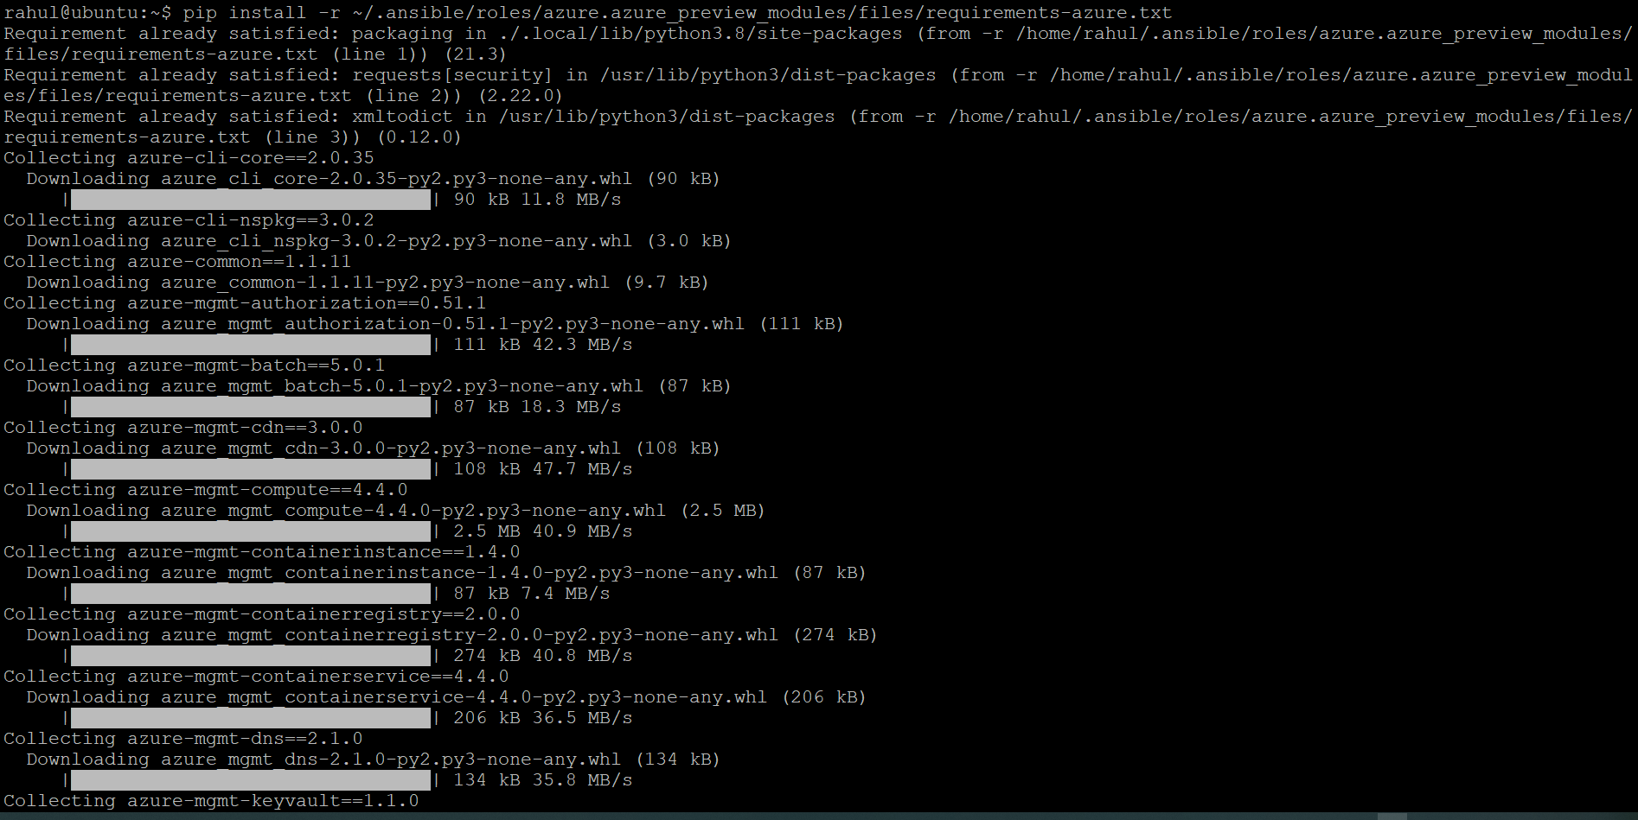

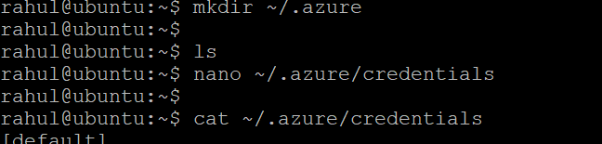

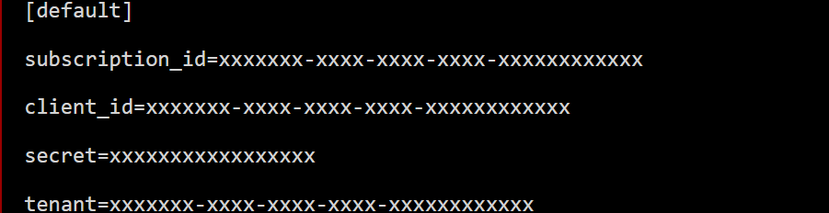



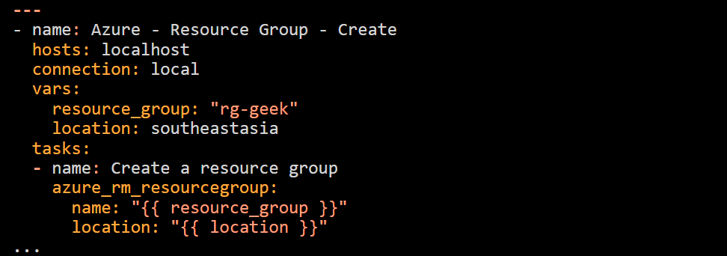

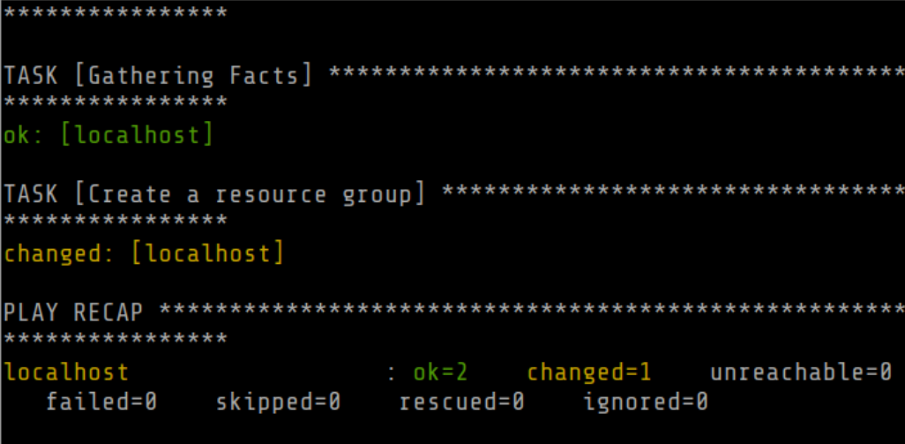

1. **Use the same service Principle created for terraform for ansible to get authenticated to Azure**

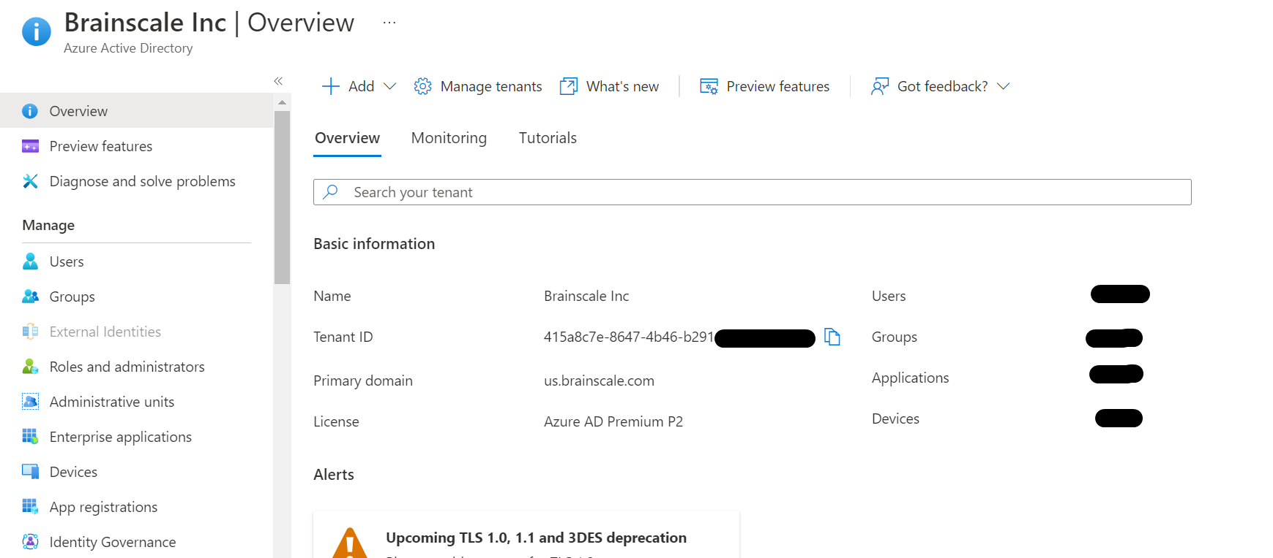

**Permissions required for registering an app**

You must have sufficient permissions to register an application with your Azure AD tenant, and assign to the application a role in your Azure subscription.

**Check Azure AD permissions**

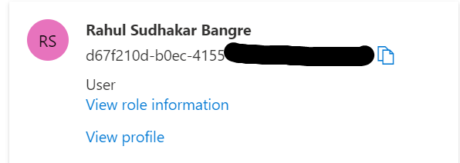

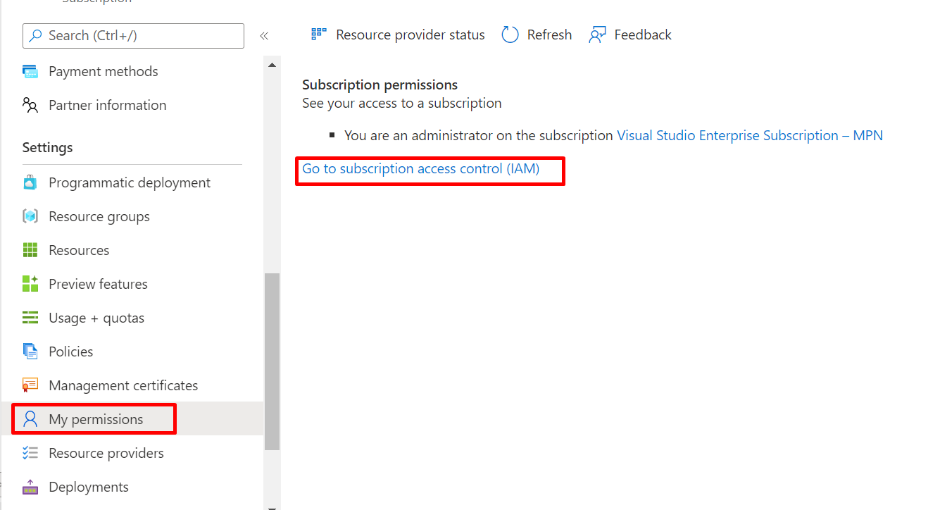

**Get tenant and app ID values for signing in**

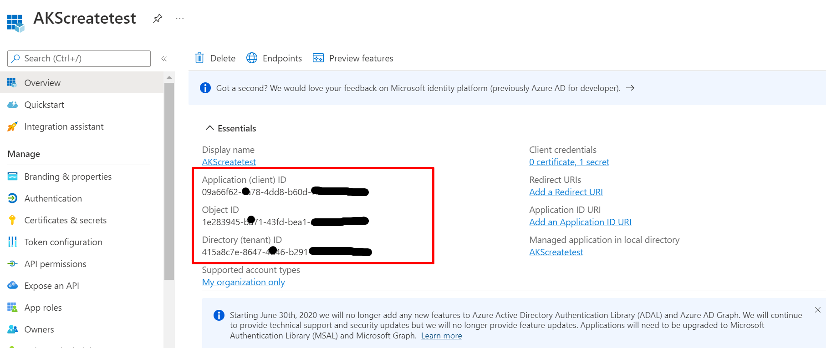

**Authentication: Two options**

here are two types of authentication available for service principals: password-based authentication (application secret) and certificate-based authentication. *We recommend using a certificate*, but you can also create an application secret.

**Option 1: Upload a certificate**

You can use an existing certificate if you have one. Optionally, you can create a self-signed certificate for *testing purposes only*. To create a self-signed certificate, open PowerShell and run [New-SelfSignedCertificate](https://docs.microsoft.com/en-us/powershell/module/pki/new-selfsignedcertificate) with the following parameters to create the cert in the user certificate store on your computer:

$cert=New-SelfSignedCertificate -Subject "CN=DaemonConsoleCert" -CertStoreLocation "Cert:\CurrentUser\My" -KeyExportPolicy Exportable -KeySpec Signature

**Option 2: Create a new application secret**

If you choose not to use a certificate, you can create a new application secret.

1. Select **Azure Active Directory**.
2. From **App registrations** in Azure AD, select your application.
3. Select **Certificates & secrets**.
4. Select **Client secrets -> New client secret**.
5. Provide a description of the secret, and a duration. When done, select **Add**.

After saving the client secret, the value of the client secret is displayed. Copy this value because you won't be able to retrieve the key later. You will provide the key value with the application ID to sign in as the application. Store the key value where your application can retrieve it.

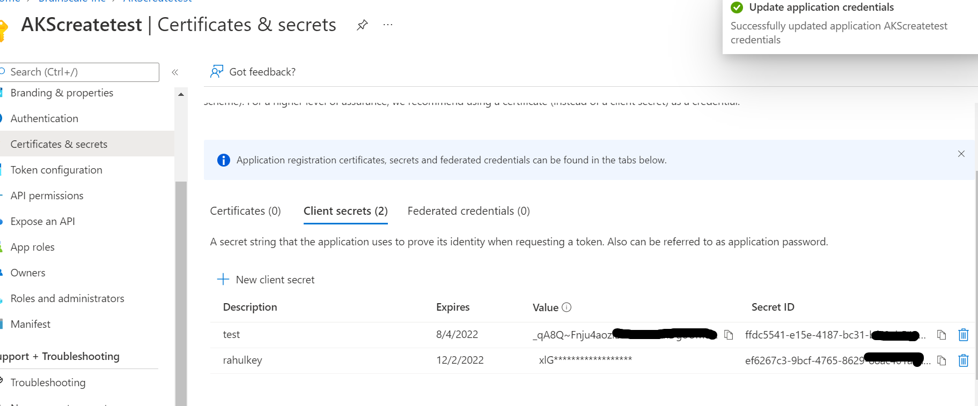

1. **Create a playbook1 to create aks cluster in azure and test**

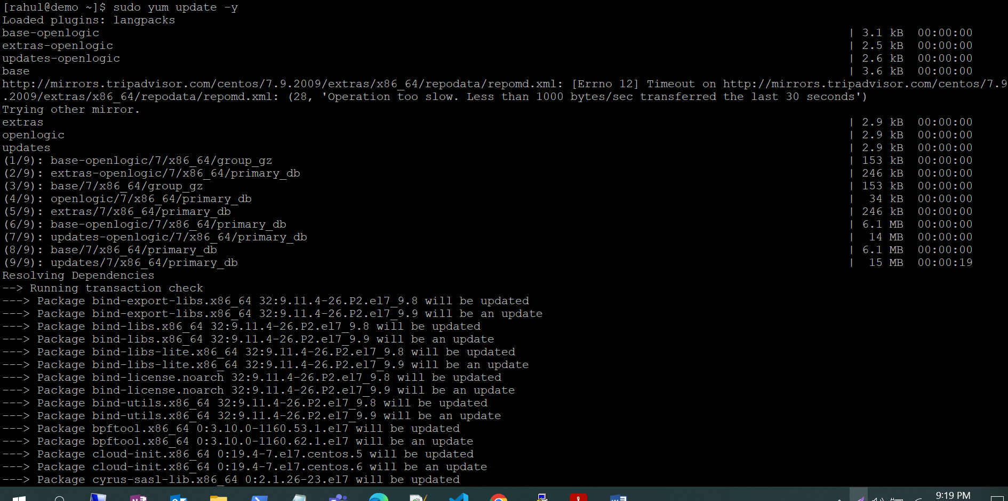

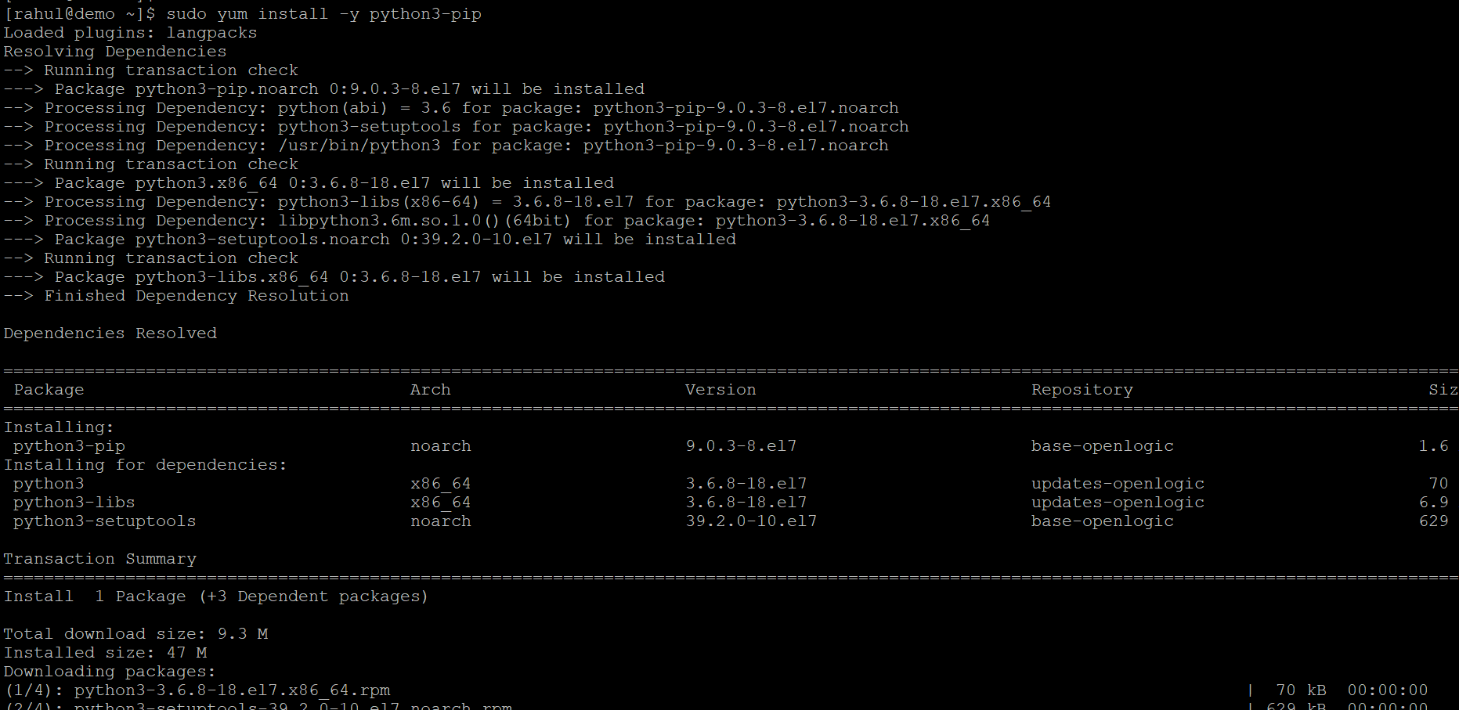

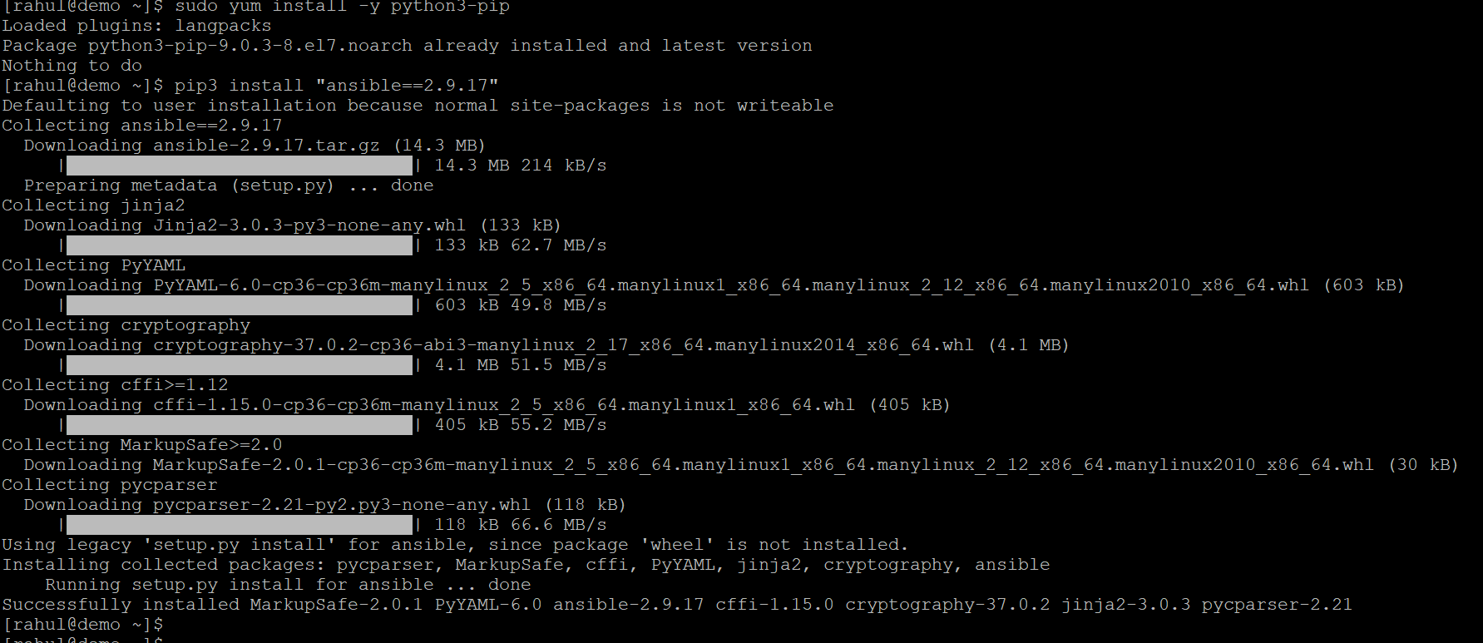

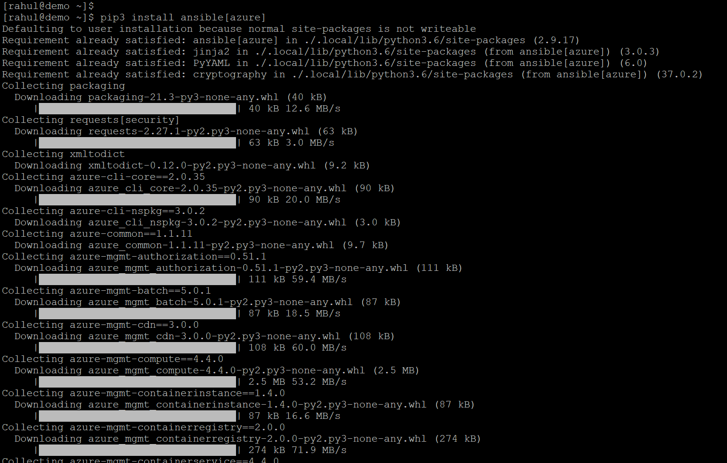

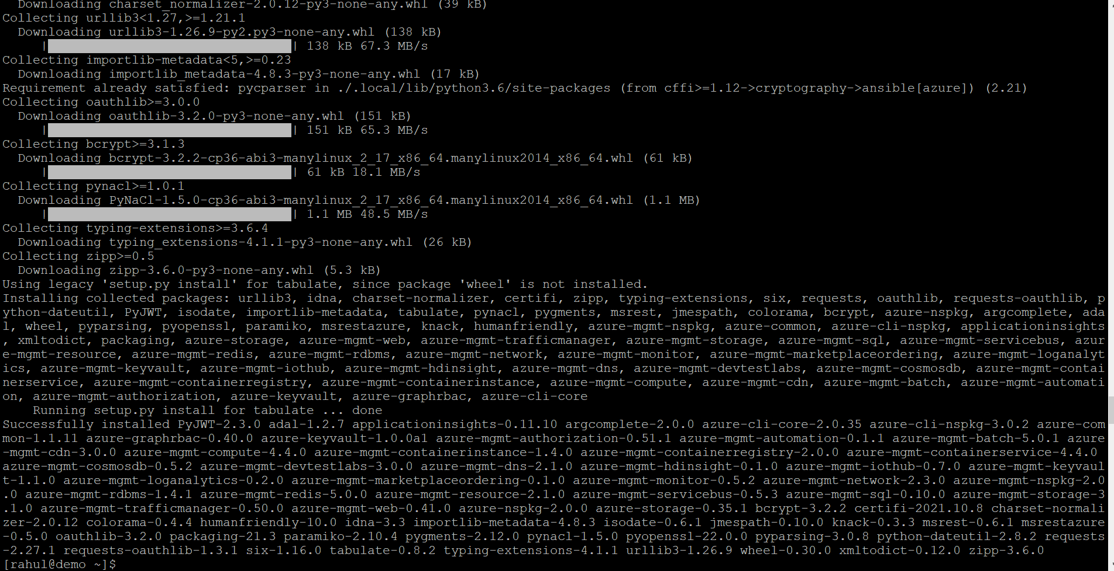

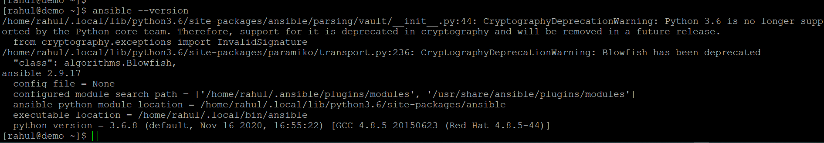

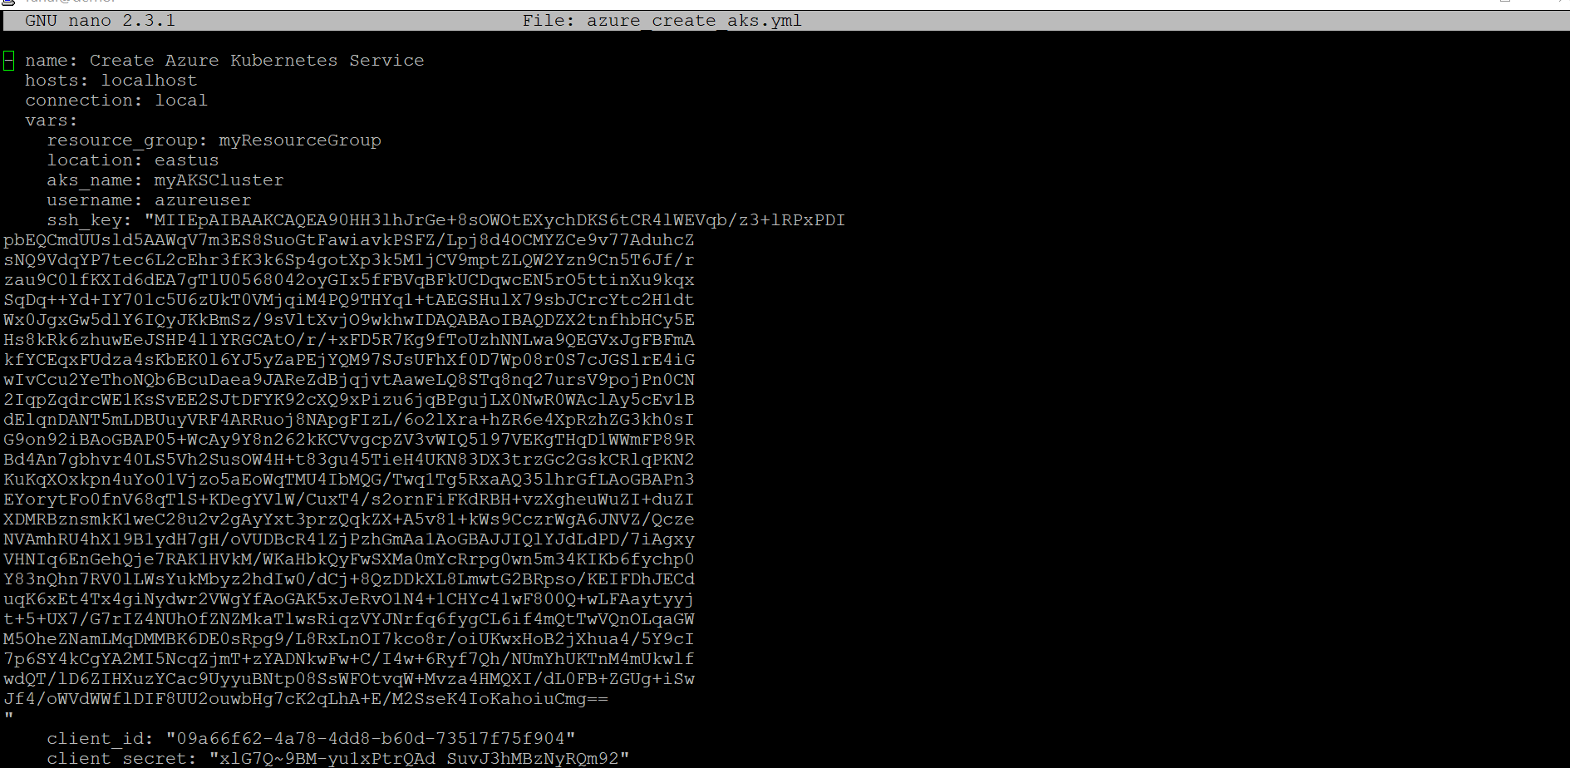

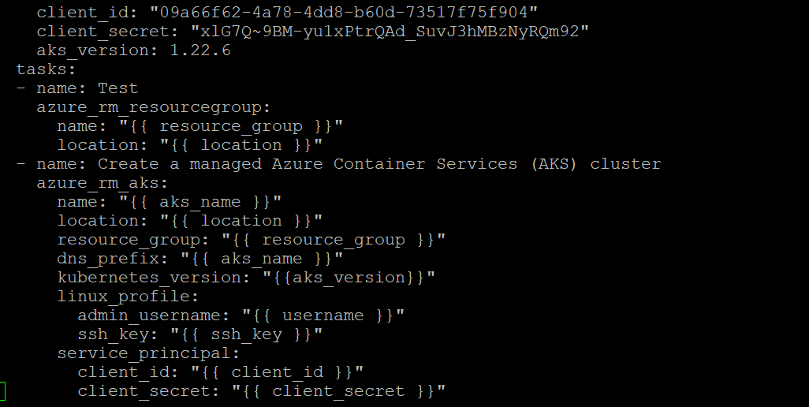

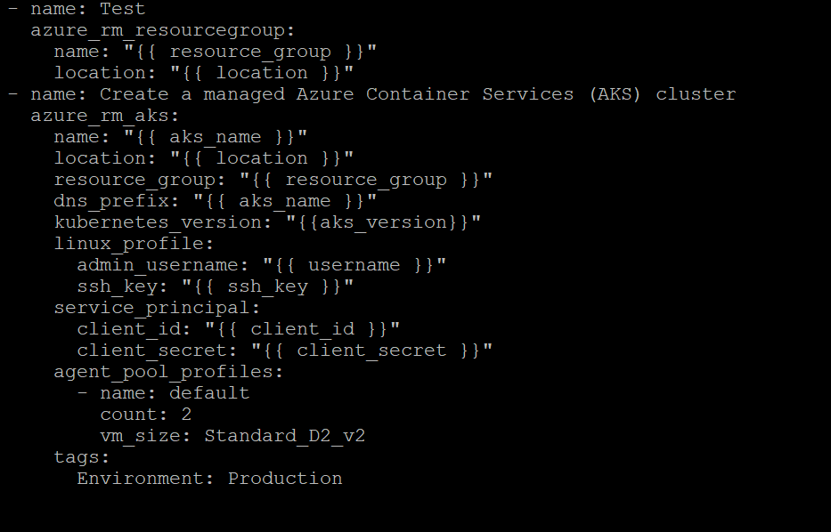

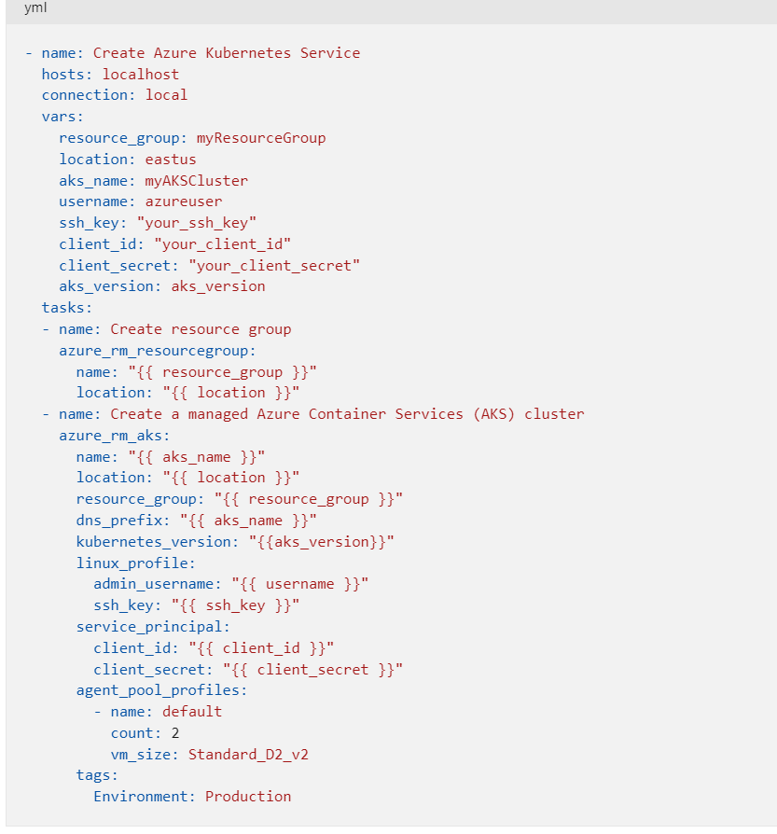

[rahul@demo ~]$ ansible-playbook azure_create_aks.ymls

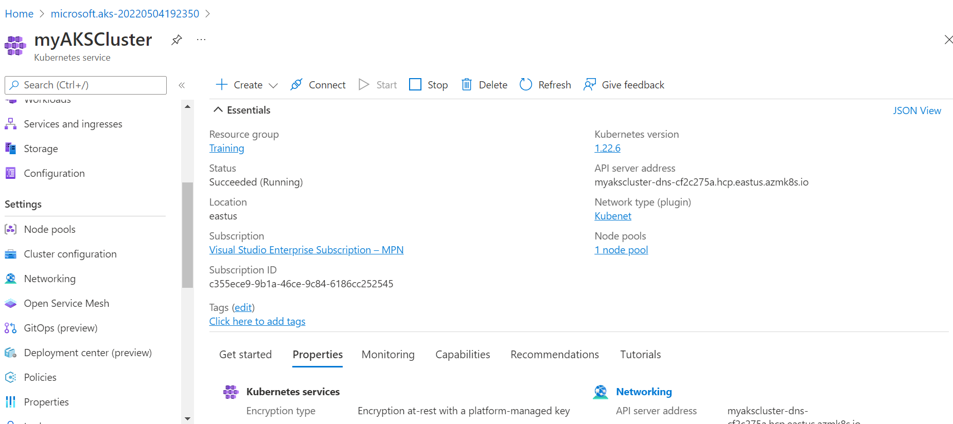

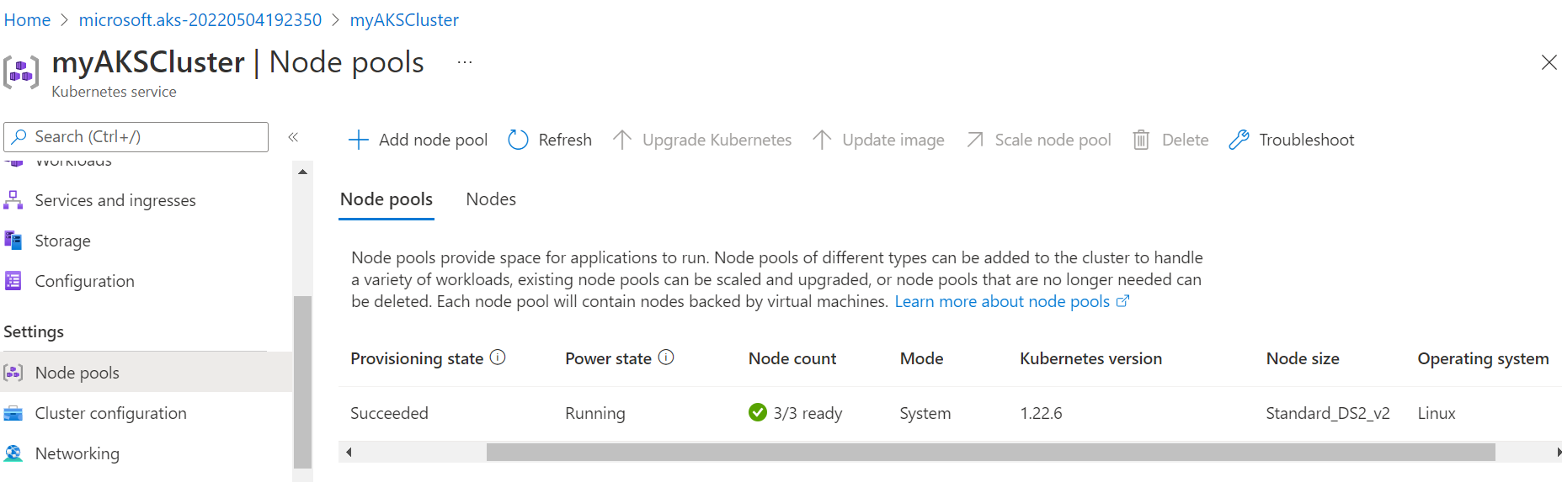

1. **Push playbook1 to Remote Git repo created**

Create playbook: -

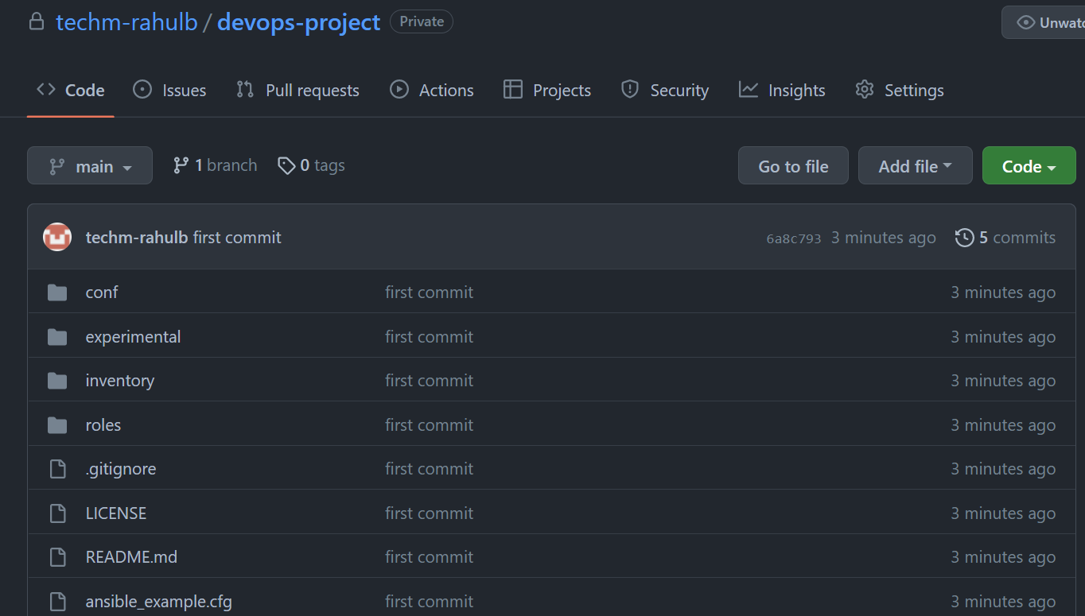

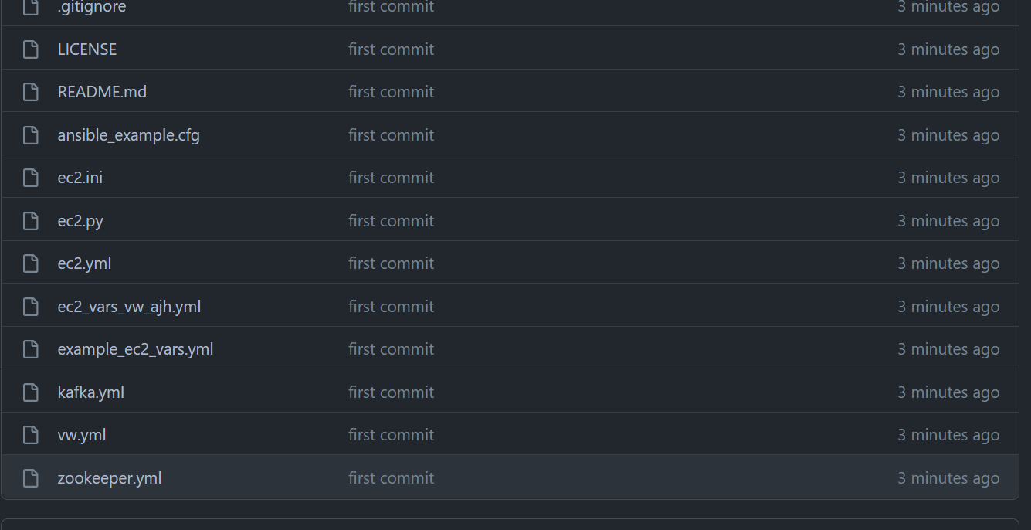

Inventory files

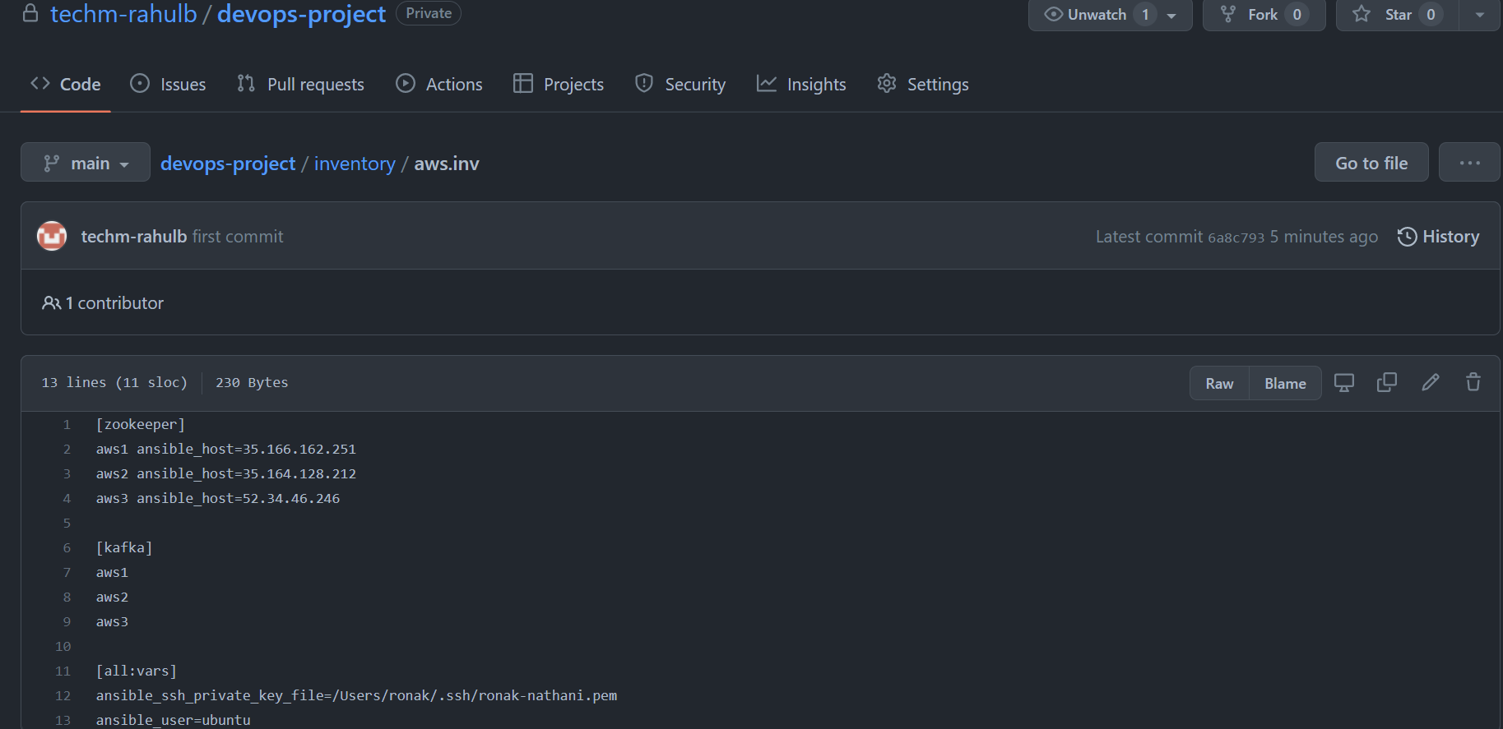

**Push Manifest YAMLs to the Git Repo**

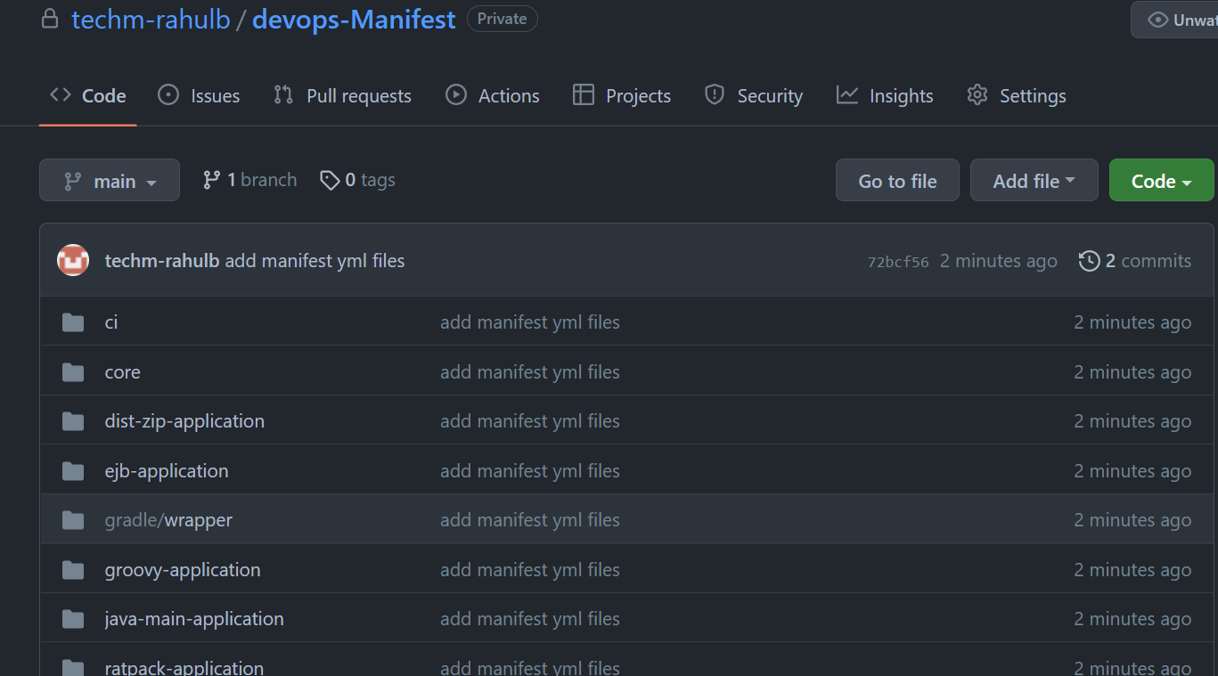

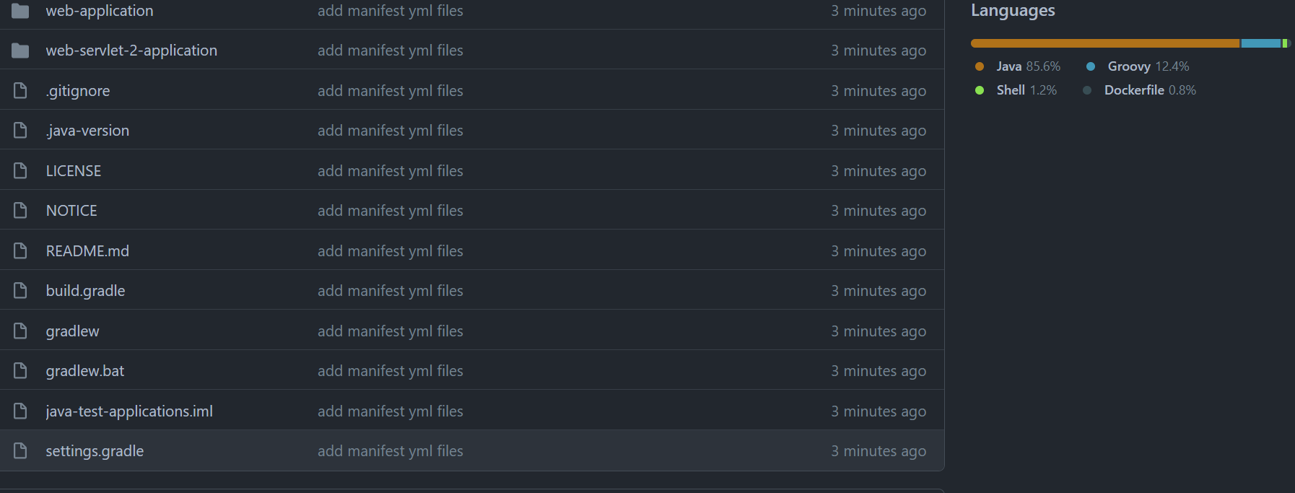

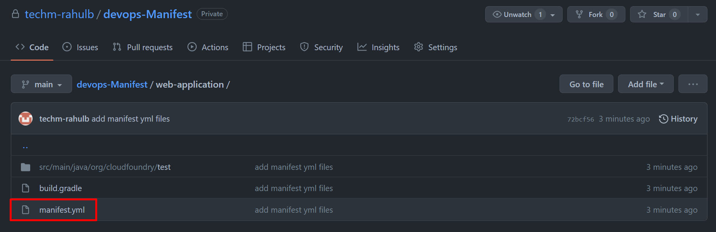

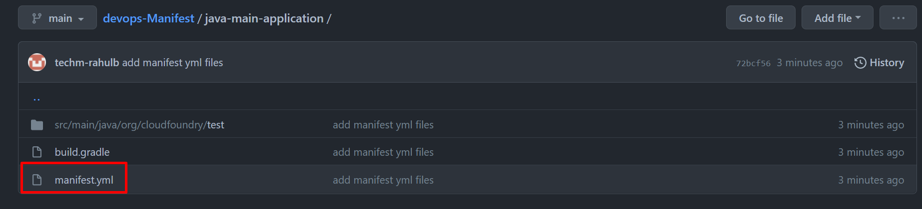

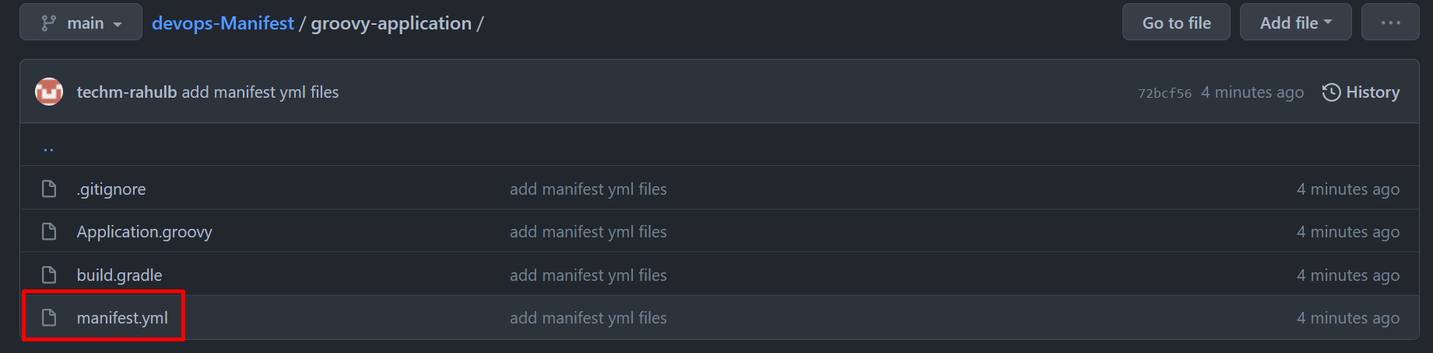

Push code manifest yamls file to github repo

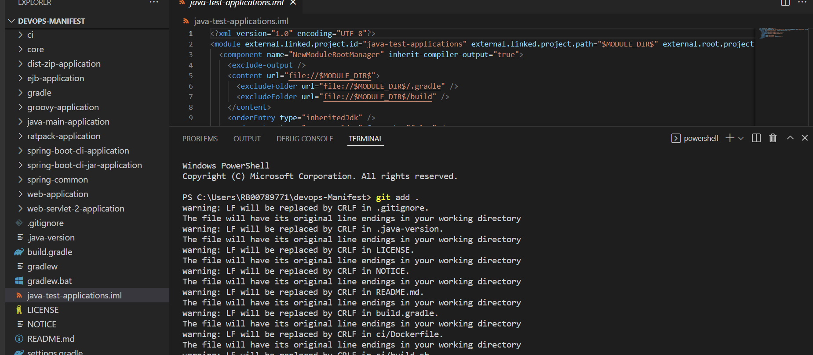

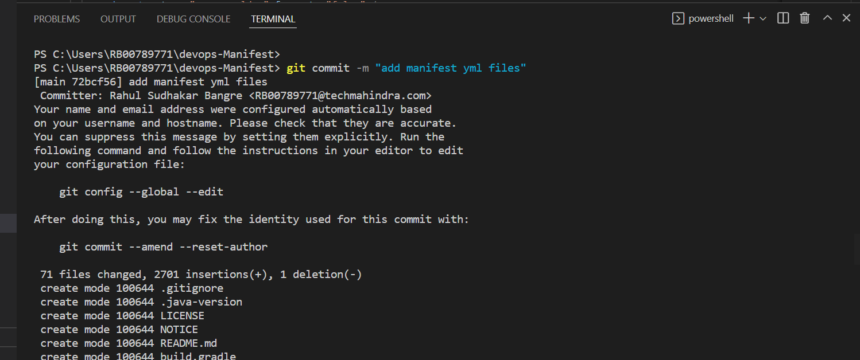

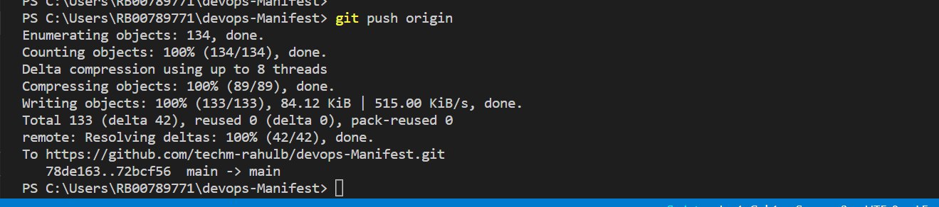

1. **Configure Git credentials in Jenkins Vault**

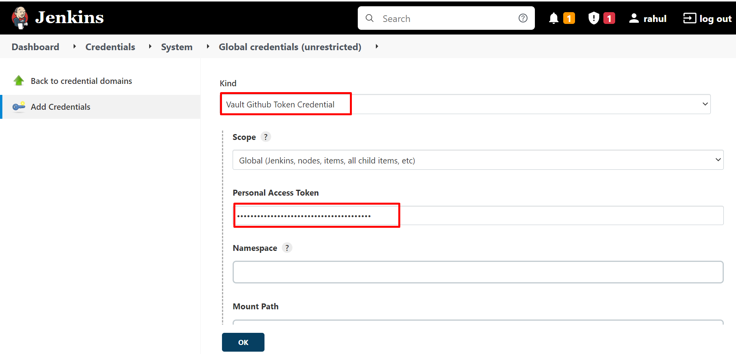

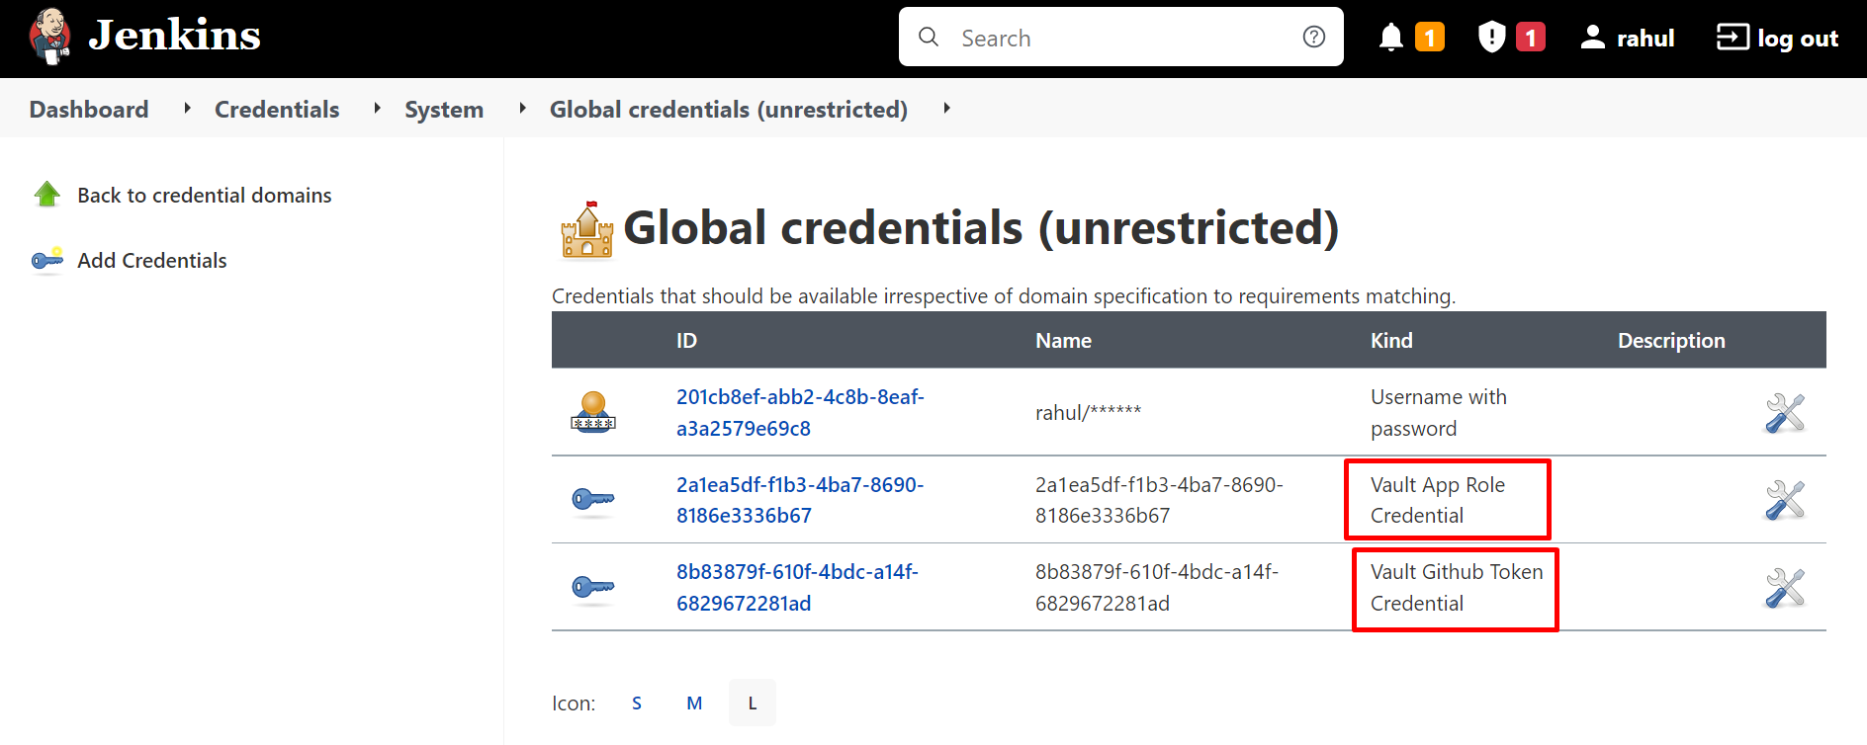

1. **Create Pipeline1 using Freestyle project in Jenkins**

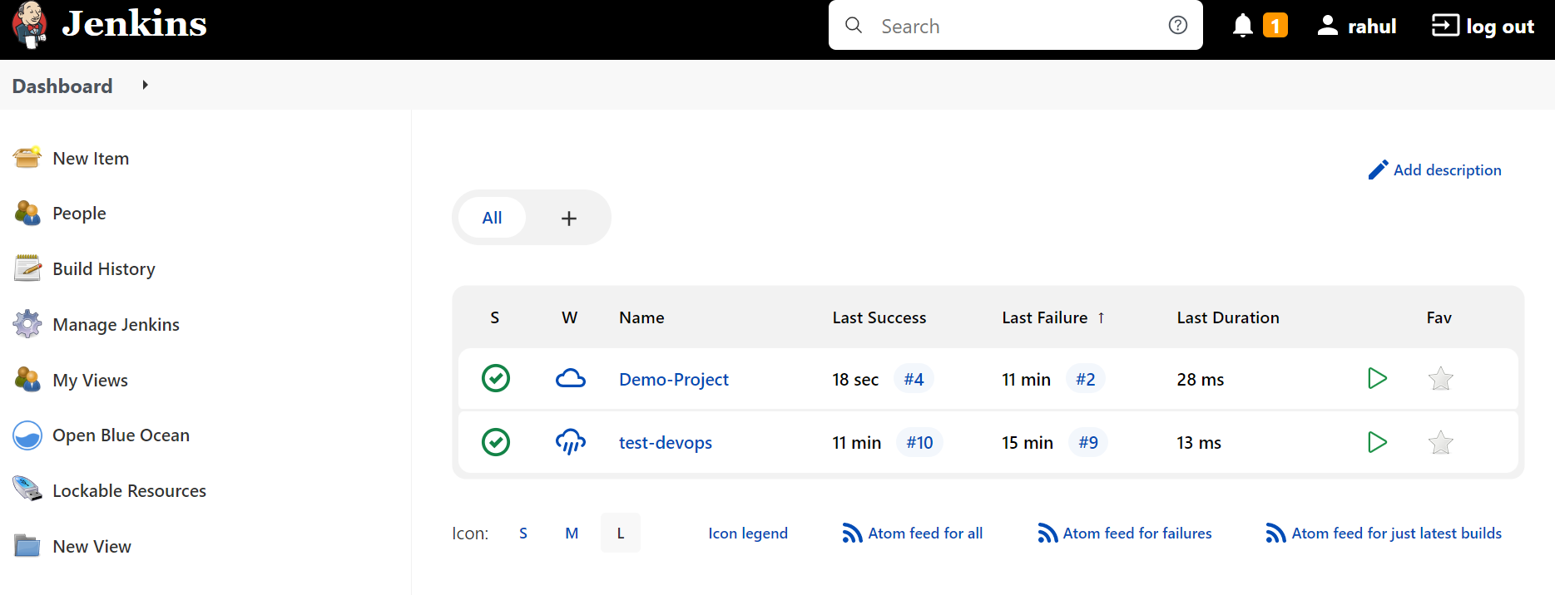

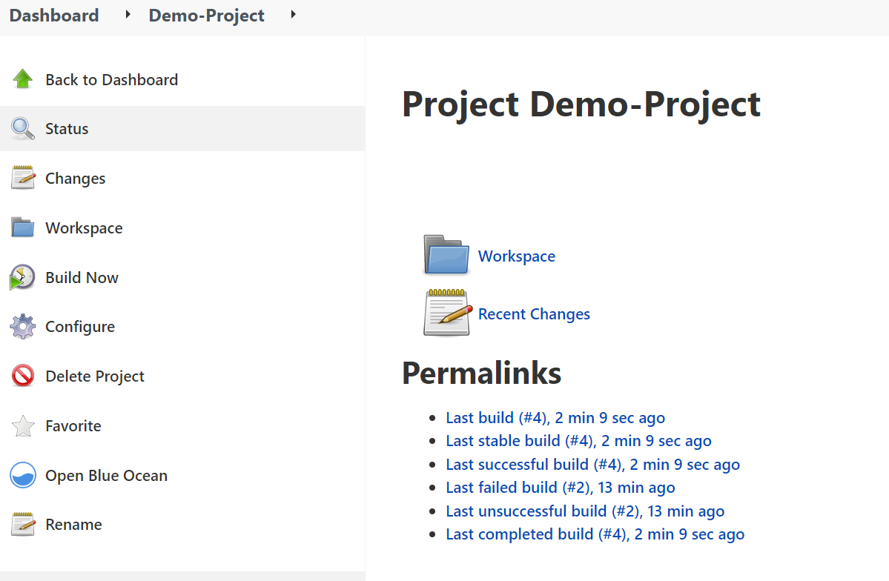

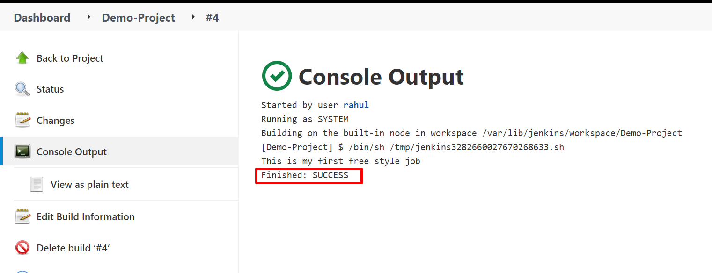

Create Blue Ocean :-

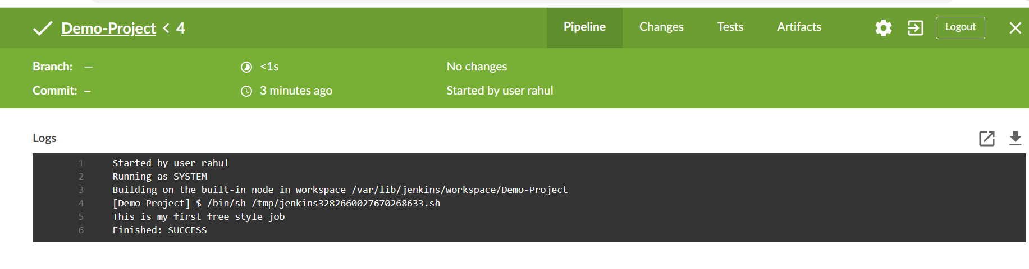

1. **Create release pipeline in Azure Devops Project**

**Create a release pipeline**

1. Visit your **Azure DevOps** team, select **Releases**, then **New** > **New release pipeline**.

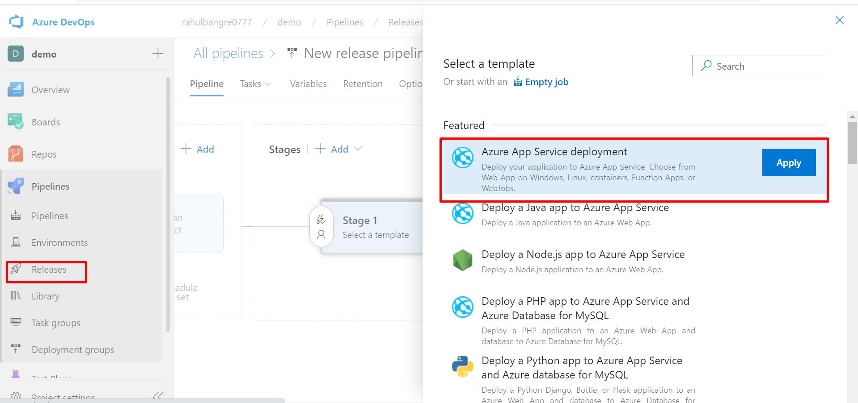

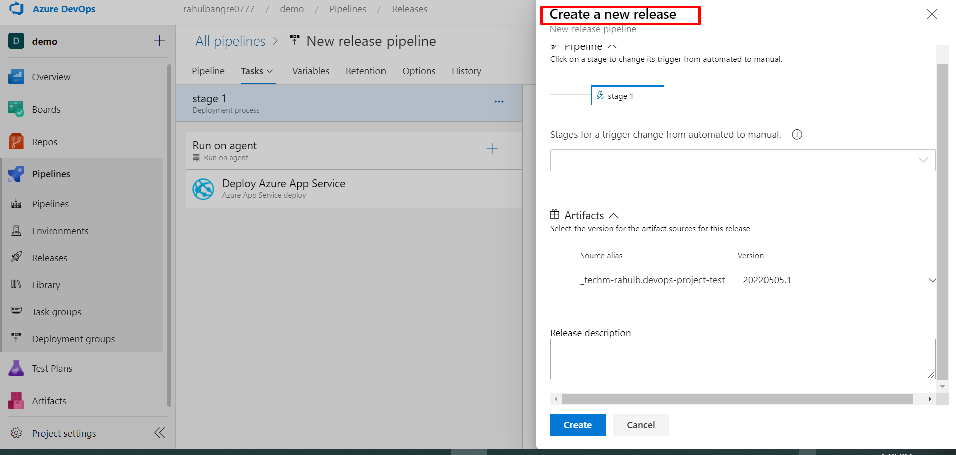

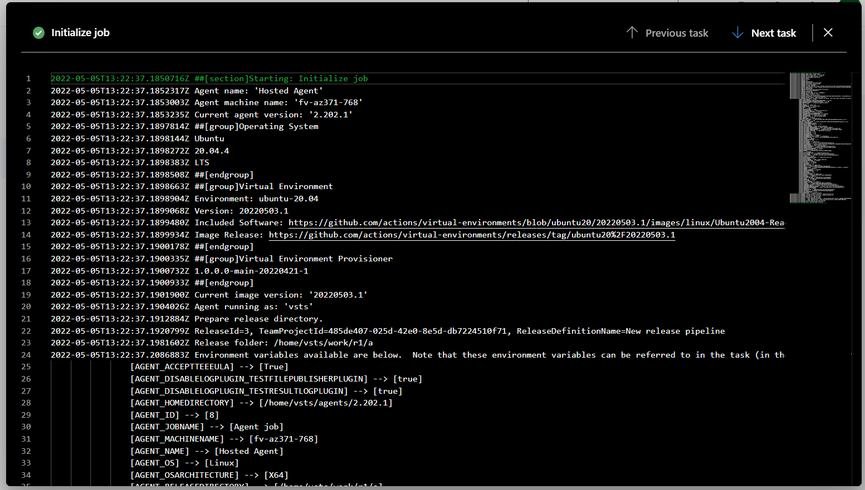

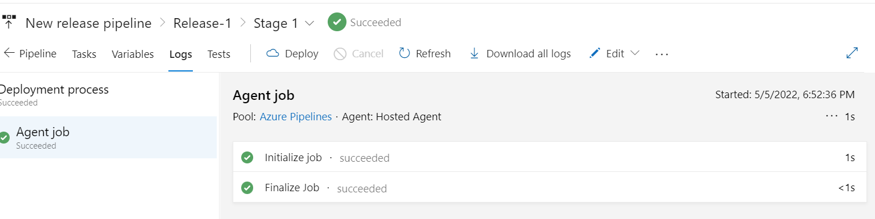

1. **Create Repo in hub.docker.com or acr**

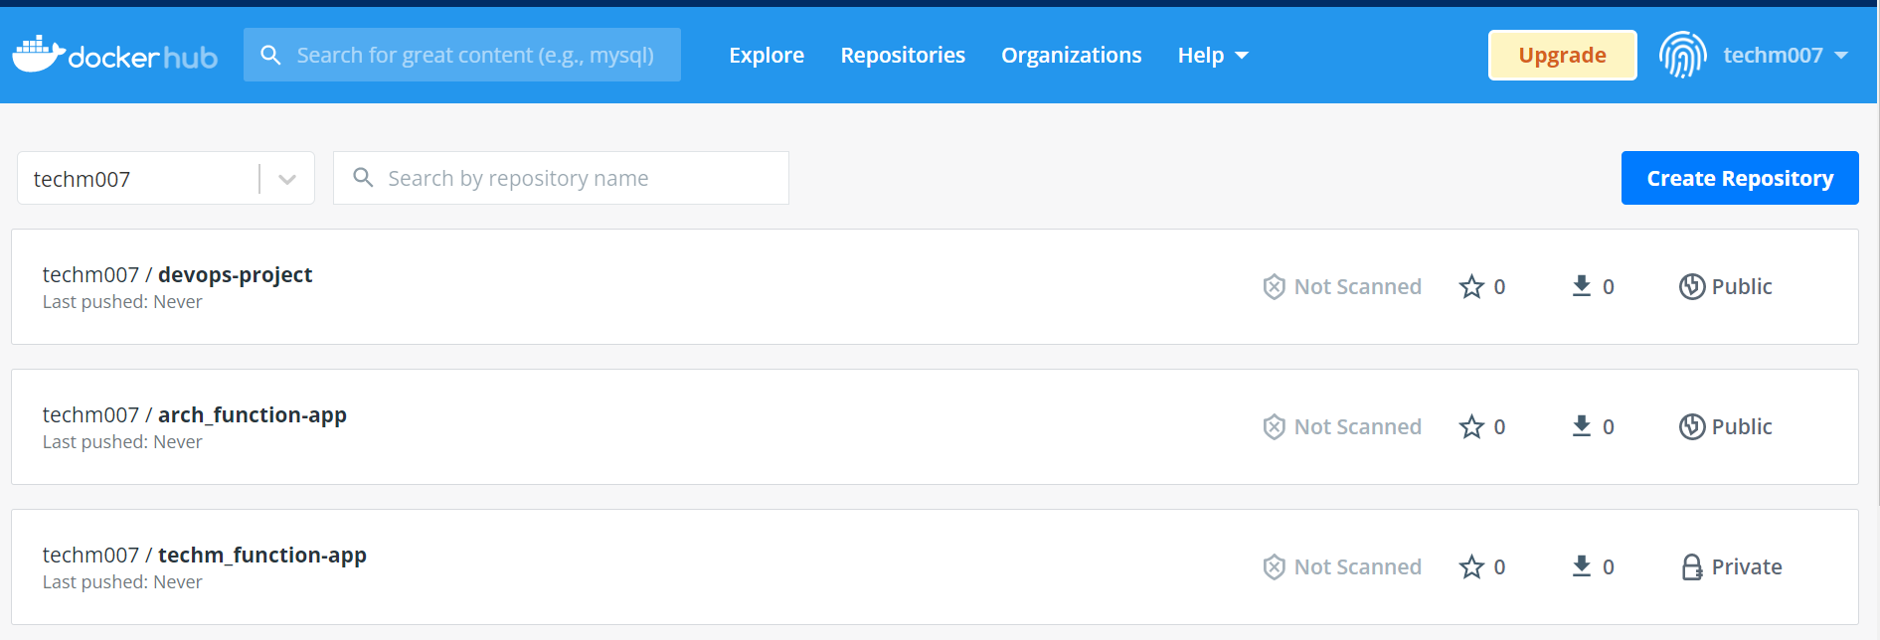

1. **For jenkins Pipeline configure Build trigger to use Github webhook for continuous integration**

Create webhook

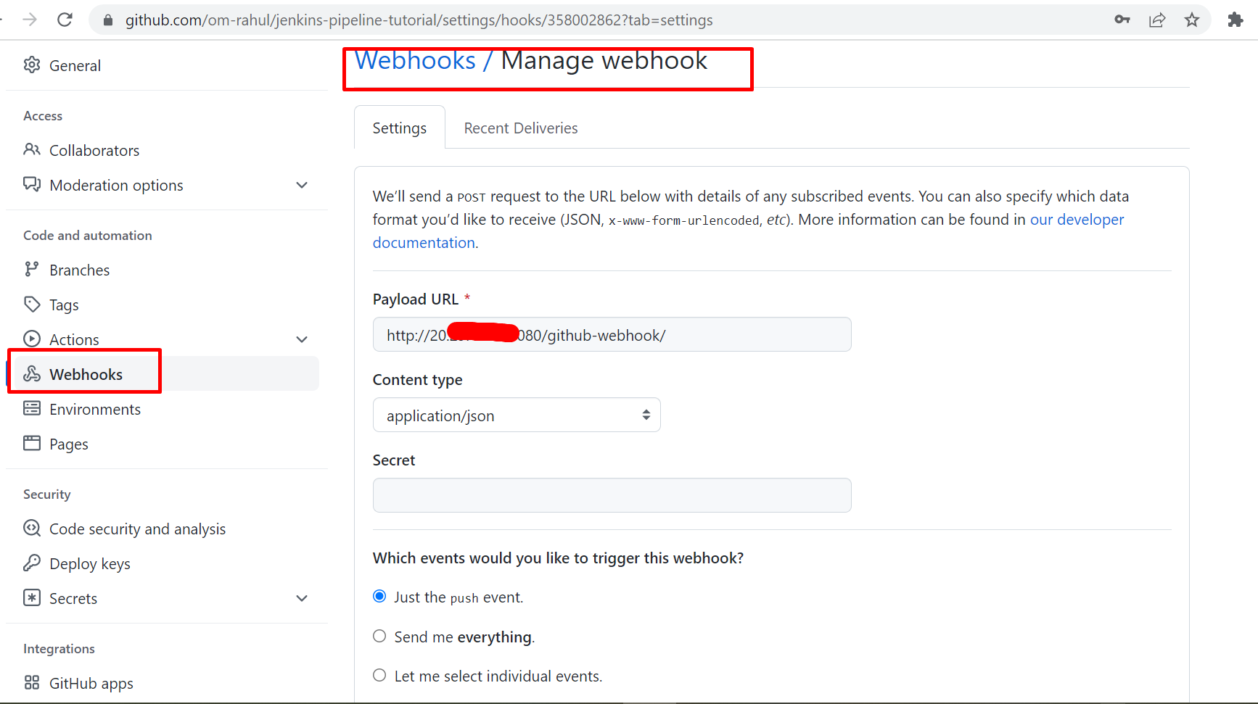

Jenkins Pipeline :-

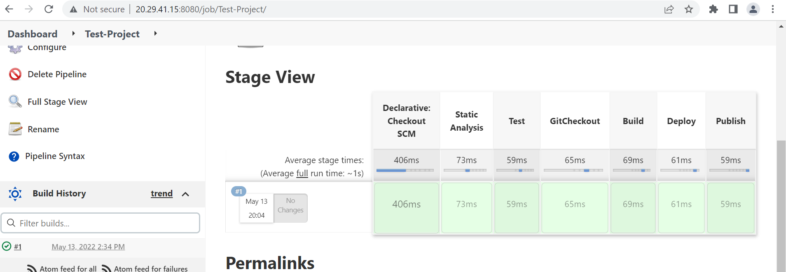

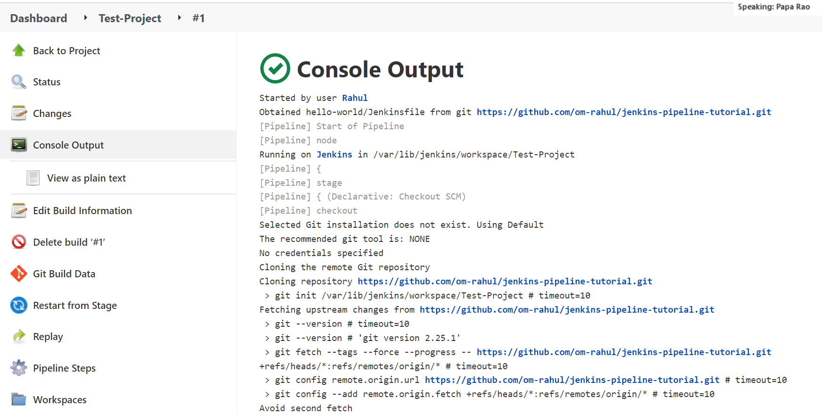

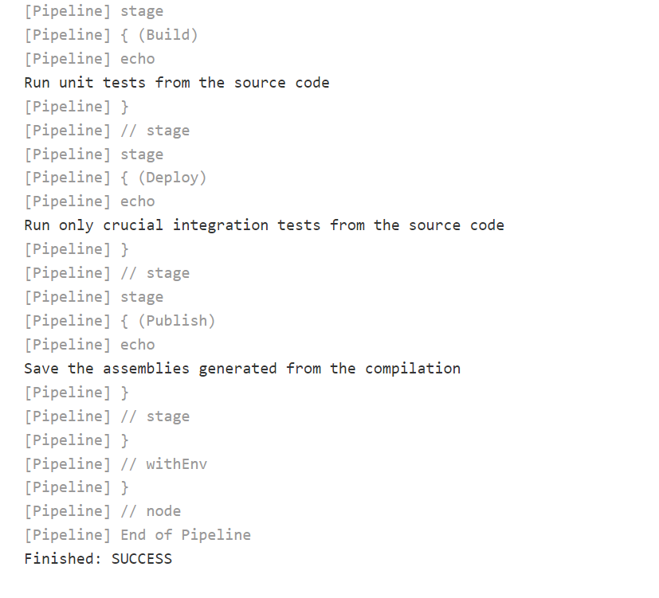

1. **In Github repo configure webhook for Jenkins**

Create Github Webhook

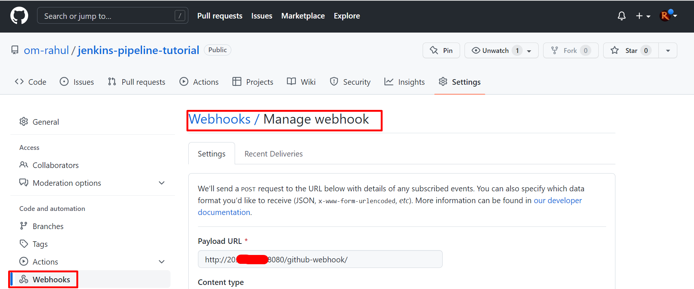

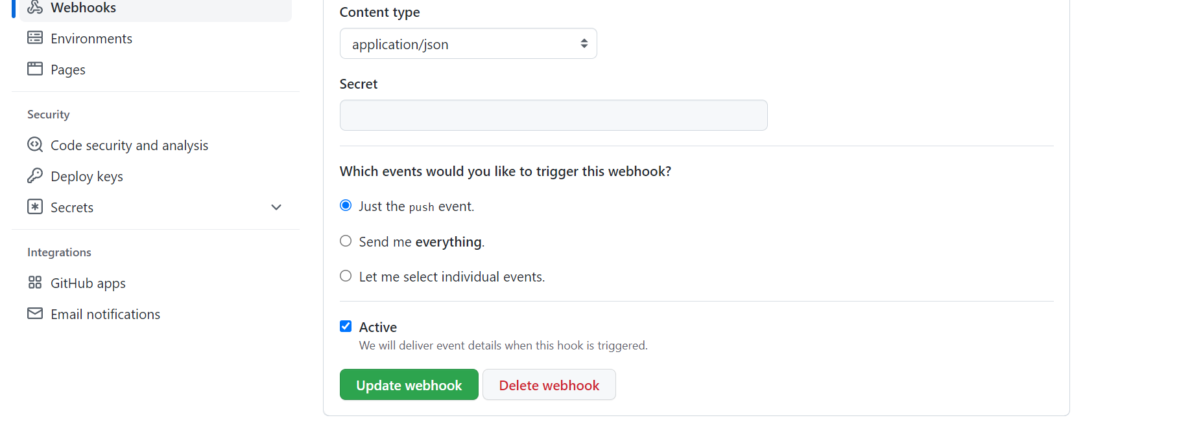

Configure and Create Jenkins Pipeline

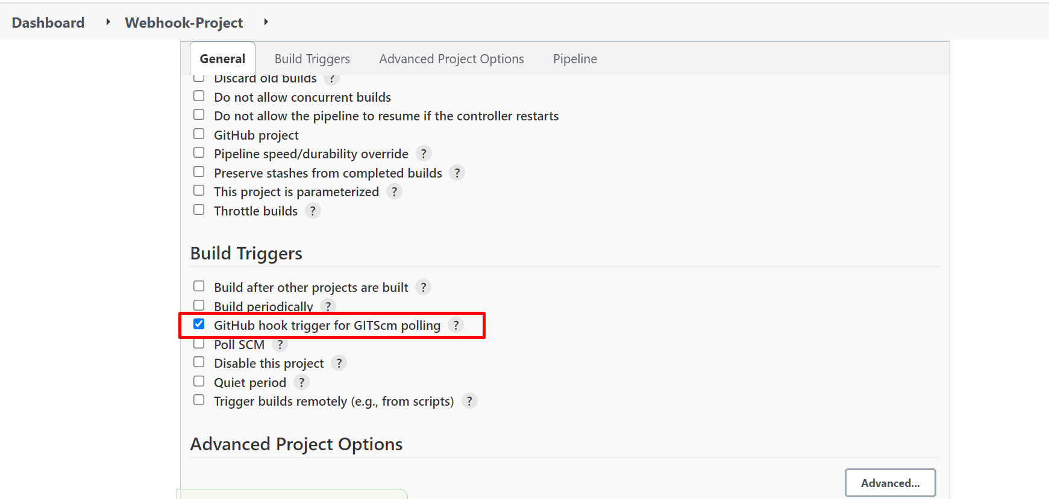

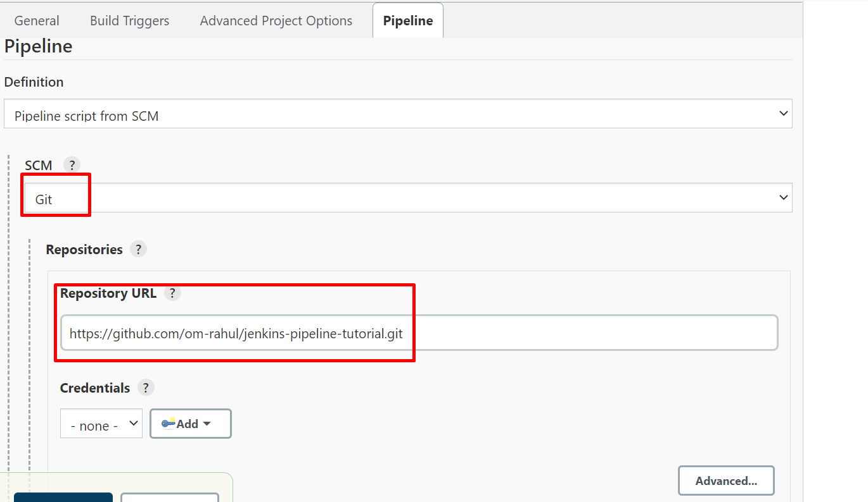

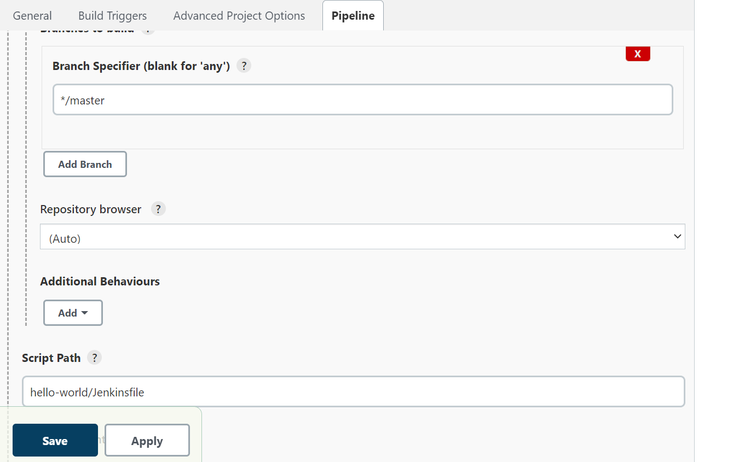

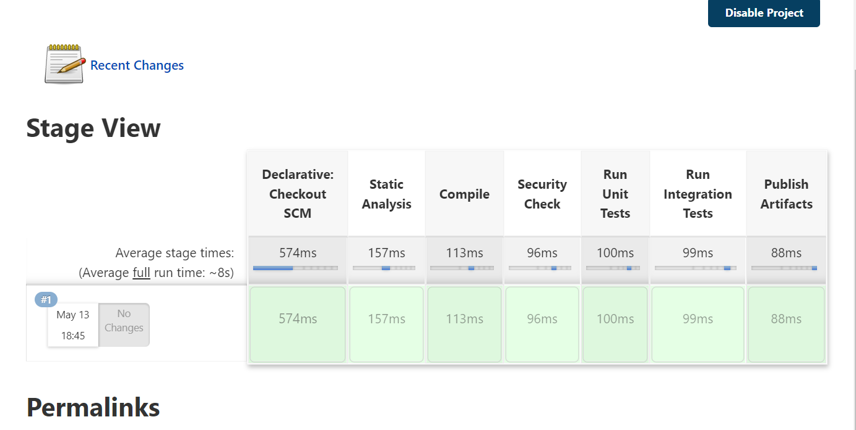

1. **In Build Stage, Step1 : use maven top level target to build**

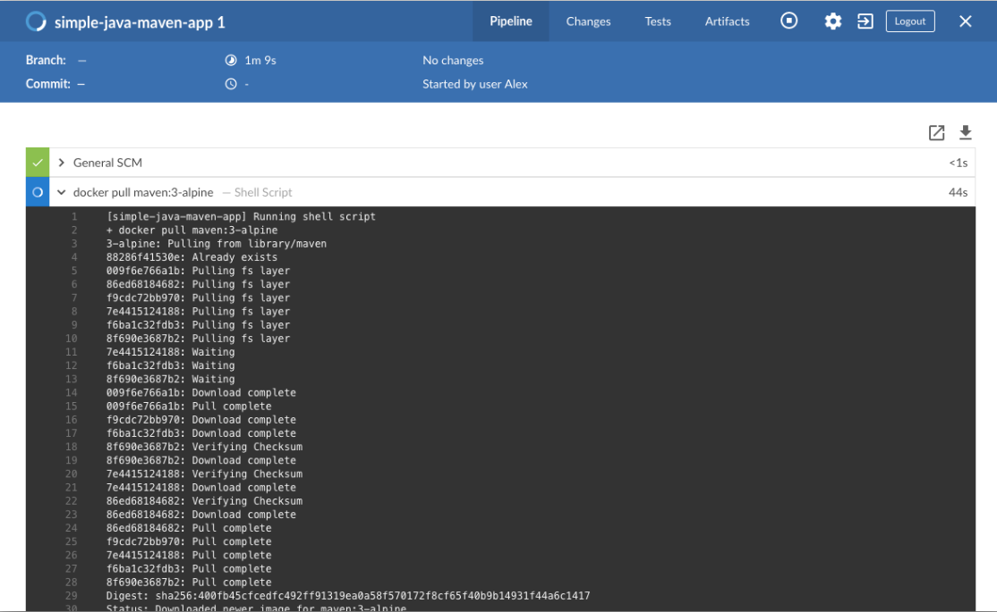

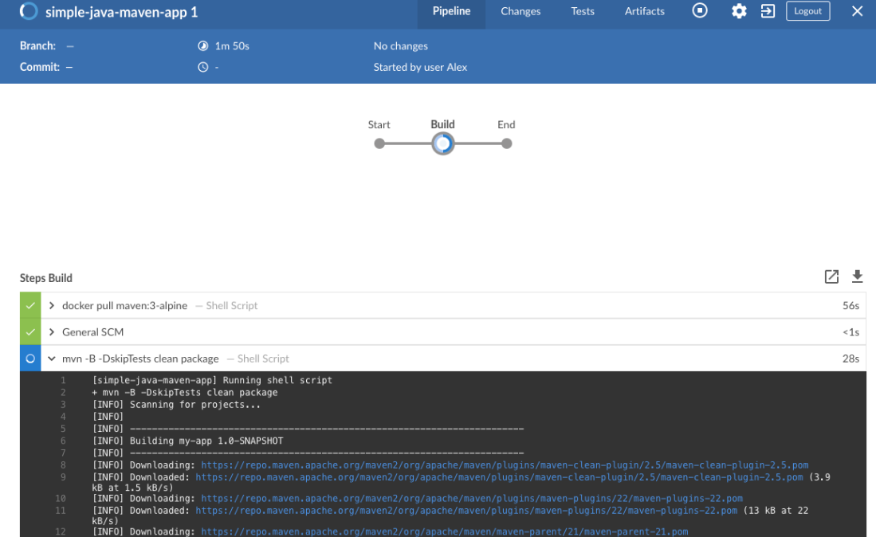

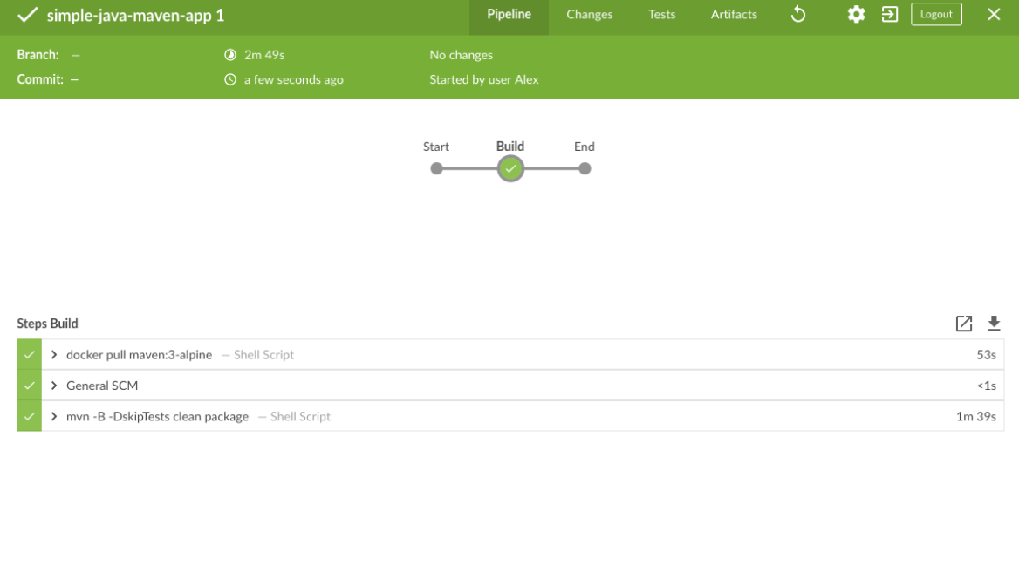

1. **In Build Stage Step 1: Run ansible Playbook1**

